

**Oxfordshire County Council**

**Adult Social Care Workforce Development Strategy**

**2023 – 2026**

# Introduction: why we need a Adult Social Care workforce strategy

Health and social care is a complex system, and the workforce is made up of people who are employed by a wide variety of providers of different sizes, and types. Many of the employers are publicly funded, although some are entirely independent for-profit or not-for-profit enterprises.

All of the employers in the social care sector in Oxfordshire face significant challenges which arise from four main factors:

* Increasing demand for care and support, as the population of Oxfordshire grows and ages.
* Challenges in recruiting new entrants to social care.
* Increasing skill levels required for adult social care work, as people’s needs become more complex.
* Challenges in retaining staff in the sector due to comparable or better pay in other sectors, for less demanding roles.

Although adult social care workforce challenges are not new, they have been become more acute in recent years for a variety of reasons, including the pandemic. Care providers report that it is difficult to attract and retain staff, particularly in frontline roles, and the council increasingly experiences similar challenges, particularly in frontline roles in our social and health care team, social work and occupational therapy. The vacancy rate across key frontline roles raises significant issues regarding the capacity and capability of the workforce. These issues are not unique to Oxfordshire, but there are other local factors that exacerbate the issues in Oxfordshire, including the very high cost of housing in our county.

This draft workforce strategy is explicitly aligned with the Oxfordshire Way strategic vision, supporting early intervention to enable people to live independently in their own home for longer. It is our intention to champion prevention practice at every stage of the health and social care system.

The strategy has been developed via collaboration with key stakeholders including internal staff and care providers, and the activity in the delivery plan will continue to be co-designed with a range of stakeholders including our staff, local care provider employers and people we support. We are committed to involve people we support, their families and our communities to learn about what is important to them when it comes to the workforce who help provide care and support for them or their loved ones.

The strategy is also informed by and aligned with:

* National policy, strategies, plans, and initiatives related to adult social care such as [People at the Heart of Care](https://www.gov.uk/government/publications/people-at-the-heart-of-care-adult-social-care-reform-white-paper)(2022), a government white paper setting out reforms to adult social care
* Oxfordshire strategies and plans related to adult social care, including Oxfordshire’s Joint Health and Wellbeing Strategy 2022, Oxfordshire’s Market Sustainability Plan and Oxfordshire’s Market Position Statement 2023-2024
* Care Quality Commission [Single Assessment Framework](https://www.cqc.org.uk/about-us/how-we-will-regulate/single-assessment-framework), which applies to local authorities from April 2023, to ensure that people are provided with safe, effective, compassionate, high-quality care and that services are encouraged to improve. CQC will provide independent assurance to the public of the quality of care in their area, including evidence that we have a quailfied and competent workforce
* Oxfordshire All Age Carers Strategy The council’s internal people strategies including Building our Workforce of the Future Togetherinternal workforce strategy (draft, for consultation, at the time of writing), the Delivering the Future Together programme which aims to make Oxfordshire County Council even better place to work, and the Council’s Equalities, Diversity, and Inclusion Framework [Including Everyone](https://www.oxfordshire.gov.uk/sites/default/files/file/plans-performance-policy/OCCIncludingeveryone.pdf).

The strategy aims to be a living document that evolves as and when required. As a minimum, the strategy and delivery plan will be reviewed annually.

The data cited in this strategy is largely drawn from Oxfordshire’s [Joint Strategic Needs Analysis](https://insight.oxfordshire.gov.uk/cms/joint-strategic-needs-assessment) (JSNA) and the [Adult Social Care Workforce Dataset](https://www.skillsforcare.org.uk/Adult-Social-Care-Workforce-Data/Workforce-intelligence/publications/local-information/My-local-area.aspx) (ASC WDS) which is published by Skills for Care. References and links are provided where other sources are used.

# Context in Oxfordshire

In Oxfordshire, as in the rest of the UK, good care and support makes a positive difference to many people. Our vision for delivering social care, the Oxfordshire Way, recognises that the role of social care is to provide support to people who have a disability or health condition to “live in the place we call home, with the people and things that we love, in communities where we look out for one another, doing what matters to us” (Social Care Future, 2021).

The Oxfordshire Way brings those responsible for providing care together with a united, shared approach to supporting the people of Oxfordshire to live well in their community, remaining fit and healthy for as long as possible. The Covid-19 pandemic accelerated the use of technology and allowed us to be innovative to ensure good quality care is delivered, as well as promoting independence and wellbeing. As digital technology becomes more available and accessible, the Oxfordshire Way seeks to build on opportunities to embed this into our practice and transform the way in which care is delivered.

The Oxfordshire Way was developed in the context of a rising demand for social care, which is predominantly driven by our growing population and the increasing proportion of older people who are living longer and developing complex care needs. According to 2021 Census, the population of Oxfordshire increased by 11% (above the growth in England at 6.6%) where the number of people aged 65 and over inreased by 25% in the last decade. Currently, there are nearly 130,000 older people aged 65 and over in Oxfordshire and this is projected to increase by another 25% by 2030

In 2021, older people aged 65+ made up 20% of the estimated population of Oxfordshire’s four rural districts, compared with 12% of the population of Oxford City

Over the past 20 years (between 2001 and 2021), there was an increase in the population of Oxfordshire from 605,400 to 725,200, a growth of 119,800 (+20%).

* The younger age group, aged 0-15, increased by 10%
* The older age group, aged 65 and over, increased by 48%

Between 2011-2021, Oxfordshire’s population increased by 10.9%. In addition to the increasing proportion of older people, more adults and older people are expected to face difficulties in their daily life.

|  |  |  |  |  |
| --- | --- | --- | --- | --- |
|  | In 2020 | In 2023 | By 2030 | Increase |
|  | **Over 65s living with a long term illness whose day to day activities are:** | | | |
| Limited a little | 31,361 | 33,458 | 38,997 | +24% |
| Limited a lot | 24,664 | 26,764 | 31,559 | +28% |
|  | **Have dementia** | | | |
| Early onset age 30-60 | 179 | 186 | 184 | +3% |
| 65 + | 9,548 | 10,321 | 12,514 | +31% |
|  | **Have moderate or severe learning disability** | | | |
| Age 18-64 | 2,335 | 2,345 | 2,375 | +2% |
| 65+ | 362 | 378 | 439 | +21% |

Source: Poppi and Pansi datasets

These projections mean that Oxfordshire will have more older people with more complex needs, which signal a higher demand for care and support in the next decade.

Although the number of informal carers has dropped both locally and nationally since the last census, a good deal of the care and support these people need is provided informally. From the 2021 Census, it was reported that 7.6% of Oxfordshire residents (52,674 people) provide weekly unpaid care.

Whilst the proportion of the population identfying as an informal carer in Oxfordshire is currently less than the national and the South East average, it is important to recognise the crucial role played by unpaid carers in society. The proportion of residents providing a significant amount of unpaid care stands at approximately 13,636 people providing more than 50 hours of care for their loved ones each week. [A national audit office report](https://www.nao.org.uk/wp-content/uploads/2018/07/Adult-social-care-at-a-glance.pdf) estimated that more care is provided by informal carers than funded by the state and the value of care the state in England would have to replace if not provided by informal care as £58.6bn – dwarfing the £20bn of state funded care. The council has led a refresh of the Oxfordshire All Age Carers Strategy to outline our vision and priorities for supporting unpaid carers effectively, the strategy can be accessed here [OCCUnpaidCarersStrategy](https://www.oxfordshire.gov.uk/sites/default/files/file/plans-performance-policy/OCCUnpaidCarersStrategy.pdf)

# Overview of the social care workforce in Oxfordshire

The paid social care workforce is made up of a diverse range of job types. Roles include social workers, occupational therapists, registered managers of social care settings, commissioners, customer service centre specialists, care and support workers, project managers, cleaners, co-ordinators, and administrators. Less obvious roles include accountants, human resources specialists, building/grounds maintenance and catering staff.

The scope of this strategy includes our entire adult social care workforce, regardless of their employer.

In 2022/23, the [Adult Social Care Workforce Dataset](https://www.skillsforcare.org.uk/Adult-Social-Care-Workforce-Data/Workforce-intelligence/publications/local-information/My-local-area.aspx) (Skills for Care) indicated that there were 18,500 filled posts in Oxfordshire (4.8% or 900 in local authority, 78% or 14,500 in independent sector, 4.3% or 800 employed by direct payment recipients and 12.4% or 2,300 in other settings). About two thirds of these roles are workers providing direct care.

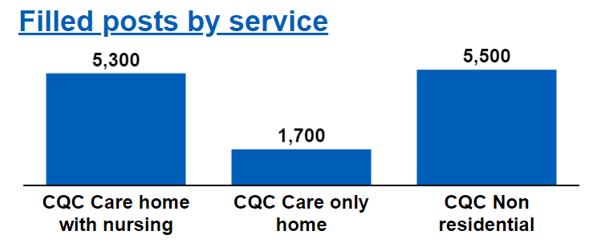 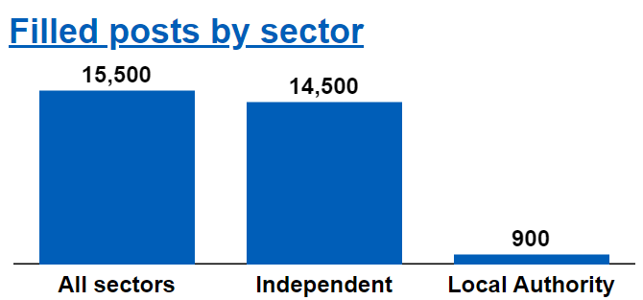

Personal assistants are employed by an estimated 800 direct payment recipients in Oxfordshire (this includes Personal Assistants who provide care to children and provide care on behalf of the NHS). Personal assistants provide a wide range of support from personal care through to help with cooking and social activities and are recognised as a key part of the workforce helping to support the County Councils Oxfordshire Way stratgeic vision. Data on personal assistants remains limited, therefore the analysis that follows focuses on internal (employed by local authority) and external workforce.

In Oxfordshire, a significant proportion of frontline care is delivered by the independent sector rather than the local authority. The graphic below excludes roles such as social workers, occupational therapists and commissioners, and indicates the relative pay rates for *care workers* in Oxfordshire. Independent employers pay a lower hourly rate relative to the local authority for similar care giving roles, and this is also the case when compared to pay rates in the National Health Service.

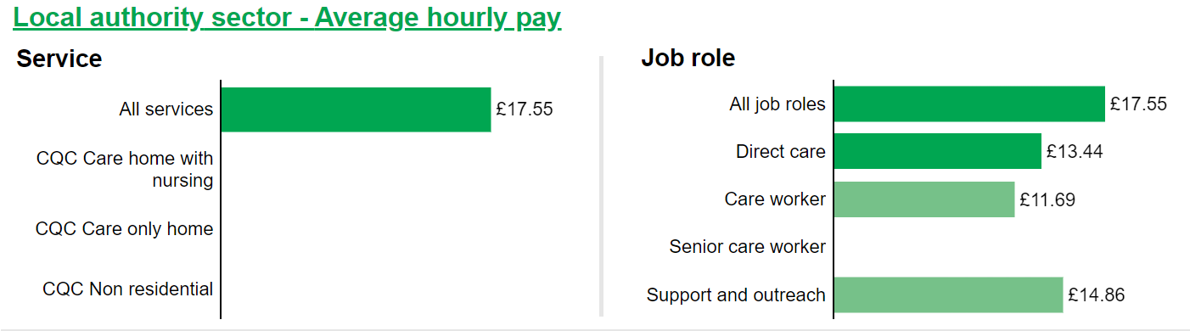

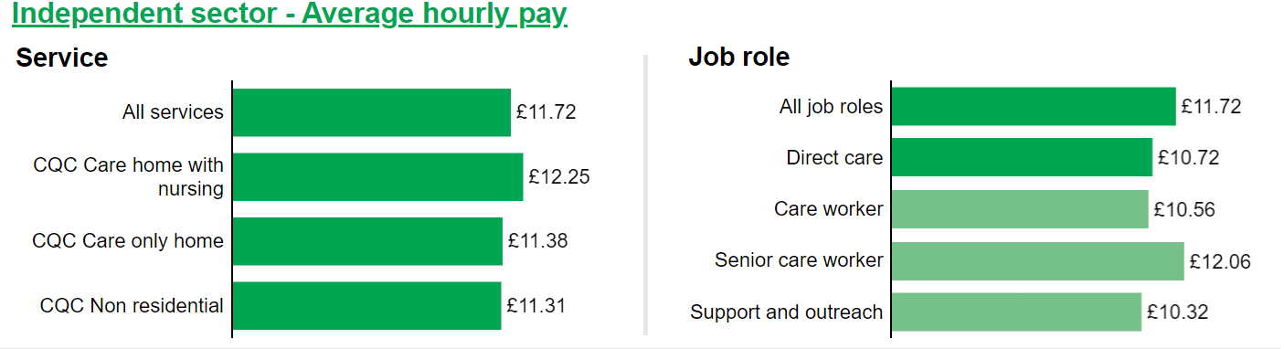

Although the chart compares these pay rates to the National Living Wage (£9.50 ph at the time the data was collected), more locally the Oxford City Living Wage is a recommended hourly minimum pay rate that promotes liveable earnings for all workers and recognises the high cost of living in Oxford city. In April 22 the recommended rate was £10.50 per hour, increasing to £11.35 per hour from April 2023.

The age and gender profile of the social care workforce in Oxfordshire is similar to South East and England; 80% of workers are female and the average age is 44/45. Our Oxfordshire workforce is more diverse with a higher percentage of non-British and people from ethnic minority backgrounds than the South East and England average.

|  |  |  |  |
| --- | --- | --- | --- |
|  | **Oxfordshire** | **South East** | **England** |
| Gender | 80% female | 80% female | 81% female |
| Nationality | 36% non-British | 26% non-British | 19% non-British |
| Proportion of workforce that are from ethnicity minority groups | 29% | 24% | 23% |
| Average age | 43 | 44 | 45 |

# Of particular interest is the proportion of the workforce who is approaching retirement age. 15% of our workforce is over the age of 60, and therefore likely to retire in the next 5 to 7 years.

# When we look at qualification rates, Skills for Care estimates show that 38% of the direct care providing workforce in Oxfordshire hold a relevant adult social care qualification. This is lower than the South East (42%) and England (48%)[1].

# The workforce challenge

Although adult social care workforce challenges are not new, they have been exacerbated since 2020.

Nationally, the number of filled posts increased by 1% (20,000) between 2021/22 and 2022/23 and the vacancy rate has fallen by 7%, a decrease of 11,000 posts. However, vacancies remain higher than the reported rate given in 2012/13 when the records began, standing at 9.9% overall as of 2022/23. The vacancy rate in adult social care remains higher than the NHS which reports an overall vacancy rate of 8.9% (June 2023)

The staff vacancy rate in Oxfordshire is for 2022/23 is given as 15.2% which is higher than the UK average of 9.9%. Analysis conducted by The Kings’ Fund in 2023[2] explains that “the vacancy rate is an important indicator of providers’ capacity to deliver social care services. Staffing also affects quality: [for example] higher staff-to-bed ratios in care homes correlate with higher Care Quality Commission ratings. In an open jobs market, it is also an indicator of the relative attractiveness of social care as a career compared to other sectors.”

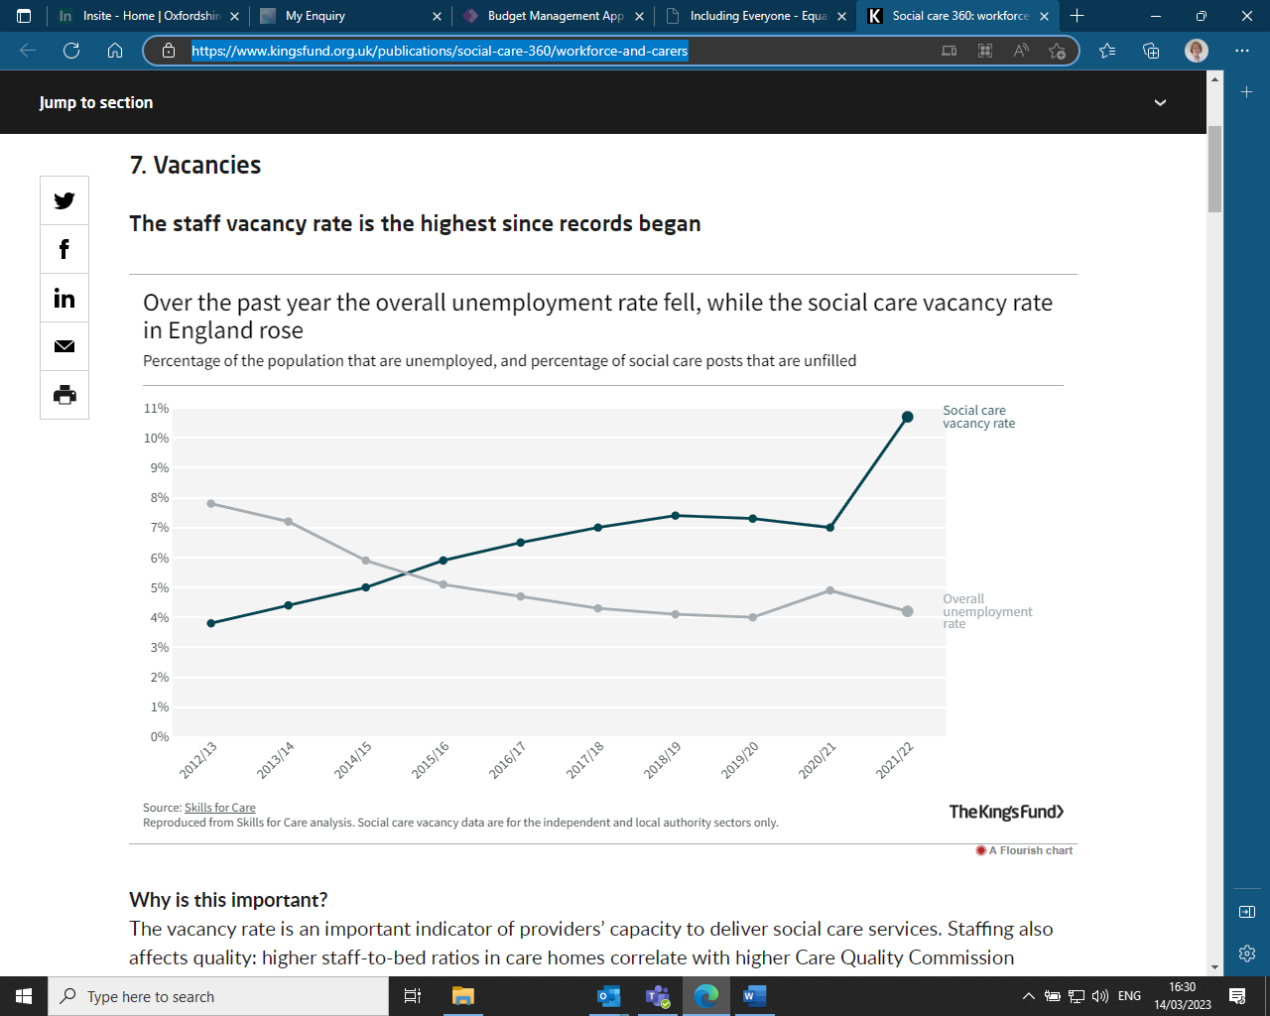

Significantly high turnover rates in Oxfordshire create a challenging picture for local adult social care employers. The staff turnover rate is higher in the independent sector (40.7%) than in the local authority (12.2%) and significantly higher than the national average for the whole sector 28.3 % (30.4% independent sector). This is a particularly challenging figure when considered alongside the approaching retirement of the 15% of our workforce who are above the age of 60 (38% + 55). Attraction and recruitment efforts need to focus on, and appeal to, younger people.

Once people are part of our sector, they seem likely to stay, with 59% of new starters recruited from within the adult social care sector. Care providers anecdotally report that frontline care workers are often tempted to move to a new employer for the sake of a small increase in hourly rate, and attraction bonuses can create a “carousel” effect of workers moving around, which disrupts services providerd and has implications for the people we support and their experiences of receiving care.

**National:**

A recent report by the [Migration Advisory Committee](https://www.gov.uk/government/publications/review-of-adult-social-care-2022) (MAC, 2022) provides a thorough review of social care workforce challenges at the national level. In Oxfordshire, we recognise many of the national issues cited in the MAC report including:

* Impact of Brexit.  Although there is no universal dataset that links migrants’ immigration status with their employment, anecdotal reports from industry experts suggest a significant proportion of frontline workforce were sourced from the EU, especially Portugal and Spain.
* Post-Brexit, international recruitment via the care worker visa programme is complicated. The Skilled Worker route – called the [Health & Care Worker visa](https://www.gov.uk/health-care-worker-visa) for the subset of occupations in health and social care – is the most direct route into the social care workforce. We continue to see proposed changes in international recruitment which create uncertainty in the workforce.
* The workforce reports feeling exhausted and demoralised after the COVID pandemic
* The cost of living crisis continues to have a significant impact on the workforce
* Shift patterns in the external sector can create barriers for part time workers such as working parents
* In many cases our workforce is paid relatively low wages, for what can be a challenging job.
* Conditions of employment such as pension and other benefits tend to be less attractive for the external workforce employed in the independent sector when compared to the internal workforce employed by the Council (or NHS employers)
* Social care roles in the external sector are perceived to be unskilled or undesirable jobs with little career progression.

**Local:**

Locally we find the additional issues also have an impact:

* We have a very high cost of housing in Oxfordshire. The Oxfordshire Joint Strategic Needs analysis (October 2022) records that the ratio of the cheapest market housing to lower earnings in Oxfordshire was 11 compared with 8 in England which suggests that it is less affordable to own a house in Oxfordshire. The very high cost of renting or buying homes limits the care sector’s ability to attract recruits from other areas, especially to entry-level posts. Coupled with this, there are not many opportunities for key worker housing locally.
* Between October 2021 and September 2022, the average lower quartile private rent for a 2 bedroom property in Oxfordshire was £929 p/m, this was 49% higher than England (£625). In the four year period from October 2019 to September 2022, the average lower quartile private rent across Oxfordshire’s districts have all increased. The highest percentage increase was in Vale of White Horse from £825 to £895 (8%).
* The ratio of the cheapest market housing and lowest earnings (lower quartile) in 2022 shows that housing was much less affordable in Oxfordshire (10.54) than England (7.37).
* Between 2019 and 2022 the lower quartile affordability ratio decreased in all districts other than Oxford City – which meant that cheaper housing became more affordable for low income workers in four out of five districts. The largest increase in affordability was in West Oxfordshire. Affordability improved by 12% over the four year period.
* Oxfordshire is the most rural county in the South East region, so many roles require a car/ability to drive which creates a barrier to entry and pressures on pay due to travel time.
* We experience strong competition from other sectors in a buoyant local labour market. For example, in Oxfordshire in December 2023, retail assistant jobs were advertised at £10.42 - £11.40 per hour, and an Oxford College advertised for kitchen porter staff at £10.90 per hour. Skills for Care data reports that the median rate paid to a care worker in Oxfordshire in 2022/23 was £11.37 per hour.
* Since publication of the MAC report in 2022, more job roles in social care have been eligible for Health and Care Worker visas, and international recruitment activity has risen significantly across the sector. It is crucial that new entrants to our workforce from overseas are recruited in line with best practice in our sector and given appropriate support from their employer to help them to settle successfully in Oxfordshire.

**Diversity:**

The Equality Act (2010) states that public bodies, including councils need to take extra steps to stop discrimination: this is known as the Public Sector Equality Duty. The key principles outlined in Oxfordshire's [Including Everyone Framework](https://www.oxfordshire.gov.uk/sites/default/files/file/plans-performance-policy/OCCIncludingeveryone.pdf) are designed to ensure we deliver equitable services to our residents and support our workforce to be confident and feel valued in their role. One of our core values is ‘Equality and Integrity’ where we embrace equality, diversity and inclusion; valuing the difference in others.

In recent years, it is increasingly accepted by many employers that despite setting out genuine intentions to create supportive and inclusive environments where all staff can thrive, this is not the lived experience of people who belong to minority groups. This strategy recognises that we need to take active steps ensure our diverse communities are represented throughout our workforce and states our commitment to improve our approach to equality, diversity and inclusion.

To look at one example of the gap between aspiration and reality, we can focus on the ethnic diversity of our workforce. The Adult Social Care Workforce Dataset illustrates that the care workforce in the independent sector is more diverse than the local authority, with a higher proportion of people reporting they are from a Black, Asian or Minority Ethnic group (27% of the social care workforce in the independent sector, contrasting with 13% of the workforce employed by the local authority). In both cases, the data also shows that the proportion of people from Black, Asian and Minority Ethnic groups in any managerial position is, at 13%, not representative of the wider workforce. Proactive steps to address this imbalance will be built into our delivery plan: for example, by promoting leadership programmes aimed at Black, Asian and Minority Ethnic leaders who want to develop and progress in their careers.

**Next steps:**

To respond to the challenges described in this strategy, a detailed workforce development delivery plan is in development, describing the activity that is planned for delivery across our sector, and setting out the way that impact will be measured.

The objectives of the delivery plan are proposed to be as follows:

1. Reduce vacancy rates across the adult social care workforce
2. Reduce turnover rates across the adult social care workforce
3. Develop the skills of our workforce using opportunities including Workforce Development Funding and Apprenticeships
4. Drive inclusivity and diversity
5. Promote opportunities to develop a career in the sector

The principles that will guide the development of this delivery plan are proposed as follows:

1. Care and support are celebrated as a meaningful and rewarding career, where people can develop and progress
2. Innovative approaches are tried and tested to recruit and develop a sustainable and highly skilled workforce that is representative of the community it serves. We attract and retain talented employees from a wide range of backgrounds with diverse skills and experience
3. Workforce initiatives are aligned to delivering the Oxfordshire Way, with a focus on preventative, strengths-based working, and a commitment to co-production
4. Care and support services deliver quality and consistency of care for residents, and enable people to live independently in their communities for as long as possible

The delivery plan will reflect activity that is already under way as well as new initiatives.

The target date for a draft plan to be published is October 2023. Once agreed, this plan will be reviewed regularly to ensure it remains relevant and is responsive to future changes including other strategies developed by other parts of the local health and social care system, particularly the Buckinghamshire, Oxfordshire and Berkshire West Integrated Care Board’s People Strategy.

1. [Oxfordshire Summary (skillsforcare.org.uk)](https://www.skillsforcare.org.uk/Adult-Social-Care-Workforce-Data/Workforce-intelligence/documents/Local-authority-area-summary-reports/South-East/2022/Oxfordshire-Summary.pdf)
2. [Social care 360: workforce and carers | The King's Fund (kingsfund.org.uk)](https://www.kingsfund.org.uk/publications/social-care-360/workforce-and-carers)