Oxfordshire Local Account

Oxfordshire Local Account - 2022-2023 
2022-2023

## Foreword

Welcome to Oxfordshire County Council’s Local Account for 2022-2023, where we want to share some of the things that our adult social care teams are really proud of achieving over the last twelve months.

This year’s Local Account reflects a lot of hard work, but we set high standards for ourselves, and we know this record could be even better if we work closely with people we support, their families and carers, to ensure it captures information that makes it real for them. Next year’s Local Account will look different because it will be properly co-produced by people who have first-hand experience of using our services.

All of the activity that you are going to read about in this document is guided by our strategic vision to support people to lead happy, healthy lives, which we call the Oxfordshire Way. A happy, healthy life means something different for each person, but in general the Oxfordshire Way aims to help people to live well and independently within their communities, remaining fit and healthy for as long as possible. This vision was co-produced with our partners and has been further shaped by people we support. By working together with other health and care organisations - including our wonderfully diverse range of voluntary sector groups, as well as the NHS - we are united by this one shared vision which is fundamentally transforming how care is delivered in the county.

The Oxfordshire Way is an important part of the council’s broader vision for Oxfordshire, leading positive change by working in partnership to make Oxfordshire a greener, fairer and healthier county. We want the council to become an employer of choice, a partner of choice, and a place maker of choice.

The Oxfordshire Way is about working with both the individual strengths of our people and collective strengths of our communities, supporting people to make their own decisions about their care options so they can live their life, their way.  Our focus, across the whole of health and social care, is to develop community-based solutions, so that Oxfordshire is a place where people can be supported close to home.  This includes creating more options for people to self-serve at a time that suits them, for example by developing online tools to assess if you are eligible for financial support for your care.

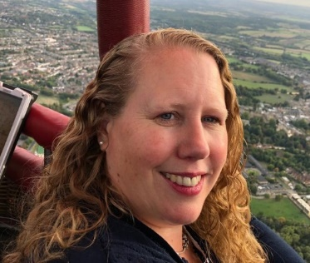This report includes some facts and figures about our performance over the last year, but most importantly it includes stories from people who we have worked with that demonstrate the way they have been supported to live their lives, their way. It makes us feel really proud to be part of this community.

Karen Fuller Interim Corporate Director for Adult Social Care

Cllr Tim Bearder

Cabinet Member for Adult Social Care

**Adult Social Care in Oxfordshire**

Adult Social Care helps people who are older or living with a disability or other long term health conditions to live independently and stay well and safe. It includes a wide variety of support, including:

* information and advice about activities in the community
* providing aids and adaptations
* ‘reablement’ services to help people after a stay in hospital
* support for carers that enables them to maintain their caring role in the way that they choose.
* support in people’s own homes such as home care
* support in day centres
* care provided by care homes and nursing homes.

Cheers M’ Dears” – toasting friendship at Banbury’s newest ‘pub at Oxfordshire County Council’s community support service (CSS) in , Banbury 


**Key Facts about Oxfordshire County Council and its residents**

|  |  |  |  |
| --- | --- | --- | --- |
| Signal outline  6424 people receiving ongoing care | 6770 Safeguarding Concerns last year | Care outline  52,675 people who say they provide care and support to a family member or friend | Questions outline  75% of issues resolved by Customer Service Centre at first point of contact in the last year |
| Group outline  23.2% of residents are from non-“white British” backgrounds | Universal access with solid fill  23% of people have a disability | City with solid fill  60% of the population live in Oxford city or main towns | Man with cane with solid fill  The number of people aged 65+ grew by 25% from 2011 to 2021 |
| Bed outline  358 admissions to care homes per 100,000 population, vs 539 per 100,000 population in England (2021/22) | Clock with solid fill  30,000 hours of care provided in people’s homes (up by 47% since April 2020) | Ribbon outline  92% of Oxfordshire’s social care providers good or excellent compared to 83% nationally | Users outline81 community micro enterprises supporting 1028 people giving people greater choice |
| Smiling face outline with solid fill  87% of people who use our surveys are satisfied | House with solid fill  88% of adults with a learning disability supported to live in their own home vs 78% in England | Shield Tick outline  73% of people who use services feel safe vs 69% nationally | Internet outline  80,000+ hits on our Live Well Oxfordshire website last year |
|  |  |  |  |

## Spending in 2022-2023

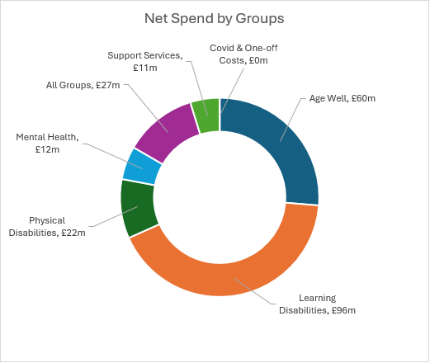

## Connected Communities

This year:

* £500,000 given to 70 local organisations to help isolated people stay connected, healthy and active in their communities.
* Live Well Oxfordshire website providing information about what is available in local areas with over 80,000 visits to the website last year.
* Signposting people to innovative preventative approaches via Live Well Oxfordshire such as Age UK’s “Walk and Talk” sessions.
* Supporting Age UK to provide the Community Information Network providing local information and connecting residents with their community.
* Oxfordshire Way working in practice as the number of people needing formal care has grown less than the population.
* 77% of contacts taken by customer services centre resolved at this first point of contact, up from 40% in 20/21.​

Through our community capacity grants we gave a grant of £9,282 to Gig Buddies which brings together volunteers with members to support them to go and do fun and interesting things like going to football matches, concerts or museums.

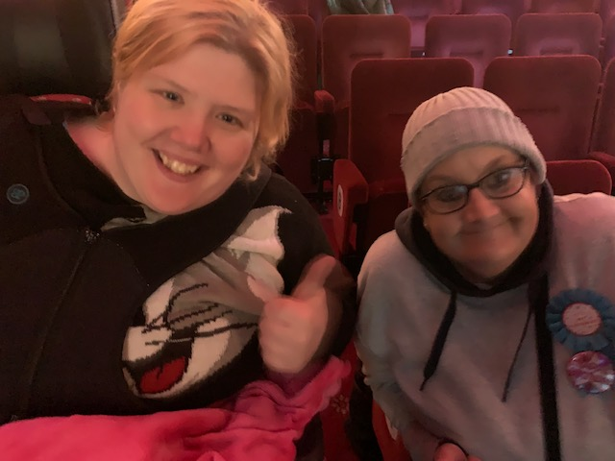

Katie, from Witney, is 32 and has a learning disability. Like many people in their early 30s, Katie enjoys going out to clubs, and loves musical theatre, and thanks to a programme which introduced her to fellow musicals fan Gina from Oxford, Katie now enjoys going to the theatre and monthly Stingray club nights for adults with learning disabilities.

**Even Better Next Year:**

* Making our information even easier to find and access, co-designing improvements to Live Well Oxfordshire and our own website.
* Making it easier to find assistive technology and equipment to help stay in your own home with a new online tool.
* Investing in more great community projects through further community capacity grants.

## Increasing Independence

**Home from Hospital**

We have been working with our colleagues in the NHS to develop our Home First service which supports people leaving hospital. Home First brings together social and health care teams to work in partnership with care and reablement providers to support people who need help after a stay in hospital and to regain independence.

Over the last year we’ve seen the impact of this way of working together with over 80% of people enabled to stay at home after support from the service, compared to 62% last year.

In May 2022 Mrs Jones* had a fall when she was out shopping, and sustained a minor head injury which resulted in her being admitted to hospital.  When Mrs D was well enough to go home from hospital, she was finding it difficult to walk and care for herself independently, so the Home First team were asked to support.

Once back home, Mrs Jones initially needed help from 2 people, 4 times a day which was provided by one of Home First’s reablement providers.  Alongside this, one of Home First’s Occupational Therapy (OT) apprentices set strength based, short term goals with Mrs Jones working towards increasing her mobility, exercise tolerance and ability to manage her daily activities.  Over a period of a few weeks Mrs Jones progressed well, regaining her ability to walk with a walking aid, and managing most of her daily activities with minimal support. Mrs Jones main wish was to get back out into the community to shop independently and visit her church. This was a longer-term goal so our OT apprentice referred to voluntary service, Active Oxfordshire to continue support with outdoor mobility.  Some months later Mrs Jones was back out shopping in the community and able to get out regularly and independently.

*name changed

**Cheers M’ Dears!**

People who use our community support service in Neithrop, Banbury are delighted with a new pub room, designed together and created with donations from the local community and funding from the Friends of Redlands charity.

The room offers a genuine pub environment including a working bar and pool table, so that members, who sometimes feel uncomfortable in a pub can enjoy the social atmosphere that comes with one.

Jennifer Farrell, Manager of Banbury CSS, said: “We’re always looking for innovative ways to deliver social care, putting the people we support at the heart of what we do.

## Living Independently: Oxfordshire Way in Action

This year:

* We are investing £5 million in social impact housing fund Resonance which will provide 26 living tenancies to support people with a learning disability and/or autism in Oxfordshire
* We supported 88% of adults with a learning disability to live in their home, compared to 78% nationally​
* We supported the opening of 3 extra care housing schemes in Chipping Norton, Didcot and Wallingford, with 235 homes created to enable people to live independently whilst having access to care.
* We funded 81 small community enterprises, who have provided 3,214 hours to over 1,000 people to support them to stay independent in their own homes
* 28.4% of older people in Oxfordshire received a direct payment compared to 26.7% nationally, supporting people to live more independently at home.

Age UK Oxfordshire’s Homeshare service pairs up older people who may be looking for some additional help or simply some company, with a person prepared to offer that help alongside an affordable place to stay.

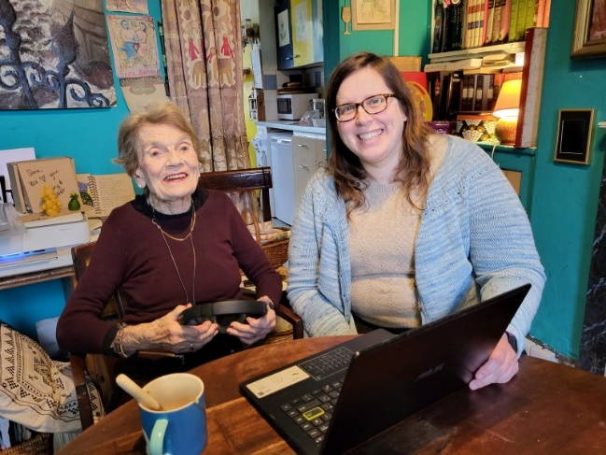

It’s an innovative example of the Oxfordshire Way in action – Oxfordshire County Council’s adult social care vision to support people to live well within their own communities for as long as possible.

The new arrangement has changed Sara’s life “After my husband died, I felt very lonely. I had been married for 66 years and never lived alone. When Mary came to live with me the dark misery suddenly lifted.”

Mary, an international occupational therapy student also also benefits from the homeshare arrangement. After her student housing wasn’t working out she found Homeshare as an alternative option.

“It’s been absolutely brilliant. I get to live with a really interesting person and to feel part of a community. I also love having someone at home to come back to and to socialise with”

Spotlight on:

The Oxfordshire shared lives programme is a service where carers who have the skills, commitment and training have chosen to share their homes and lives with people who need support. There are around 100 shared lives households in Oxfordshire offering everything from short stays and support for a few hours a day to more long-term places to live. Find out more at [oxfordshire.gov.uk/sharedlives](http://www.oxfordshire.gov.uk/sharedlives)

## Designing Better Together

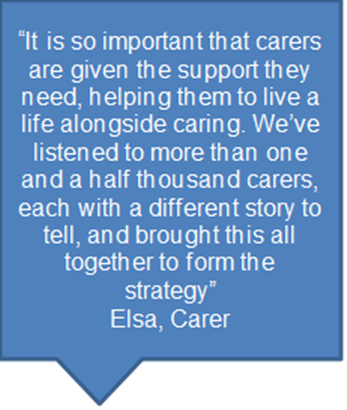

Oxfordshire County Council has developed a new all-age unpaid carers strategy directly with people who have real life experiences of being an unpaid carer – a process known as coproduction.

Elsa Dawson, from Eynsham in Oxfordshire, has been central in developing the strategy, using her own experience as well as talking with other carers about how they can be better supported. Elsa’s daughter, Elisa, has Angelman Syndrome – a rare condition which causes epilepsy, affects speech development and results in daily health complications.

During the initial stages the council heard from 1,600 carers of different ages and faiths and from various locations across Oxfordshire. Partners in health, education and social care (HESC), city and district councils and voluntary organisations such as Carers Oxfordshire have also been helping to create the final version of the strategy for consultation.

Carers told us that they felt isolated after the COVID pandemic and that they were tired and anxious especially in relation to their finances. They also fed back that information and guidance designed to support them was not easy to locate. The strategy aims to better identify carers and bring partners together to support them.

**Spotlight on:**

We launched the Neurodiversity Support Network (Oxfordshire) to help promote the strengths of neurodiversity and dispel myths. The network is co-chaired by people who are neuro-diverse who are leading on work they have identified as a priority to improve their experience of health and social care in Oxfordshire.

**Even better next year:**

More people with lived experience are joining our Team Up Board and we are working with them to make our co-production even stronger.

We will work with existing local groups and continue to expand the range of ways for people to work with us, from one-off feedback to a full co-design of a service

* **Co-production** is a process where professionals and citizens share responsibility for the creation of products and services.
* Oxfordshire’s Team Up Board brings together people with lived experience and social care and health professionals to help support better co-production
* We have a Working Together Guide and you can find out more at
* <http://www.oxfordshire.gov.uk/coproduction>

## Working in Partnership

This year we have worked with our partners to support our local communities:

* Closely collaborating with our communities, voluntary sector, and other system partners to develop social prescribing and community capability and capacity, building on Oxfordshire’s thriving voluntary sector offer
* Our Community Information Network is delivered by Age UK and connects residents with their community supporting them to live life to the full
* Working with our health colleagues to develop a Transfer of Care Hub to support people to get home from hospital
* Working with care providers to co-design our refreshed workforce strategy, Market Sustainability Plan and Market Position Statement
* Working in Communities of Practice across the county, bringing together practitioners from social care with colleagues working on the front line in local charity, voluntary and community organisations to improve awareness of and access to all available support, and to offer a more joined-up experience for adults with social care needs within the community.

Oxfordshire County Council has funded the Care Workers’ Charity hardship grant to offer quick financial support to people working in Oxfordshire’s care sector. It has paid out more than £260,000 to over 440 people.

For Elena who supports older people living in a care home in Burcot, south Oxfordshire, the winter was going to be financially tough. Like most of us, household bills were on the rise and Christmas credit card debts needed to be paid. - Elena was given £500, to help get her car back up and running, as well as contributions to the general cost of living, taking some of the pressure off.

Councillor Tim Bearder, Oxfordshire County Council’s Cabinet Member for Adult Social Care, said: “Elena and the hard-working staff like her are performing an incredibly important, difficult and often undervalued role, caring for our friends and families who need additional support. This council recognises their contribution and feels it is vital that our care professionals have access to this fund, helping to offer financial support during this difficult time.

“This is a reflection of how much we value the job they do to support our most vulnerable residents and I would urge anyone in the industry who is facing financial hardship to apply.

“Everyone knew prices were going up but when my car broke down I was beginning to worry about how I was going to pay for it all. I just needed a bit of short-term help, to plug the gap.”

Elena

Even better next year:

We are launching a new website aimed at bringing more people to caring positions in Oxfordshire. We are developing the site in partnership with Oxfordshire Association of Care Providers (OACP), and it will highlight the broad range of jobs available in the care sector as well as providing a free platform for care providers to advertise any opportunities they have available.