Building Family Connections

Oxfordshire County Council Children’s Services want all children and parents to have the best possible relationships with each other, filled with warmth, care, and connection. However sometimes, for many different reasons, these relationships can break down, leading to children moving into the care of other family members, foster parents, or the local authority.
This information leaflet describes the process that Children’s Services use to guide the building and re-building of connections between parents and children following these family breakdowns. This process is based on research by the National Society for the Prevention of Cruelty to Children (NSPCC) into the factors which strengthen parent-child relationships, and the factors that increase the risk of family breakdown. By using this evidence, we aim to support you to have a safe relationship with your child, and as this relationship develops, to work collaboratively with you and your family to understand what is possible in terms of your future contact with each other.

How long will this process take?
The breakdown in the relationship between a parent and child is often accompanied by a range of difficult and intense emotions, such as loss, anger, relief, guilt, sadness, and shame. Understandably, children and parents often miss each other so much that they want to be reunited as soon as possible. However, the research tells us that these kinds of rushed returns home can often lead to high levels of distress, and further family breakdowns, which is an outcome that nobody wants.
The process discussed in this guidance can take a long time, as it attempts to gain a full understanding of your family’s strengths and difficulties, and the kinds of change and support that you might need to have the safest possible relationship with your child. This period of time might feel very difficult for you and your child, but by taking this measured approach, and not making any rushed decisions, this process aims to avoid any further breakdowns in your relationship with each other.

Will this mean that my child returns home?
The focus of this process is not based on whether or not your child will return to living with you full time. Instead it focuses on the relationship itself. There are many different ways to have a relationship with your child, and what makes up a safe and connected relationship for one family might not feel right for another.
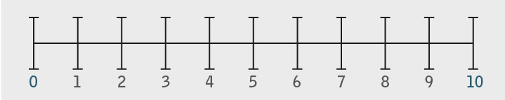
If you imagine a scale of contact between 0-10, with 0 being no contact at all, and 10 being a child living at home full time with their parents, you can see that there are many other forms of contact and connection between the two ends of the spectrum. For example, you might feel safer and more comfortable at the moment to contact each other over the phone, or to visit each other every other week. You might go out on day trips together, or your child might spend a couple of nights living at your house and spend the rest of the week with another carer.
By working with you to explore what you would hope to be different about your relationship in the future and aiding you to access the support and services needed to make these changes, this process aims to help you to have the safest and most connected relationship possible with your child, whether they are living at home or not.

Wilkins M. and Farmer E. (2015) Reunification: an evidence-informed framework for return home practice. London: NSPCC.

