A guide to the

**NVR group**

A new approach to supporting families experiencing child violence



This guide contains more information about NVR, what it means and what you can expect from the group**.**



**What is NVR?**

NVR stands for **Non Violent Resistance**. It is a therapeutic approach that helps parents to connect with their children and find new ways of managing violent, destructive and/or controlling behaviour.

NVR encourages parents to make a stand (resist) against violent or destructive behaviour from their child, without using physical or verbal aggression. It is involves trying different ways of talking to your child and enlisting the support of other people who are close to you.

NVR uses some ideas from the civil rights movement, where people like Martin Luther King and Ghandi used non-violent ways to bring about change.

NVR may be quite different to other approaches you have tried, such as using rewards and consequences to improve behaviour. However, there is evidence that NVR is successful in reducing aggression and improving relationships.

**What can I expect from the NVR group?**

A psychologist from the team will be in touch to arrange an initial assessment appointment with you to determine if the group will meet your family’s needs and to give you some more information.

If you and the psychologist agree that the group could be helpful to you, you will be invited to attend.

The group will run over 10 sessions with several additional individual meetings. Sessions will mostly be on a weekly basis, with some longer gaps to allow for you to practice the tools discussed in the group.

We do not normally meet with the child or young person because the approach requires parents to make changes first.

**Tell me more about NVR…**

There are several aspects to NVR that fit together. You will learn about how to make these work for you and your child in the group.

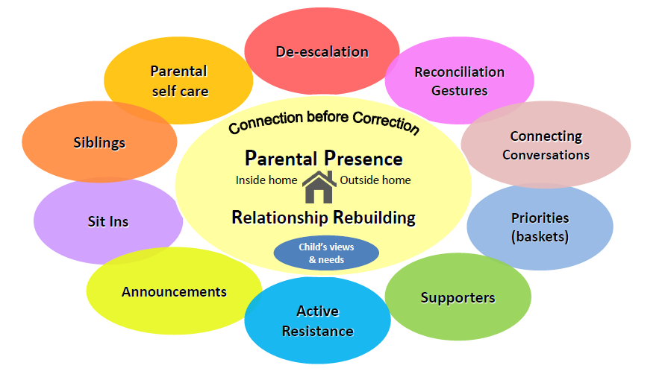

**Parental presence & rebuilding your relationship**

Increasing parental presence is a key principle of NVR. Many parents experiencing child violence find that they have withdrawn both physically and emotionally from their child’s environment and life. For example, they may rarely go into parts of the house where their child spends lots of time.

Increasing parental presence is a non-violent way of regaining authority and modelling your values.

This goes hand in hand with another key principle of NVR - finding ways to rebuild your relationship with your child. Violence can leave families struggling with conflicting emotions and get in the way of kinds of relationships they would like to have with each other. NVR aims to help you to reconnect.

**De-escalation**

Most violent young people refuse to be controlled. When parents try to control, the result is escalation of conflict or aggression.

Recognising the different forms of escalation and taking control of your own reaction will help to reduce conflict. In NVR, you deal with the behaviour later when you have both calmed down.

“*Strike while the iron is cold*”



**Reconciliation gestures**

Reconciliation gestures are acts of unconditional love. These acts are not a reward since they are made regardless of behaviour. The possibilities for reconciliation gestures are infinite and they need not cost money. They could include bringing a drink, offering to do a favourite activity, buying a small present, or cooking a favourite meal. Some gestures may be thoughtfully targeted to meet your child’s deeper needs.

Reconciliation gestures may be rejected, but that does not undermine their power in rebuilding the relationships.



**Priorities**

Families often find that children who are violent do lots of other things that they do not like. For example, being rude, not tidying up, and not doing homework. However, trying to change lots of behaviours at the same time is likely to be overwhelming and less successful. NVR aims to help you prioritising the behaviours that need to change.

Sorting behaviour into priorities makes it easier to know what to deal with and what to let go of (for now).



**Supporters**

You need support to do NVR. This enables you to share the problem and makes it more likely for you and your child to succeed with reducing violence.

Involving people close to you as supporters can be done respectfully and creatively, and with help from your therapist if you would like this.

Many families experiencing child violence find that they have become increasingly isolated and keep quiet about what is happening. Keeping silent can actually help to keep the violence going. Involving supporters is a respectful and sensitive way of breaking the silence.



**Active resistance**

Sometimes families experiencing child violence find that they have been compromising important areas of their life.

An important part of NVR is finding ways to actively resist the role that violence plays in your family life. This can help families to break the cycles that might be keeping the violence going whilst also reclaiming their lives.



**Announcements**

Announcements are a carefully planned messages or statements delivered to the child.

The announcement draws a line in the sand as parents state their commitment to resisting the aggressive behaviour alongside their love for their child. This might also include apologising for the things parents have done wrong in the past, expressing concern for the future if the violence continues, and hopes for a positive future without violence.

Part of the detailed planning process includes preparation for all of the child’s possible responses.



**Sit-in**

The sit-in is a parental act of resistance against unacceptable violence. It is, literally, a planned time when parents, possibly with a supporter, sit in the child’s space.

The sit-in reasserts parental presence, reinforces the announcement, and can provide a reflective space for the child. The child may walk out, but the message communicated by you, as a parent, is clear.

It is not always necessary to carry out a sit-in.



**Siblings**

Siblings are often affected by violence, sometimes being the main target of the aggression. NVR involves explaining how you are dealing with the violence and taking action to keep them safe.

Siblings can be encouraged to keep a diary so that their experience is acknowledged with empathy. They may also have their own “supporter” to help them.



**Self Care**

NVR is demanding and it is vital that you allow yourself time to recharge your batteries.

This involves planning how to be kind to yourself and ensures that you as a person are not lost in parenting your child.

*“I have come to believe that caring for myself is not self-indulgent. Caring for myself is an act of survival”* – Audre Lorde

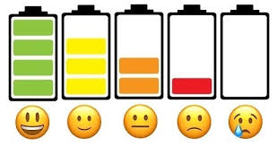

**What will happen now?**

If you agree that it would be helpful to find out more about the NVR group and see if it could be helpful to your family, your social worker or support worker can make a referral to the group.

A member of the Clinical Team will let you or your worker know of the next steps.