Emotionally Warm and Attuned Parenting

This document is an attempt to offer some guidance to parents and carers who may be struggling to connect with their children on an emotional level. The purpose of this guidance is not to blame or shame parents for ‘doing it wrong’ – no parent is perfect, children do not come with a ‘how-to’ guide, and as humans we all make mistakes and have bad days. Instead this document aims to explain sometimes confusing terms that parents may have heard, and to offer some tips and examples of how to provide more opportunities for emotionally warm and attuned parenting.

What are ‘emotional needs’?

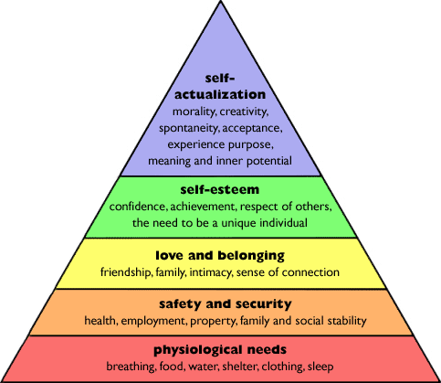
A Clinical Psychologist named Abraham Maslow, described a Hierarchy of Needs, with the most basic biological needs for our body to survive at the bottom, and the needs that enable us to fulfil our potential at the top (Maslow, 1943). Whilst a child’s biological needs and physical development are extremely important, a child’s emotional and social development are equally important. In fact, emotional health is an important factor in a child’s future success in school, work, relationships and life in general. Just as we wouldn’t be able to think clearly if we were starving, when our emotional needs aren’t being met it can distort our sense of self, leave us feeling scared and upset, makes learning difficult and limits our potential to live life to the full.

In the well acclaimed book ‘How to raise emotionally healthy children’, Dr Gerald Newmark (1999) identified five critical needs that all children (and parents) have. The excerpt below provides a summary of the five critical needs (in no particular order) and examples of each:
- Need to feel secure.
Children need to feel safe and secure. Safety and security are important both physically and emotionally. Physically, children need to feel safe in their bodies, be protected from harm and have a safe place to sleep every night. A child’s environment needs to be free from harmful substances and safe to explore. A child also needs age-appropriate routines, structure and boundaries to ensure they feel safe and protected. Emotionally, children need to grow up in a positive environment where people care for each other and show it, where people express themselves and others listen, where differences are accepted, and conflicts are resolved constructively. This helps a child to feel safety and security in their relationships with others.
- Need to feel respected
Children need to feel respected. For that to happen, they need to be treated in a courteous, thoughtful, attentive and civil manner. One of the best ways for children to learn about respect is to feel what it’s like to be treated respectfully and to observe their parents and other adults treating one another the same way.
If we want children to grow up feeling respected and treating others with respect, we need to avoid sarcasm, belittling, yelling; we need to keep anger and impatience to a minimum; we need to avoid lying; we need to listen more and talk less; we need to command less and suggest and request more; we need to learn how to say “please,” “thank you,” “excuse me” and “I’m sorry”—yes, even to children. We need to become conscious of our mistakes, willing to admit them and ready to make corrections. This will help us cultivate these values in our children.
- Need to feel important
Feeling important refers to a child’s need to feel: “I have value. I am useful. I have power. I am somebody.” This need is evident at a very early age. Pressing a button in an elevator—me, me. Children want to do things for themselves, and so often we get in their way.
Parents need to avoid being all powerful, solving all family problems, making all decisions, doing all the work, controlling everything that happens. Involve your children—ask their opinions; give them things to do; share decision-making and power; give them status and recognition and have patience with mistakes when it takes a little longer or is not done as well as you could have done yourself. If children do not feel important, if they don’t develop a sense of value in constructive ways, they may seek negative ways to get attention, to feel “I am somebody.”
- Need to feel accepted
Children have a need to feel accepted as individuals, with their own uniqueness, and not treated as mere reflections of their parents, as objects to be shaped in the image of what parents believe their ideal child should look like. This means that children have a right to their own feelings, opinions, ideas, concerns, wants and needs. Trivializing, ignoring or ridiculing a child’s feelings or opinions is often experienced as a rejection which weakens the relationship. Paying attention to and discussing a child’s feelings/view, even when you do not like or agree with them, strengthens the relationship.
- Need to feel included
Children need to feel included. They need to be brought in, to be made to feel a part of things, to feel connected to other people and to have a sense of community. This can happen when children have opportunities to engage with others in meaningful ways and experience doing things together (e.g. activities/projects). It is important for the family to create these opportunities. People who do things together feel closer to one another. Family activities offer a way to become closer and to have fun, learn and contribute to others.

Key terms you might have heard

What is ‘emotional warmth’?

Emotional warmth can be described as when parents and carers spend time focusing on making sure a child’s emotional needs are being met, alongside giving the child a sense of being specially valued and loved. This can include saying affectionate and loving things, providing cuddles, and giving the child praise and encouragement. Emotional warmth also means spending time doing fun things together as a family, laughing and enjoying time with your child. It also includes trying to provide comfort and a sense of safety when the child is scared, upset, or angry.

What is ‘emotional attunement’?

Emotional attunement can be described as focusing your attention on how you think your child is thinking and feeling in a situation and trying to put yourself in their shoes. It then means responding in a way that you think they need, given what you think they are currently feeling. For example, when a child falls over and a parent says, “oh that must have hurt, let me give your knee a kiss better”, they are recognising that the child is in pain, and responding in a soothing way that helps the child to deal with this pain.

What does ‘strengthening relationships’ mean?

When social care talk about strengthening the relationships that you have with your children, this means trying to build a balanced relationship with plenty of structure alongside plenty of warmth and connection. There are lots of different ways to do this, which will be discussed in the ‘practical ideas and tips’ section below, but one way to think about a strong parenting relationship is to imagine it as two hands – one hand providing warmth and nurture, and the other hand providing structure and boundaries.

We often find that if one hand takes over and dominates, it can have negative implications for the parent-child relationship and the child’s development. For example, if the child only receives warmth and nurture with no support around structure and boundaries, then the child may not develop the skills needed to tolerate disappointment/frustration when being told no. If a child feels that their parent/carer is unable to take the lead in setting limits, they may begin to assume control over situations and may begin to make demands that are not in their best interest. Having too much control can also be quite frightening for a child and this anxiety can lead to further attempts to assume control in order to feel safe, which can be experienced as exhausting for both the child and parent/carer.

On the other hand, if a child receives boundaries and structure alongside low levels of warmth and nurture, the child may begin to feel unloved, misunderstood and/or unworthy of care. The child may begin to confuse their behaviour with their sense of self (e.g. I did a bad thing therefore I am a bad person), with beliefs such as ‘I am bad’, having a powerful influence on behaviour. If a child believes that they are bad in some way, they may give up trying to do good.

By balancing the two hands of parenting, that is, balancing the need for ‘connection’ (warmth and nurture) with the need for ‘correction’ (boundaries and structure), you can create a stronger relationship between you and your child. In addition, children typically respond better to boundaries and structure within the context of an emotionally warm parent-child relationship.

When there are significant concerns that a child’s emotional needs are not being met

What is ‘emotional neglect’?

There are many types of neglect, which can look very different in different situations and different families. One of these is emotional neglect, which involves a child not getting their emotional needs for nurture and stimulation met. This could be through not spending enough time listening to a child’s feelings, not spending enough time praising them for their achievements, or not spending enough time giving them loving attention. No parent is perfect, and no one would be able to do these things all the time. For this to be seen as neglect it would need to be an ongoing pattern of behaviour where the parent is consistently unable to prioritise and meet the child’s emotional needs.

What is ‘emotional abuse’?

The NSPCC (2020) defines emotional abuse as “any type of abuse that involves the continual emotional mistreatment of a child. It's sometimes called psychological abuse. Emotional abuse can involve deliberately trying to scare, humiliate, isolate or ignore a child. There might not be any obvious physical signs of emotional abuse or neglect. And a child might not tell anyone what's happening until they reach a 'crisis point'. That's why it's important to look out for signs in how a child is acting.”

Why might my own childhood experiences be important?

Being a parent can feel like a daunting task which doesn’t come with a ‘how-to’ guide. Often, most of the knowledge we have about parenting comes from our own experiences of receiving parenting as a child, and we tend to pass these parenting styles on to our own children. Whilst this process allows us to pass on lots of helpful parenting knowledge through the generations, it can mean that some of the difficulties we experienced as children can also be passed on.

For example, if you come from a family in which tricky feelings like anger and sadness weren’t spoken about very much, then it can be scary when you are confronted with your own child’s feelings of anger and sadness. By thinking about what your childhood was like, it can allow you the opportunity to choose the useful things that you would like to pass on to your children, and the less useful things that you would like to do differently now that you are a parent yourself. This video talks about this idea in more detail https://www.youtube.com/watch?v=Vy3EwAQ0lwo.

What the literature says is helpful

There are lots of different approaches to parenting, all of which can be useful when trying to create a more nurturing, safe environment for your children. As a group of Clinical Psychologists, we believe that parenting approaches that focus on the parent-child relationship are particularly helpful. Please see the list of suggested parenting related books that are available for purchase via Amazon if you would like more information or guidance on the topic. Please note that this list is not exhaustive and there are many books available with more being published every year. If you have any financial difficulties in purchasing your chosen book, please speak to your allocated worker to find out if they can support you to access the relevant information.

Attachment Theory
Attachment Theory, developed by Psychologists John Bowlby (1969) and Mary Ainsworth (1979), focuses on the deep and meaningful emotional bonds that connect children with their main caregivers, whether these are parents, grandparents, teachers or foster carers. Attachment can be understood within an evolutionary context in that the caregiver provides safety and security for the infant, enhancing their chance of survival. The infant produces innate ‘social releaser’ behaviours such as crying and smiling that stimulate innate caregiving responses from adults. The type of ‘social releaser’ or ‘attachment strategies’ that are used within relationships can change over time, depending on context (the person and place) and the child’s stage of development (https://familyrelationsinstitute.org/dmm-model/). The attachment relationship between a child and their main caregiver/s, and the strategies used within these relationships, act as a prototype for all future social relationships. The quality of the attachment relationship therefore has important implications for the child’s social, emotional and cognitive development, and at the heart of attachment-informed parenting is the development of a strong, safe and connected parent-child relationship.
One example of these kinds of strong relationships can be seen when children feel safe enough to be able to move away from their parents to explore their surroundings (e.g. to go and play in a tree), knowing that their parents will still be there as a safe and secure base when they return. This is important because it teaches children that they can both explore their world and be protected and comforted. This concept is sometimes referred to as the Circle of Security (Cooper, Hoffman & Powell, 2017).
Another important aspect of the attachment relationship can be seen when parents help their child to regulate their emotions. Emotion regulation is the ability to recognise one’s emotional state and respond to these emotions in helpful ways. Parents play an important role in helping their children to develop these skills. The first step for parents is to regulate their own emotions, giving themselves a chance to parent from a place of calm. This is a vital process, as we cannot assist someone else to make sense of their emotions when we ourselves are feeling strong and overwhelming emotions. Finding ways of feeling calm – especially in moments of stress – can make all the difference. Some parents find it helpful to take several slow deep breaths (in through the nose and out through the mouth), or to use a meaningful mantra/saying, or to take themselves out of the situation for a couple of minutes, even if this just means popping to the toilet.

Learning to regulate emotions takes place over time when parents repeatedly support their child to notice their feelings and put a name to the feeling, thereby helping them to make sense of their internal experience and to learn that their emotions can be tolerated and are not dangerous. For example, when a child is jumping up and down waiting to open their birthday presents, a parent might naturally say “you look so excited, this is so exciting”, helping the child to notice their emotional experience in that moment and how this links to feelings inside their body. By providing comfort and support when experiencing strong feelings, your child experiences what helps them in these moments. For example, in response to a sad looking child, a parent might say “you look sad, what’s the matter?”, thereby helping the child to label the feeling and experience comfort from talking about the difficulty within a trusted relationship. All these experiences help to shape the child’s learning about their emotional world, making it easier to notice, name and manage their emotions as they grow up.
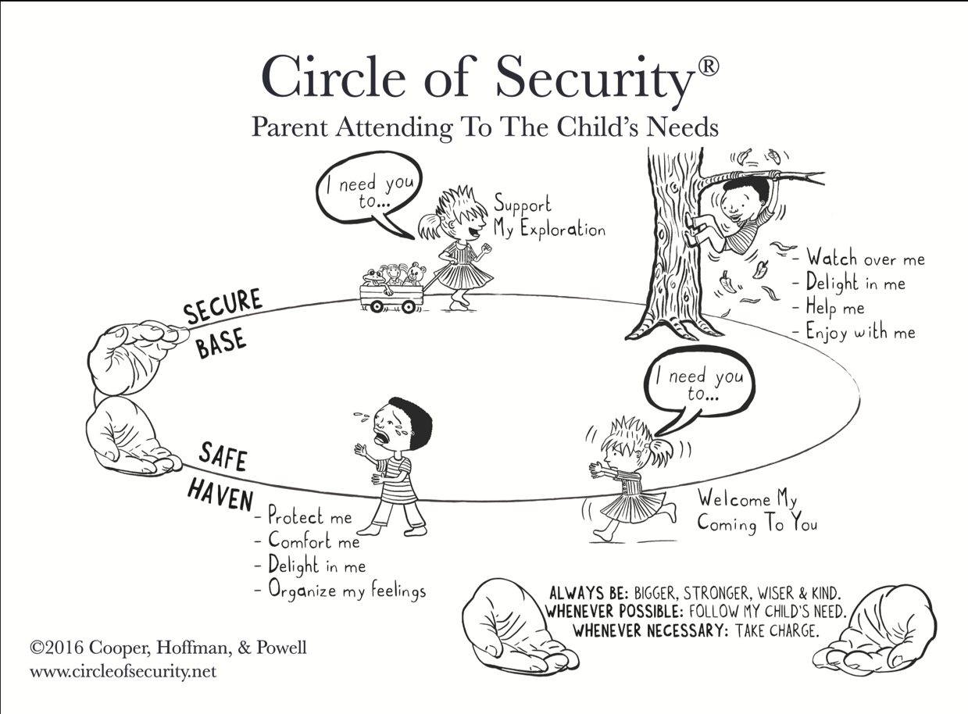
Theraplay

This approach was first developed by Dr Ann Jernberg, a Clinical Psychologist who specialised in the treatment of children and young people experiencing emotional and psychological difficulties (Jernberg, 1978). Theraplay aligns with attachment theory, with the aim of strengthening the parent-child relationship, self-esteem, trust in others, and joyful engagement between a parent and their child. Theraplay sessions are typically structured and guided by a trained Theraplay practitioner. Theraplay principles can help us to identify important components of natural, healthy interactions between parents and young children, and to consider the importance of play in providing opportunities for such interactions. Theraplay views healthy and emotionally secure relationships as comprising the following four key components:
- Structure – The parent consistently creates clear patterns and routines, setting boundaries and limits, and providing order. This creates a sense of predictability and safety for the child, allowing them to have a safe experience within the relationship.
- Nurture – The parent provides soothing, loving attention and care. This allows the child to develop a sense that they are worthy of love and care.
- Engagement – The parent spends time connecting with the child’s thoughts, feelings and experiences through conversation and shared activities. This also includes taking part in fun activities that bring the parent and child a sense of shared enjoyment, and openly naming their shared joy. This allows the child to experience being seen, heard, felt - and accepted by their parent.
- Challenge – The parent provides opportunities for exploration of the world and support for the child to learn and master new skills. This builds the child’s feelings of self-confidence and their courage to try new things. It also lays the groundwork for later adolescence and adulthood, when the child will begin to explore more widely and become more independent.

PACE

This approach was first developed by Dr Dan Hughes, a Clinical Psychologist who specialises in the treatment of young people who have experienced emotional neglect and abuse (Hughes & Golding, 2012), but has now been adopted as a helpful model for many parents. The PACE approach also aligns with attachment theory and it offers a structure for conversations with children that allows them to feel emotionally understood and accepted by their parent – thereby promoting a sense of emotional connection, self-awareness and emotional literacy. The type of conversations that draw on PACE principles can often feel quite different from a problem-solving approach. The four principles of the PACE acronym are as follows:

- Playfulness – Playfulness focuses on having a light and playful attitude when interacting with your child, not taking yourself too seriously and being able to laugh at your own mistakes. One way to show your child your playful attitude is to adopt a lighter tone of voice, like you would if you were reading them a story.
- Acceptance – Unconditional acceptance of who your child is and how they think and feel is vital to creating a safe and trusting relationship. This means having the courage to sit with the difficult or uncomfortable feelings they might express, rather than judging their feelings negatively or trying to get rid of difficult emotions.
- Curiosity – Curiosity focuses on having an open mind and a genuine interest in your child’s experiences and perceptions of the world. To be truly curious it is important to suspend your own judgements or views about the ‘right’ way to see things, and just to listen. Asking your child about their experiences allows them to be open and honest with you.
- Empathy – Empathy involves connecting with your child’s emotion and helping them to name these feelings. To show empathy it is important to think about what feelings might be underneath any behaviours we see. For example, if your child is shouting and swearing after having found out they failed an exam, rather than focusing on their behaviour you could say “I can feel how upset you are, this is a really hard situation”. This helps you to connect with your child’s feelings, opening up the possibility of further conversation or the chance to provide comfort. Please see the following YouTube videos for an explanation of the difference between sympathy and empathy (Brené Brown on Empathy: https://www.youtube.com/watch?v=1Evwgu369Jw) and a lovely example of Acceptance and Empathy in action (Inside Out Sadness Comforts Bing Bong: https://www.youtube.com/watch?v=QT6FdhKriB8).

Practical ideas and tips

Using the approaches of Theraplay and PACE, here are some practical tips and example activities to help you interact with your child in a way that promotes emotional warmth and attunement. This list is in no way exhaustive and some of these ideas might be a better fit for your family than others. Some of the activities feel really strange at first, but the idea is to connect with your child on a deeper level, and to consistently show them that they are safe and loved.

If your child has gone through some difficult and potentially frightening experiences, it may be important to go at their pace, introducing small activities slowly, and allowing them to get used to these before moving on to others. This is particularly true with children who may have experienced physical and sexual abuse, as it is important to gently promote the use of safe and caring touch, at a pace that doesn’t feel scary or overwhelming for the child.

All Children

- Surprise them with their favourite snack and a silly drawing in their lunchbox.
- Find opportunities to ask questions about the things your child is interested in, such as what they like about it, when they first started liking it, how it makes them feel etc.
- Remember to tell your child that you love them each day.
- Try to read to your children as much as possible, asking them questions about the story afterwards. If you struggle with reading, you could also listen to an audiobook together.
- Have a special ringtone on your phone for when they call you and let them know it belongs to them.
- Put up pictures of you and your child around the house or attach them to your fridge.
- Try going out for walks together as a family.
- Find something that you can praise your child for each day, whether this is for tidying their room, for being helpful, or simply for being themselves.
- Set up a home disco by putting on your favourite music and dancing together.
- Try having a tug of war as a family. You could use a rope, a stick, or a blanket.
- Try to ask your child about how they are feeling at least once a day.
- Make a timetable for your child, so they can see the structure of each day, including slots for nursery/school, playtime, and bedtime routines. At the beginning and end of each day you can go through this timetable with them, thinking about how the day has been, and what things are happening tomorrow.
- If you see that your child is angry or upset, offer them a chance to talk about what is upsetting them, and let them know that you love them and are here for them.
- Try to resist the urge to immediately solve any problems your child talks to you about. Instead, try to listen to their experience and let them know that you understand how they are feeling. Often, the recognition of their feelings and a hug can feel more important than any solution you could offer.
- Help them to connect with their friends, by setting up a sleepover, helping them to send a text, or even writing a letter to someone they haven’t seen in a while.
- Try making them their favourite meal, just because.

Younger Children

- Next time you see your child playing, ask them to explain the game to you.
- Try to instate a bedtime routine e.g. each night after dinner, give your child a bath, help them brush their teeth and get into their pyjamas, and read them a story in bed.
- Try blowing bubbles and allowing your child to pop them. You could even challenge them to pop the bubbles with their elbows or their feet!
- Blow up a balloon, and then try to balance this between you and your child. Can you make it across the room without using your hands or dropping the balloon?
- Try having a face painting session at home.
- Try having a thumb wrestling competition.
- Play the ‘magic carpet ride’ game. Have your child sit on one end of a blanket, holding on tightly, as you pull them around the room. You could ask your child where they are flying to or describe the different things they might see if they were flying somewhere.
- Play hide and seek together around the house.

Older Children

- Play a 3 word story game over text: Create a story together 3 words at a time. Take turns adding 3 words to create a silly story.
- Send your child a text to let them know that you’re thinking of them or send them a picture that reminds you of something you did together.
- Play the £1 gift challenge. Each of you has ten minutes to find a gift for the other in a £1 discount shop. It ends with hot chocolate and gift giving at home.
- Set up a ‘home spa’, with nail painting and hand massages.
- Help them to fix something of theirs that is broken (e.g. a bicycle or toy). Chat with them whilst you are working on this together.
- If your child is struggling with schoolwork, offer to help them with a piece of work. It doesn’t matter if they say no; the important thing is that they know you are willing to help them.
- Whatever your child enjoys, spend time trying to take part in this with them. For example, if your child enjoys playing video games, try asking them to teach you how to play one of the easier games.
- Try to find opportunities to have meaningful conversations with your child. The NSPCC and Childmind have created guidance on how to have these kinds of conversations.

Suggested parenting related books

- Parenting from the Inside Out – By Daniel Siegel
- Brain Based Parenting - By Dan Hughes and Jonathan Baylin
- Attachment-Focused Parenting – By Dan Hughes
- Nurturing Attachments – By Kim Golding (more fostering and adoption)
- Everyday Blessings: The inner work of mindful parenting – By Myla and Jon Kabat-Zinn
- Parenting with Theraplay- By Vivien Norris
- How to Raise Emotionally Healthy Children: Meeting the Five Critical Needs of Children…and Parents Too!- By Gerald Newmark
- The Book You Wish Your Parents Had Read: And Your Children Will Be Glad That You Did - By Philippa Perry
- How to Talk So Teens Will Listen and Listen So Teens Will Talk – By Adele Faber & Elaine Mazlish

References:

Ainsworth, M. S. (1979). Infant–mother attachment. American psychologist, 34(10), 932.

Bowlby, J. (1969). Attachment and loss v. 3 (Vol. 1). Random House. Furman, W., & Buhrmester, D.(2009). Methods and measures: The network of relationships inventory: Behavioral systems version. International Journal of Behavioral Development, 33, 470-478.

Cooper, G., Hoffman, K., & Powell, B. (2017). Circle of Security in Child Care: Putting Attachment Theory into Practice in Preschool Classrooms. Zero to Three, 37(3), 27-34.

Hughes, D., & Golding, K. (2012). Creating loving attachments: Parenting with PACE to nurture confidence and security in the troubled child. Jessica Kingsley Publishers.

Jernberg, A. M. (1979). Theraplay: A new treatment using structured play for problem children and their families. Jossey-Bass.

Newmark, G. (1999). How to Raise Emotionally Healthy Children: Meeting the Five Critical Needs of Children-And Parents Too!. Nmi Publishers.

NSPCC. (accessed on 01/06/2020). Emotional Abuse.
https://www.nspcc.org.uk/what-is-child-abuse/types-of-abuse/emotional-abuse/.

Maslow, A. H. (1943). A theory of human motivation. Psychological review, 50(4), 370.

Mcilroy, T. (accessed on 28/05/2020). Understanding the Emotional Needs of a Child: 25 Tips for Parents. https://empoweredparents.co/emotional-needs-of-a-child/

