Brain development
The image below is from research conducted by Dr Bruce D Perry, Ph.D (PDF), illustrates the negative impact of neglect on the developing brain.
The CT scan on the left is from a healthy three-year-old with an average head size. The image on the right is from a three-year-old child suffering from severe sensory-deprivation neglect. This child’s brain is significantly smaller and has an abnormal development of cortex.
Dr Perry’s research showed that, when a baby experiences severe trauma, the mid-brain part of the brain overdevelops. This results in children having overdeveloped safety and stress responses, resulting in them acting more impulsively.
When children experience neglect, the thinking/feeling parts of their brain do not develop. This results in an underdevelopment of the higher reasoning part of the brain.
If children experience both trauma and neglect, then this can result in anxiety, impulsive behaviour, poor affect regulation and motor hyperactivity, with poor empathy and problem-solving skills.

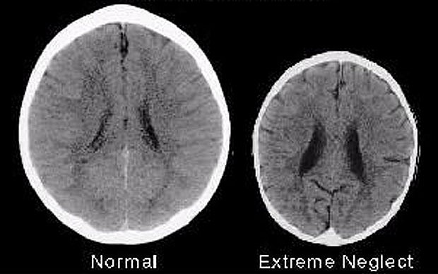

As a result, early childhood educators have a prime opportunity to provide children with interactions that can support children’s growth and development, particularly their language and communication skills.

