During the first three years of life, children transition from complete physical dependence to independence with a majority of basic self-help and mobility skills. All newborn babies share a gradually progression and development as they age from infants into young children. Babies learn how to control their muscles and movements. As motor development continues, babies will learn to interact with their environment.
Physical development is development of the body. There are two different types of physical skills which children will need to develop:
- Gross Motor Skills or large muscle movement - ‘Gross’ in this context means ‘large’ and ‘motor’ means ‘movement’. For example, the muscles in our legs and arms that we use for running or throwing.
- Fine Motor Skills or small muscle movement. For example, those in our hands that we use to manipulate objects.

Why is movement and physical activity important for babies and young children?
It is important for their physical development, health, well-being, neurological system and the brain, communication and social development.
Chief Medical Officers recommend that physical activity should be encouraged from birth, particularly through floor based-play and water-based activities in safe environments.
Children who are capable of walking unaided should be physically active daily for at least 180 minutes (3 hours) spread throughout the day. All children and young people should minimise the amount of time spent being sedentary (being restrained or sitting) for extended periods (except time spent sleeping)

Movement guidance
- The Statutory Framework for the EYFS states: ‘children must also be helped to understand the importance of physical activity…’ (DfE, 2014:5)
- Dept. of Health recommend 3 hours of playful activity as a minimum for children aged birth to 5. (2011)
- Sitting still and being sedentary is not something a child can master until they are 6 - 7 years old. “The most advanced form of movement is the ability to sit still.” Sally Goddard Blythe (2000)

Tummy time
Benefits for development: -
- Eye tracking
- Promotes cervical and lumbar spine stability and neck strength

Crawling on hands and knees
Benefits for development: -
- Vertical eye tracking
- Eye-hand co-ordination
- Balance away from the floor - this forms the basis of balance throughout life.

The outdoor environment is where fine motor development begins.
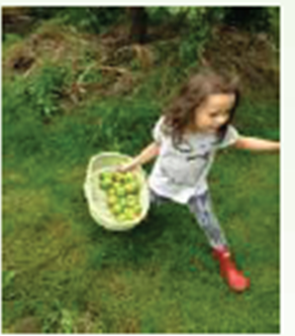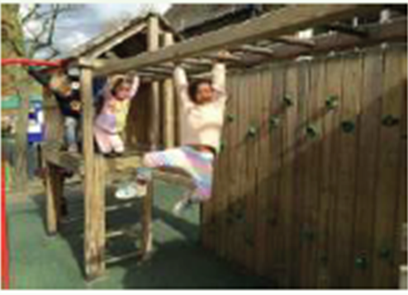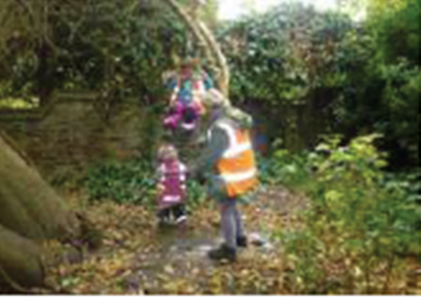

Fine motor skills develop from whole body movement
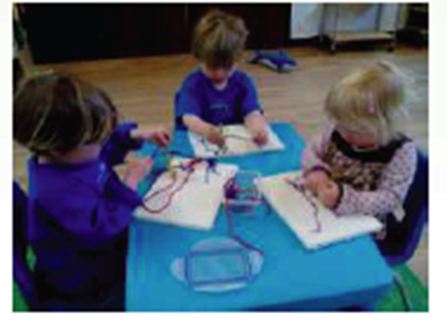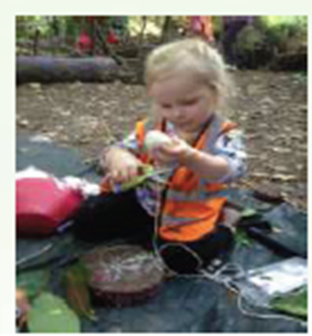
Physicality matters
To move, to run, to find things out by new movement, to feel one’s life in every limb, that is the life of early childhood. ’Margaret McMillan (1930:23)

‘It amazes me how quickly and how often we forget that we are embodied, that we see the world the way we do because we live in these bodies.’ Sir Ken Robinson (2012)

‘Young children learn about themselves and their environment through movement. …movement is ‘thought in action.’ Marjory Ouvry (2003:12)

For further information about physical development:
- Early Years Foundation Stage (EYFS)
- The Movement Environment Rating Scale (MOVERS) UK physical activity guidelines - GOV.UK
- Infographics on physical activity - GOV.UK
- The best start in life (pdf format, 204Kb)
- Start active Stay Active
- NHS Children's Occupational Therapy Activity Resources

