Reference: Strategic Planning / Water
Oxfordshire County Council
County Hall
New Road
Oxford OX1 1ND

Bill Cotton –
Corporate Director for Environment and Place

11th May 2023

Ofwat

By email: rapid@ofwat.gov.uk

Dear Sir / Madam

Regulators’ Alliance for Progressing Infrastructure Development (RAPID)
Draft Decisions for Strategic Resource Options – Gate Two
Representations closing date: 11 May 2023

Further to the opportunity to make representations on RAPID’s draft decisions on the gate two submissions for strategic water supply options, released on 30th March 2023, please find attached to this letter, comments from Oxfordshire County Council.

These comments follow those that we made on RAPID’s draft decisions on the gate one submissions in October 2021. These representations do not fetter any future position the County Council may wish to take on the various proposals.

Oxfordshire County Council has also recently responded on some of the regional plan and water resources management plan consultations recently. Copies of those comments are also being sent with this letter so that RAPID has a full understanding of the Council’s position. Relevant district councils in Oxfordshire and the Group Against Reservoir Development (GARD) are also making comments that we support.

We note that RAPID’s process envisages decisions being made on these gate two submissions on 28th June 2023 and after that there will be a process leading to gate three submissions on various dates between 2023 and 2029.

Yours faithfully

www.oxfordshire.gov.uk

OXFORDSHIRE COUNTY COUNCIL RESPONSE
ON RAPID’S DRAFT DECISIONS
GATE TWO

COMMENTS APPLICABLE TO ALL OPTIONS

The Gated Process and the Strategic Water Resources Options

- The Regulators’ Alliance for Progressing Infrastructure Development (RAPID) is an alliance consisting of Ofwat, the Environment Agency and the Drinking Water Inspectorate. Figure 1 below from Ofwat’s website shows the gated process that RAPID is undertaking for potential strategic regional water resources. Oxfordshire County Council’s interest is predominantly in the options which are progressing through the standard gates. The standard gate one submissions from the water companies closed on 5 July 2021. RAPID’s draft decisions on those were released on 14 September 2021, Oxfordshire County Council and others commented in October 2021, and RAPID’s final gate one decisions were released in January 2022 indicating what the regulators expected by the gate two deadline. The standard gate two submissions from the water companies closed on 14 November 2022. RAPID’s draft decisions on those were released on 30 March 2023 for comment by 11 May 2023, and RAPID intends to release its final decisions on 28 June 2023.

Figure 1 – Timeline of RAPID’s process
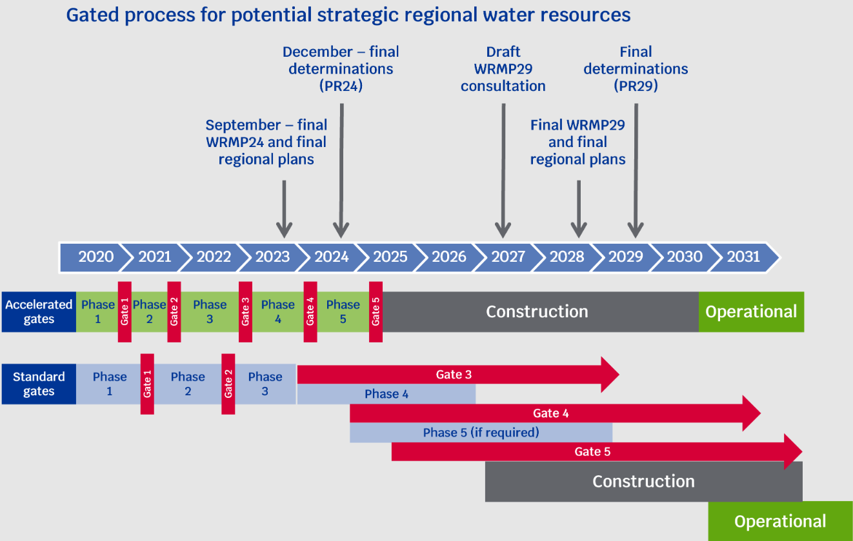

- Figure 2 from Ofwat’s website shows the strategic water resources options. Draft decisions are currently available for consultation on twelve schemes following the ‘standard gate two’ as listed in the Figure 3 which we have prepared. In 2019, Ofwat determined how much total funding would be available to the water companies to develop the various proposals going through the gated process. The maximum allowance to develop the schemes with reference to the 2019 Ofwat document is listed together with the proposed changes to the funding included in RAPID’s draft decisions. The suggested gate three dates contained in RAPID’s draft decisions are also included in the Figure 3.

Figure 2 – Map of England and Wales showing strategic water resources options.
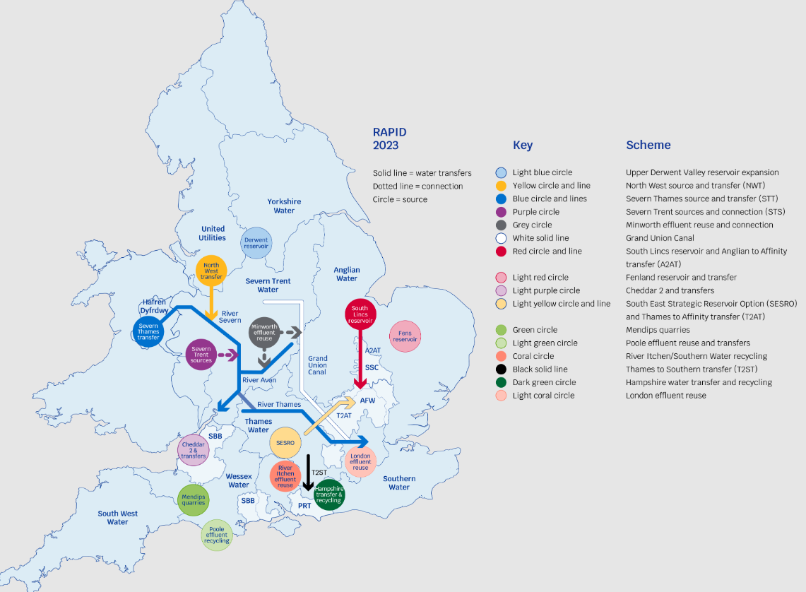

Figure 3 – List of Standard Gate Two Schemes
Name | Companies | Max funding 2019 | Max funding now | Draft gate three
South East Strategic Reservoir Option (SESRO) | Thames Water / Affinity Water | £121.7m | £121.7m | Jan 25
Severn to Thames Transfer (STT) | Thames Water / Severn Trent Water / United Utilities | £66.6m | £83.6m | Jan 25
London Water Recycling | Thames Water | £62.9m | £62.9m | Nov 23
South Lincolnshire Reservoir | Anglian Water / Affinity Water | £38.6m | £47.4m | Sep 24
Fens Reservoir (added in 2021) | Anglian Water / Cambridge Water | £24.5m | £33.8m | Sep 24
Grand Union Canal Strategic Transfer (GUC) | Severn Trent Water / Affinity Water | £18.0m | £19.2m | Sep 24
Thames to Southern Transfer (T2ST) | Thames Water / Southern Water | £15.0m | £15.0m | Nov 27
North West Transfer (Vyrnwy Reservoir NWT) | United Utilities | £14.7m | £24.4m | Jan 25
Anglian to Affinity Transfer (A2AT) | Anglian Water / Affinity Water | £11.5m | £8.6m | Sep 24
Thames to Affinity Transfer (T2AT) | Thames Water / Affinity Water | £10.9m | £13.6m | Dec 29
Minworth Water Recycling | Severn Trent Water / Affinity Water | £9.0m | £11.7m | Sep 24
Severn Trent Sources (STS) | Severn Trent Water | £5.3m | £8.2m | Jan 25

- The purpose of RAPID’s draft decisions at this stage is to state whether the proposed strategic water resource solutions should continue to receive development funding and progress through the gated process. The draft decisions largely agree to progress the schemes that the companies want to, and in most cases agree additional development funding.

- RAPID’s draft decisions offer various gate three dates going forward as shown in Table 3. If these decisions are finalised, there will be one scheme with a November 2023 deadline, five schemes with a September 2024 deadline, four schemes with a January 2025 deadline, one scheme with November 2027 deadline and one scheme with a December 2029 deadline. We query this amendment to the process which previously envisaged that schemes would be able to be compared with one another at the same time. Comparison is made more complicated with timelines dispersed over six years.

- Of the 12 strategic water resources option draft decisions, 7 are the subject to our specific comments below. In the comments below we advise that SESRO should be removed from the draft regional and company water plans and not progress to gate three. We do not have specific comments on the remaining 5 options: South Lincolnshire Reservoir, Fens Reservoir, North West Transfer (Vyrnwy Reservoir), Minworth Water Recycling, and Severn Trent Sources (STS) although they are referred to under other headings below and we generally support options which are resilient to climate change.

- To progress any strategic water resource option, advice from local authorities is critical. Oxfordshire County Council and the district and city councils, town councils and parish councils in the county expect to be involved, highlighting matters that the water companies need to consider and respond to. The schemes will also need to be informed by consultation with those living closest. We expect the RAPID decisions to clearly highlight in their final decisions the need to work with local councils and communities, and act on that advice.

- We remain concerned that RAPID is not addressing the pace at which extreme and unpredictable weather impacts of climate change are accelerating. The increasingly frequent malign and savage weather events of the last few years have shocked climate scientists, and it appears that weather systems are much more sensitive to temperature rise than had previously been believed. The IPCC AR6 (2022) predicts climate impacts at 1.5C that were predicted for 4C in AR5 (2014). There are multiple documented reasons to expect temperature rises to accelerate in this decade (including saturation of land and ocean CO2 sinks, “termination shock” from reduction in SO2 emissions) and we cannot predict how that may play out, though past experience is not encouraging. When dealing with radical uncertainty and existential threats, we should apply “least risk” models, asking “what is the worst that could happen?” and seeking to mitigate that as early as possible. We believe the system should be aiming for resilience to (for example) extreme multi-year drought by the early 2030s.

- There are other options which could provide water supply which are not included in the RAPID gated process. The regulators’ funding should also support the development of a wide range of options including smaller, more innovative and less environmentally damaging solutions. We would like to see funding, for example, of nature-based catchment management schemes where projects are developed to retain water, manage flood risk and create new nature reserves, alongside a much greater focus on aquifer recharging.

National Policy Statement for Water Resources Infrastructure 2023

- The need for the various options is being considered through regional and company water resources plans as required by a government guideline, following the National Framework 2020 for water resources called ‘Meeting our Future Needs’. Oxfordshire County Council’s comments on the draft regional and company plans have been sent in the last few months.

- On 17 April 2023 (i.e. during this RAPID consultation period), the government published a National Policy Statement for Water Resources Infrastructure. This National Policy Statement (NPS) is about the development of nationally significant infrastructure projects for water resources and is relevant to the current considerations by RAPID. The NPS will be used as the primary basis for examination of development consent applications for water resources infrastructure, such as reservoirs and transfer pipelines.

- The NPS states in paragraph 1.4.5 that: “If a nationally significant infrastructure project is included in a published final water resources management plan, the ‘need’ for that scheme will have been demonstrated in line with government policy. The applicable statutory requirements, and ‘need’ would not be expected to be revisited as part of the application for development consent”. Oxfordshire County Council is seeking changes to the water resources plans, for example we are seeking that the plans do not include provision for the SESRO.

- The role of each water infrastructure type such as reservoirs, water transfers, and desalination, is set out in 2.6 of the NPS. Section 3 of the NPS sets out the assessment principles while Section 4 indicates how impacts will need to be assessed in development consent applications.

- Given the existence of this now finalised NPS, we expect that RAPID will need to review its draft decisions to make sure that the final decisions are consistent with the new national guidance.

Estimating the need for building new strategic infrastructure

- The top priority needs to be building resilience to unpredictable and rapidly evolving climate impacts, which are currently accelerating ahead of any predictions, and can be expected to accelerate further in this decade. This would result in a fundamentally different prioritisation based on resilience to future water shortages and speed of delivery. Given the urgency of climate change, the need for new items of strategic infrastructure that will take a long time to build is over-estimated relative to the need for smaller schemes that can be brought forward quickly and provide resilient sources of water. We favour the use of existing or refurbished infrastructure, such as the canal transfers, or infrastructure which is underground, such as pipelines.

- Oxfordshire County Council has stated in its responses to the draft plans that the amount of additional water supply needed in the South East has been seriously overestimated because of incorrect population growth models and poorly evidenced environmental targets. In particular we understand that the “high” level of environmental action suggested is not supported by those with knowledge of chalk streams, shows an extremely poor cost-benefit ratio, and may result in adverse unanticipated consequences such as winter ground water flooding from very high water tables. In addition, we can see an inevitable opportunity cost, given the need to minimise costs to bill-payers, whereby the search for an illusory perfection for chalk streams comes at the cost of delaying action on rampant sewage pollution in the rest of the Upper Thames.

- If the water companies do more to reduce leakage and reduce demand, the need for building new items of strategic infrastructure will be diminished. Oxfordshire County Council maintains its view, as set out in our responses to the draft regional plans and company water resources plans, that the plans should be revised, reflecting better targets on leakage reduction and future water consumption. Innovation will have a role to play in this, for example with household appliances using less water.

- If the regional and company water resources plans are reframed to prioritise resilient schemes such as water recycling, water transfers, and desalination, this will mean that other options such as the SESRO are not needed. We have asked for such changes and expect that such a reframing of the plans will also involve less total cost to the billpayer, given that options such as the SESRO are enormous projects, currently with a high price tag, and costs are likely to spiral on such projects.

Carbon Costs

- As requested in our response to the gate one submissions, we think that RAPID needs to continue to seek evidence that the companies are embracing innovative designs and opportunities to generate or be powered by renewable energy and/or sequester carbon. We have also noted the criticality of the timing of energy use: the later the date, the lower the expected emissions. For each option pursued, there is a need for comparable carbon assessments and a focus on meeting net zero carbon commitments. It should be clear in the RAPID decisions that the companies will be required to set out the carbon costs of their proposals in relation to the government’s commitments to reduce carbon emissions. The carbon footprint of each may be a key factor in choosing between options. RAPID should compare each of the draft decisions to ensure they are consistently seeking evidence about carbon costs. There should be accounting on when construction happens in relation to the amount of renewable energy sourcing the national grid and whether low carbon hydrogen will be available and used, for example for heavy vehicles. Low energy demand once in use will not be an effective mitigation for high energy use in construction, especially if construction is early in the period of the plan.

Summary:

RAPID should clearly state in its decisions that to progress any strategic water resource option, advice from local authorities is critical and schemes need to be informed by consultation with local communities. We query the RAPID process which seems to largely agree to the companies’ requests for additional development funding and extended timeframes. Different timeframes in future will make comparison difficult and schemes need to be compared on a “like for like” basis. The regulators’ funding should also support the development of more innovative and less environmentally damaging water resource solutions.

RAPID needs to focus much harder on building early resilience to the accelerating, increasingly malign and radically uncertain impacts of climate change. Radical uncertainty in the face of existential threats requires a “least risk” approach. Our submission to the WRSE draft reginal water resources plan contained an example of how the most climate-resilient schemes could be executed as early as possible.

RAPID will need to review its draft decisions in relation to the new National Policy Statement on water resources infrastructure released in April 2023.

If the regional and company water resources plans are amended in line with realistic population projections and cost-effective environmental interventions as requested by Oxfordshire County Council, then it will be clear that there is no need for the SESRO. RAPID should recognise in its decisions that schemes will not progress to gate three if not included in the final water resources plans.

RAPID should require schemes that progress to set out their carbon costs in a comparable way. The accounting will need to factor in the timing of the proposal in relation to decarbonisation of the national grid and availability of low-emission vehicles. RAPID should ask that opportunities for innovation and power through renewables be brought forward.

SOUTH EAST STRATEGIC RESERVOIR OPTION (SESRO)

- This is the proposal for a reservoir to be located between Abingdon, Steventon and East Hanney in Oxfordshire. It would store raw water from the River Thames at times of abundant flow, to be released back into the river when needed for subsequent re-abstraction further downstream, recognising there will be losses en route. Elements of the proposal include: bunds at an estimated height of 15m to 25m above natural ground level; screening mounds; an underground pipeline from the River Thames; an auxiliary drawdown channel; new and realigned roads; a railway siding; and visitor facilities.

- There are six reservoir options of various sizes and phasing. Figure 4 below shows the largest option which would store up to 150 Mm3 of water as shown on Ofwat’s website. However, it is recognised that the draft Water Resources South East (WRSE) regional plan and draft water resources management plans indicate that the current proposed option is one that would store up to 100 Mm3 of water. Figure 5, taken from the SESRO concept design report submitted by Thames Water and Affinity Water shows a possible scheme for the 100 Mm3 option.

- The SESRO location is in the Thames Water area, but it is a joint proposal with Affinity Water. The proposal envisages water being supplied for both those companies and also others, including Southern Water. We noted in our response to the WRSE regional plan that all the promised supplies are not possible contiguously even at the planned maximum daily supply.

- The draft decision allows for continued funding and progression to gate three. RAPID is agreeable to a gate three date for this scheme of January 2025 alongside a forward programme of DCO application submission in autumn 2026, gate four at least a month after that submission in November 2026, construction starting in 2029 and the reservoir operational in 2040.

Figure 4 – Schematic of 150 Mm3 option for SESRO
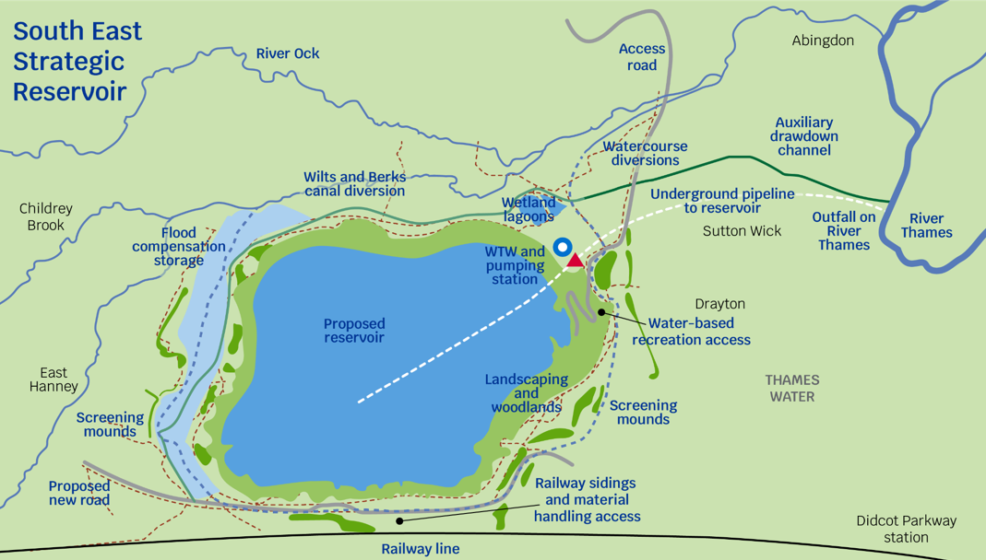

Figure 5 – Schematic of 100 Mm3 option for SESRO
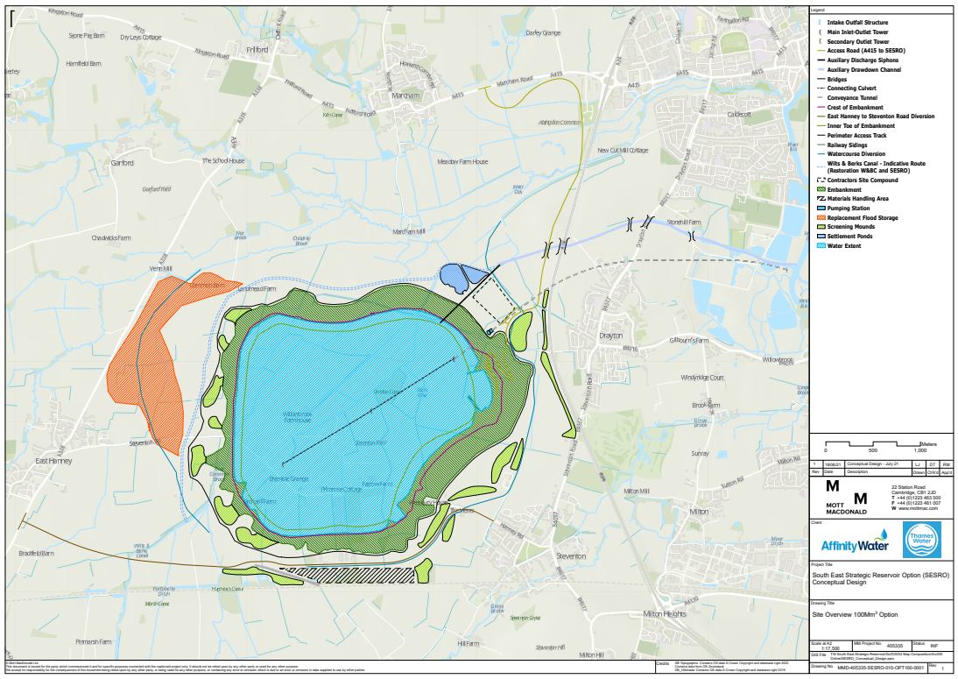

- The regulators’ concerns about the draft regional plan and draft water resources management plans are summarised on page 8 of the draft decision as: needing to understand the sensitivity of the choice between 100 Mm3 and 150 Mm3 in respect of the size of the Havant Thicket Water recycling option; that there is a question about whether 100 Mm3 or 150 Mm3 is most resilient; and whether 100 Mm3 is better environmentally.

- The regulators’ concerns about the work received are summarised on page 9 of the draft decision as: concerns about the methodology for Landscape and Visual Impact Assessment (LVIA); and concerns about development of a flood risk model.

- The key area of work identified in the appendix to the draft decision is to develop the 100 Mm3 option to understand the environmental impact and benefits compared to the 150 Mm3 option.

- Oxfordshire County Council’s position as set out in our responses on the draft regional plans and draft water resources management plans in relation to the SESRO is that it is not needed at all. We think that RAPID should recognise in its decisions that there are significant objections to SESRO seeking it be removed from the plans (we note that ‘stakeholder negativity’ is referred to in respect of some other options, and that is more so the case with this option, for example in the comments made by the Group Against Reservoir Development and Oxfordshire County Council).

- If the proposal proceeds, Oxfordshire County Council and Vale of White Horse District Council need to be involved in providing preapplication advice. However, Oxfordshire County Council has numerous concerns about the SESRO proposal:

- Size – The 100 Mm3 (and 150 Mm3) size is overly large covering too much land close to populated areas.

- Effectiveness – This reservoir will not be able to be filled during periods of prolonged drought and could be rapidly emptied.

- Time to construct – The length of time taken to construct SESRO (some ten years) crowds out multiple smaller and more resilient schemes.

- Cost to construct – The huge cost of the SESRO and the related pipelines (at least £2 billion) is disproportionate to other lower cost options. There is also a high opportunity cost in failing to be more resilient as a result of not progressing other options.

- Completion date – A completion date of 2040 requires a very early decision to proceed and will result in a high carbon footprint given that the national electricity network is not yet decarbonised and construction vehicles use petrol or diesel.

- Environmental effects – The extent of the adverse environmental effects mean that obtaining a Development Consent Order should be difficult to achieve, for example:
- A high carbon footprint.
- Significant disruption in the area due to construction effects over a long period.
- Visual effects e.g. as a result of bunds of 15 to 25m above ground.
- Impacts on the amenity of those living nearby e.g. the scale being oppressive.
- Impacts from traffic including congestion and air quality issues.
- The need for active travel and public right of way connections.
- The need to create and use a railway siding to reduce road impacts.
- How the Hanney Road / Steventon Road will be diverted.
- What the proposal means for flood risk in the area.
- Concern about the health of water within the reservoir given that it will be untreated.
- Impacts on archaeology.
- Impacts on biodiversity, including protected species.
- The level of biodiversity net gain to be provided for.
- How recreational benefits would be secured.
- How the Wilts & Bucks canal might be restored.
- The potential to replace existing solar farms on the land.
- Safety concerns.

- Ongoing operation costs – There will be significant ongoing costs for pumping water and maintaining facilities.

- Lack of clarity about how to share the water - The SESRO is designed to enable transfers of water to other areas in the South East, but there are better options those areas could utilise.

- We recognise that RAPID has been set up to progress strategic water resources options so is probably not in a position to refuse to allow SESRO to progress to gate three until it is removed from the regional and company water resources plans. However, we wonder why RAPID queries whether the 100 Mm3 is better environmentally than the 150 Mm3 option. Is it because the size apparent from the concept designs, both covering an area of near 7km², is not much different? We understand that an environmental benefit of the 100 Mm3 size might be lower bund heights. It is self-evident that a smaller reservoir will have reduced environmental impacts. RAPID should not be suggesting that 150 Mm3 be further investigated. RAPID’s decision should be amended to give more support to working up options smaller than 100 Mm3, recognising that both the 100 Mm3 and 150 Mm3 size are extremely large, and more benefits would likely result from a smaller size.

- RAPID’s decision needs to be clearer on the many environmental effects (as noted above) that will need to be addressed for any reservoir in this location. RAPID should also use the opportunity to direct the companies to include a range of environmental benefits in any scheme proposal. In respect of potential benefits associated with a reservoir at Abingdon, we would note the following examples:
- Provision of a wide range of recreational and community uses.
- Construction of a flood barrier for Abingdon as part of the project.
- Construction of the Wilts and Berks canal through the site as part of the project.
- Provision of a new railway station at Grove constructed together with the sidings for construction materials.
- Housing built for construction workers, to be later sold as affordable housing.
- Employment and skills plans implemented to encourage local employment.
- Provision of service infrastructure, such as GP facilities.
- Provision of transport infrastructure, such as new cycle routes.
- Provision of renewable energy infrastructure, such as solar panels.
- Creation of new habitats to improve biodiversity.

- Overall, we think that RAPID’s identified actions and recommendations are light compared to other draft decisions on the strategic resources options discussed below.

Summary:

RAPID should recognise that there is significant opposition to SESRO and that it may be removed from the regional and company water resources plans and therefore not progress to gate three. The current water resources draft plans include provision for a reservoir of 100 Mm3 and RAPID should give more support to working up smaller options, not larger ones. RAPID should take the opportunity in their decision to direct the companies to provide for environmental benefits as part of any scheme. RAPID’s decision should be clearer on the need to address the many environmental effects, which may show that some or all reservoir sizes should not progress further.

SEVERN TRENT TRANSFER (STT)

- This is the proposal to transfer water from the River Severn to the River Thames. In order to support transferring water from the River Severn, supply solutions for the River Severn are also being investigated: North West Transfer (Vyrnwy Reservoir), Minworth Water Recycling, and other Severn Trent Water Sources.

- The first option to transfer water from the River Severn to the River Thames involves a pipeline from Deerhurst to Culham in Oxfordshire. The second option involves reinstating parts of the Cotswold Canals from Gloucester Dock to Culham as well as sections of pipeline. The proposal includes water treatment works at the intake locations to mitigate potential impacts on water quality or from invasive species on the River Thames. A discharge outfall structure would be constructed within the banks of the River Thames at Culham.

- The STT is being put forward jointly by United Utilities, Severn Trent and Thames Water. Figure 6, taken from Ofwat’s website, shows the STT in relation to some of the supporting elements. Figure 7, from Thames Water’s website, shows the scheme in relation to more components.

- The companies have decided that Thames Water will be solely responsible for the interconnector route going forwards. There will be continued joint working by the three companies on the system co-ordination and the River Vyrnwy Bypass pipeline.

- RAPID’s draft decision includes a checkpoint in December 2023. Subject to that checkpoint, the proposed date for gate three is January 2025, DCO application in July 2026, and gate four in October 2026. The solution is planned to be construction ready in 2029 and operational in 2033.

- RAPID’s overall assessment of the submission is that it is good but falls short of meeting gate two expectations in some areas. Stakeholder and customer engagement is one area that RAPID considers the companies need to further develop. RAPID’s draft decision states that there is a considerable programme risk because of the potential impact on the Severn Estuary Habitat Regulations site. Six priority actions have been identified for completion by December 2023 around engagement; the Habitat Regulations site; drinking water quality; and alignment with the regional and company water resources plans. There are six other actions and seven recommendations for further work.

Figure 6 – Schematic of STT two route options with some supporting elements by RAPID
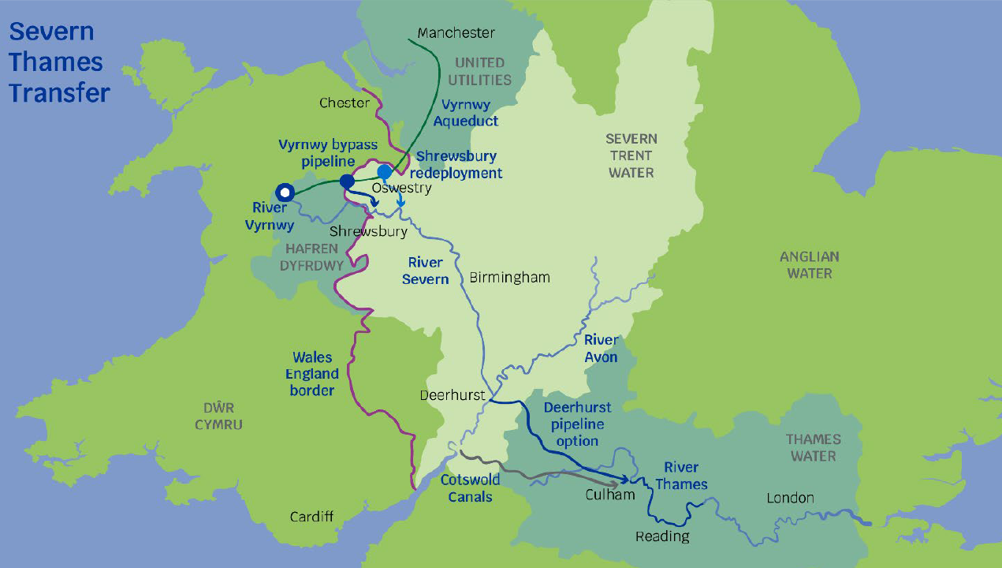

Figure 7 – Schematic of STT two route options with supporting elements by Thames Water
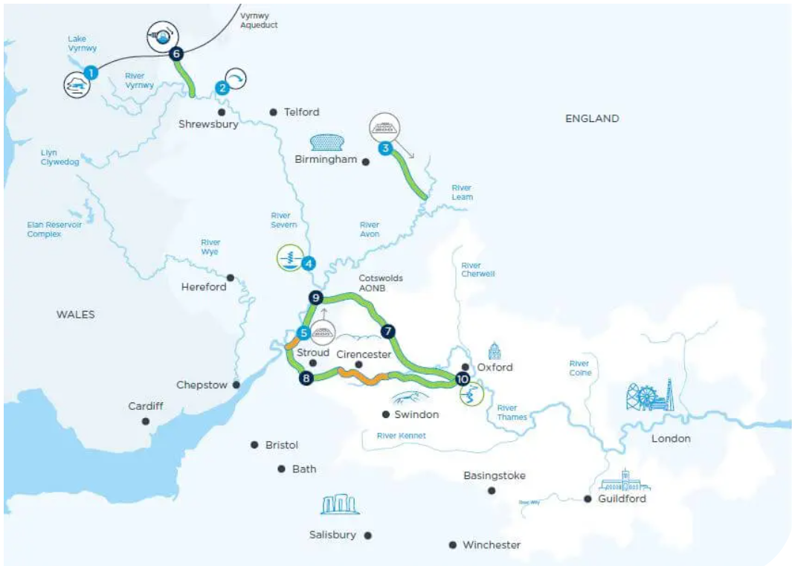

- RAPID’s draft decision on the STT appears overly negative although we recognise there are environmental concerns, particularly about construction over such a long distance. Either option for the interconnector route will bring water into the water-stressed South East from areas with higher rainfall which are likely to be less affected by more extreme climate impacts, and a pipeline or canal will have fewer ongoing adverse effects than a SESRO. Vrynwy is in an area likely to maintain high winter rainfall, and the use of recycled water from the Severn Trent Sources appears to make this more resilient. We support the fact that RAPID’s draft decision asks for both route options to continue to be investigated.

- Our comments on the draft regional and company plans seek that STT be brought forward in time. We think that SESRO is not needed, noting that STT can be progressed earlier.

- The RAPID decision should be amended to support the companies to progress work needed for the Development Consent Order application along the timeline suggested to lodge the planning application in July 2026. We agree with the additional allocation of development funding that RAPID proposes, which is still considerably less than that identified for the SESRO. Oxfordshire County Council, West Oxfordshire District and Vale of White Horse District need to be involved in providing preapplication advice along with other authorities on the proposed route. We agree that the companies need to further develop customer and stakeholder engagement.

Summary:

RAPID should support the companies to progress the climate-resilient Severn Trent Transfer (STT) and develop customer and stakeholder engagement as well as seeking preapplication advice from authorities along the route. RAPID’s draft decisions should be amended to be less negative to this strategic water resource option.

GRAND UNION CANAL TRANSFER (GUC)

- This proposal is to transfer water from Minworth wastewater treatment works to the Grand Union Canal and into the Affinity Water supply area. The Grand Union Canal would be upgraded as part of this and there would be connections at either end. Between the gate one and gate two submissions, the additional work has identified the southern end point at Leighton Buzzard. Figure 8, taken from Ofwat’s website, shows the solution schematic.

- Severn Trent Water and Affinity Water are jointly promoting this. RAPID is agreeable to a gate three deadline of September 2024, with a proposed development consent order application in 2025, gate four in November 2025, the solution construction ready in 2027 and operational in 2032.

- It appears that good progress has been made between gate one and gate two and there are no priority actions identified by RAPID, although there are some 11 actions and 5 recommendations to take place before gate three.

- The main issue is that a conditional review point may be set for the Minworth water recycling scheme, and that could lead to a conditional review point also for the GUC given that the scheme is dependent on Minworth as the source of water.

Figure 8 – Schematic of Grand Union Canal (GUC) Strategic Transfer from Minworth
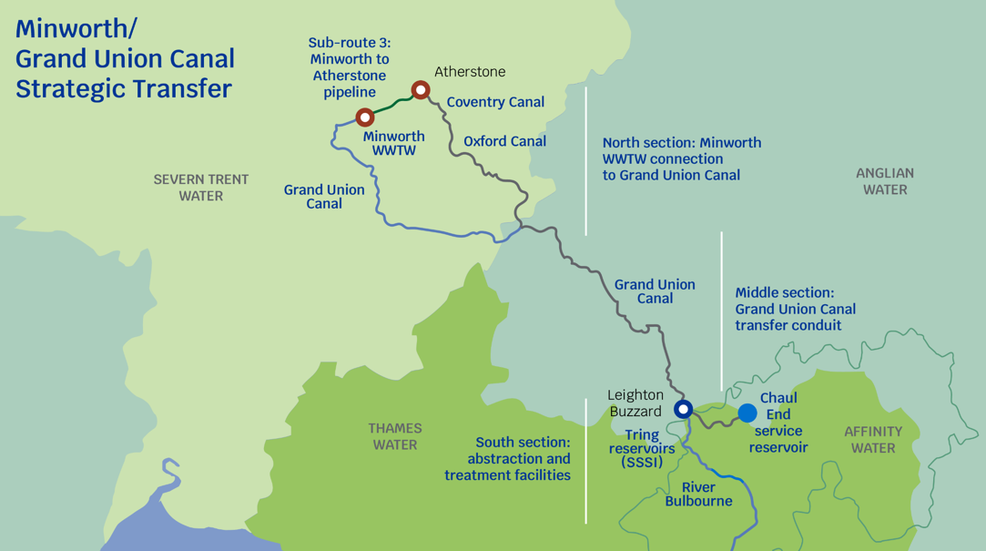

- Oxfordshire County Council’s position is that the GUC option sensibly uses an existing canal resource to get water from the Midlands to London, as well as providing a high level of climate resilience by using recycled water. It is understood that the option is supported by the Canal & River Trust and there would be benefits from upgraded facilities, flood alleviation, habitat creation etc. Given that the source of the water is to be treated wastewater from the Minworth Waste Water Treatment Works, it is an option which is resilient to drought. The GUC will help reduce the need for other options to transfer water to Affinity Water’s area. We trust that RAPID’s concerns about Minworth water recycling will be overcome to allow this scheme to proceed to a development consent order application. Oxfordshire County Council does not expect to be specifically involved as the route does not land in include Oxfordshire.

Summary:

It appears that good progress has been made with this Grand Union Canal (GUC) strategic water resource option which sensibly uses an existing canal, offers environmental benefits, and is an option which is resilient to drought given it involves treated wastewater. Development of this option reduces any perceived need for the SESRO. RAPID should support the companies to progress the GUC.

THAMES TO AFFINITY TRANSFER (T2AT)

- This proposal is a pipeline to transfer water from Thames Water’s area to the Affinity Water area. There have been two options, one from the west (at the Lower Thames Reservoir) and one from the east (from the Beckton Waste Water Treatment Works or from Teddington). The draft regional plan and water resources management plans options are that from the west. The water companies have suggested focusing on their preferred option from the west for gate three, such that no further work will be done indefinitely on the other option from the east, and RAPID’s draft decision agrees that. This preferred option is said to rely on the SESRO.

- The timeframe is gate three in December 2029, planning application submission in 2031, construction being ready in 2034, half the transfer operational in 2040 with the remaining transfer operational by 2045.

- We have not included a copy of the schematic in this response as Oxfordshire County Council has no particular comments on the route of a pipeline from the Lower Thames Reservoir area to Harefield, which is understood to be a distance of less than 10 miles at the eastern edge of Buckinghamshire. However, we have objected to the SESRO proposals and are concerned that there is no reflection in the RAPID draft decision of the uncertainty surrounding the SESRO. It may be that such a transfer can take place as a result of other proposals, such as the STT, but such dependencies should be made clear in the RAPID decision.

Summary:

The dependency on SESRO or STT apparent in the option for a transfer to Affinity Water from the west (T2AT) should be made explicit in the RAPID decision.

THAMES TO SOUTHERN TRANSFER (T2ST)

- This proposal is a pipeline to transfer water from Thames Water’s area to the Southern Water area. Figure 9, taken from Ofwat’s website, shows the option from Drayton (in Oxfordshire) to a point south of Winchester near Southampton, which includes two alternative routes around Newbury. It is clear in the text of RAPID’s draft decision that such a pipeline is entirely dependent on the prior development and commissioning of the STT or SESRO.

- This infrastructure may well only have come to appear necessary to the water companies in the context of extreme assumptions about the need to stop abstraction from chalk streams and failure to consider resilient solutions such as aquifer recharging.

- Previously this was a joint proposal 50:50 by Thames Water and Southern Water, going forward the accountability will be mainly with Southern Water. The timing anticipated is gate three in November 2027, a planning application submission in 2029, construction to be ready in 2032 and the solution operational in 2040.

Figure 9 – Schematic of Thames to Southern Transfer (T2ST)
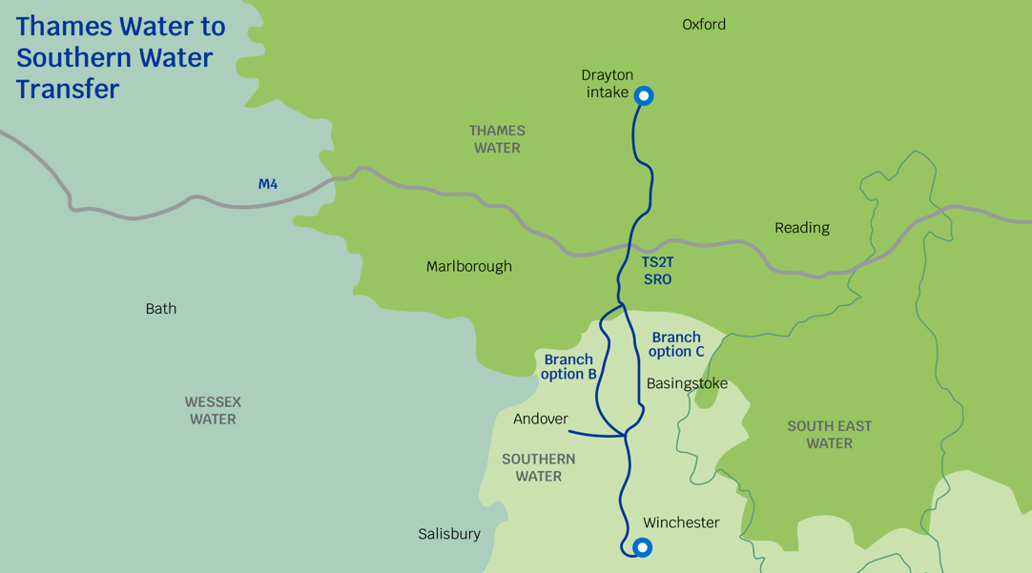

- This proposed pipeline covers a distance of some 50 miles, starting in Oxfordshire. There has been very limited consideration of it to date, reflective of the fact that the proposal is relatively new, and the proposed timeline is several years away. Oxfordshire County Council will need to be involved to consider local effects, particularly from construction, if it proceeds. However, Oxfordshire County Council’s overall view, as stated in its responses to the draft regional and company water resources plans, is that it is not needed, as the Hampshire area can be better served by more local solutions developed close to where the water is needed. We note that Southern Water is already proceeding with the Havant Thicket Reservoir (some 8 Mm3 in size) and there are other options for water recycling and desalination. The coastal area this is meant to serve should be better reflected in an amended graphic showing the coast.

- There is some inconsistency between the draft decisions in that actions about low carbon materials are proposed in this draft decision but not in others. As stated earlier in this response, we consider that all the strategic water resources options should be improved so that opportunities for innovation, renewable energy and carbon sequestration are taken.

- We recognise that RAPID has been set up to progress options so is probably not in a position to refuse to allow T2ST to progress to gate three if it remains in water resources plans. However, we think that the RAPID decision needs to be more critical. We note that there is a recommendation to provide information on the interaction with other solutions, specifically SESRO and STT as potential sources, and ongoing Southern Water solutions, and would endorse that, as we think that such information will highlight that this is not a good option to progress.

Summary:

The RAPID decision should be more critical of the option for a long pipeline south towards the coast (T2ST) which is not needed if more local solutions are developed.

ANGLIAN TO AFFINITY TRANSFER (A2AT)

- This proposal is a pipeline to transfer water from Anglian Water’s area to Affinity Water’s area. Figure 10 taken from Ofwat’s website, shows the option, with two alternative routes from the Peterborough area to a service reservoir between Saffron Walden and Thaxted. Although shown in the schematics fully, the submission of this option in November 2022 was accompanied by a letter and supporting note from the water companies recommending that the full scope of the Anglian to Affinity Transfer (A2AT) does not progress to gate three. Instead, they propose only a pipeline between the Peterborough area and Grafham, consistent with the proposals contained in the draft regional plans and resources management plans. Oxfordshire County Council has commented on those draft plans indicating that instead the whole proposal should continue to be progressed.

- RAPID’s draft decision is to fund only the Peterborough to Grafham transfer element to gate three, as requested by the companies. Affinity Water will cease to be a solution owner, i.e. this will be promoted by Anglian Water alone. The suggested new name is the Peterborough to Grafham Transfer.

- The timeframe for this reduced scheme is gate three in September 2024 followed by a planning application submitted in 2025 with the solution construction ready in 2029 and operational by 2041.

- We consider that RAPID should push back on the companies’ proposal not to progress evaluations for the full route, so that, if needed, such a pipeline could be swiftly built. As stated in our response on the WRSE draft plan, it appears that cost and technical feasibility have not been the reasons for the recommendation not to proceed with assessing the full length, but instead that the companies have decided in favour of the SESRO and STT to help with Affinity Water’s requirements rather than the A2AT. (In all cases Affinity Water also requires the GUC transfer.) The A2AT could be part of a solution where SESRO is not proceeded with and would provide more resilience in the water supply network.

Figure 10 – Schematic of Anglian to Affinity Transfer (A2AT)
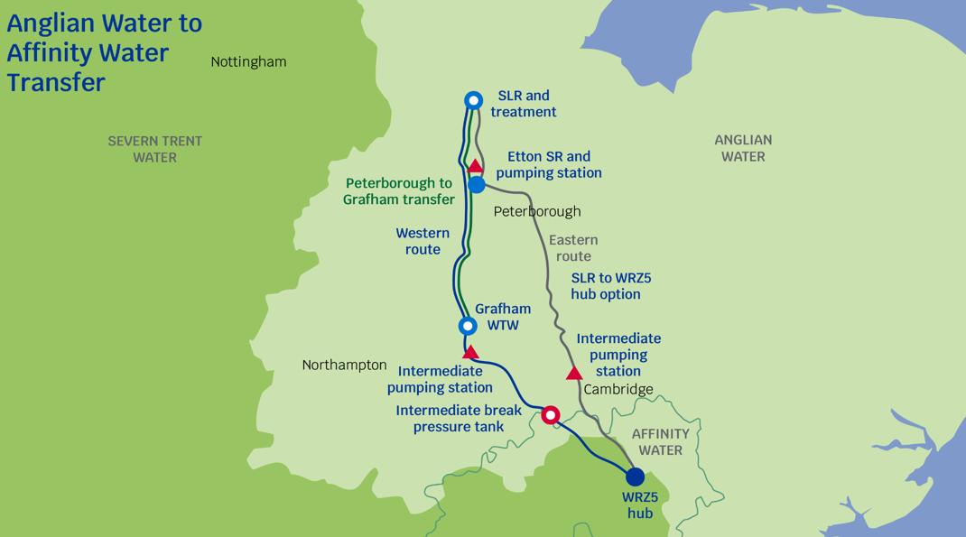

Summary:

RAPID should seek in its decisions for the route of a water pipeline from Peterborough to a service reservoir between Saffron Walden and Thaxted to be fully investigated. Such a transfer (A2AT) could be needed in future given limited other options to supply Affinity Water. Only looking at route options between Peterborough and Grafham could lead to a choice which has poor implications for the continuation of the route in future.

LONDON WATER RECYCLING SCHEMES

- The London water reuse proposed schemes are being proposed by Thames Water and involve treating effluent, discharging the treated water to the River Thames and abstracting it downstream as needed. This solution is designed to augment flows in the River Thames to support abstraction downstream for London water treatment works (WTW) and the Thames Lee Tunnel to Northeast London. There were four sub-options: Teddington Direct River Abstraction; Mogden South Sewer Scheme; Mogden Water Recycling Scheme; and Beckton Water Recycling Scheme. However, Thames Water recommends not proceeding with the Mogden South Sewer Scheme, so there are now the remaining three sub-options.

- RAPID is recommending progression to gate three very soon, in November 2023. Thirteen priority actions have been identified, to be undertaken no later than the end of August 2023. There are also other actions and recommendations in the draft decision. RAPID is expecting Thames Water to provide a timeline for the various actions in its representation on this draft decision.

- One issue is that while the Teddington Direct River Abstraction scheme is in the draft WRSE regional plan and Thames Water draft WRMP24, both the Mogden Effluent Reuse and Beckton Effluent Reuse schemes are not. Oxfordshire County Council is concerned that climate resilience is being treated as a minor consideration rather than a critical success factor. We support progressing recycling schemes including those in London, and we think that RAPID should resist removing further recycling schemes without highly compelling reason. We have not included a copy of the schematic in this response as we have no particular comments on the location of the schemes.

Summary:

RAPID should give priority to climate resilience and resist removing any proposed London water recycling schemes without compelling reason. We appreciate that RAPID is seeking quick action and a timeline to progress various actions associated with the currently proposed London water recycling schemes.

CONCLUSION

- RAPID’s draft decisions need to be reviewed having regard to comments made during this consultation and the new National Policy Statement on water resources infrastructure. Oxfordshire County Council repeats our concern that climate resilience seems virtually to have been omitted from the criteria used to prioritise schemes. Our views on the various strategic resource options are set out in responses to the draft regional and company water resources plans, which are attached to this response. We consider that the SESRO should be removed from the WRSE regional plan and company plans and not pursued as a strategic resource option. RAPID should recognise in its decisions that options will not progress to gate three if not included in the final water resources plans.

- RAPID’s decisions should state that the companies need to seek advice from local authorities as well as consult with local communities. The decisions should be consistent with each other, and all companies should be required to undertake work to assess all environmental effects, set out carbon costs and identify environmental benefits that the companies can provide with the schemes.

