Active Travel Tranche 2:

East Oxford LTN Evaluation Snapshot Report

DOCUMENT HISTORY

*Revisions – Amendments*

|  |  |
| --- | --- |
| VERSION AND DATE | Changes |
| V 1.0 – 12/05/2023 | 1st draft completed |
| V 2.0 – 31/05/23 | 2nd draft completed |
| V 3.0 - 3/6/23 | Final |

**Main authors**

Innovation Hub (iHUB) officers, Oxfordshire County Council:

Behavioural and Data Science Lead Officer

Future Mobility and Placemaking Team Leader

Innovation Planning and Project Officer

Innovation Researcher

Data Analysis & Modelling Team:

Insight Analyst

# Executive Summary

1. This snapshot report provides a partial evaluation of the effects of the East Oxford Low Traffic Neighbourhoods (LTNs) since their implementation on 20th May 2022. It is not a full evaluation and does not cover all effects of the LTNs. More detailed analysis is also required within the elements which have been included in this report, such as more detailed review of traffic impacts. In addition, it should be noted that during the evaluation period considered, there were significant levels of vandalism of bollards and general non-compliance with traffic restrictions, which will have impacted significantly on the evaluation. As such, it should be considered indicative rather than definitive. A complete evaluation, covering greater analytical detail and other effects, which will include bus reliability, speed and journey time analysis, will be undertaken over the summer period, to be published to support the cabinet decision, expected in October, on whether the LTNs should become permanent.
2. The following aspects are presented in this report:

* Sensor-derived traffic volume changes by mode (car, pedestrian and cycle) for both within LTN and along the boundary roads immediately surrounding them
* Automatic traffic count survey traffic volumes by vehicle type (car, LGV, HGV and motorcycle) within the LTNs
* CCTV survey count modal volumes for cyclists and pedestrians within the LTNs
* Air quality impacts in terms of Nitrogen Dioxide (NO2) both within the LTNs and on the boundary roads, including roads bounding the Cowley LTNs, to consider whether the East Oxford LTN have had any influence on air quality on roads immediately surrounding the Cowley LTNs, given their close proximity
* The impact on Emergency services response times, based on South Central Ambulance Services (SCAS) modelled data using Optima Predict

1. The report indicates that overall, vehicle traffic levels within the LTNs have decreased significantly, in line with the objective of the scheme, whilst cycling has seen some modest increases within the LTNs; pedestrian movement within the LTNs is a more mixed picture, with some streets showing decreases and others increases. Generally, the impact has not been consistent, with some roads measured seeing greater increases or reductions respectively than others. A notable exception within the LTNs is Jeune St, which is one-way and does not have a traffic filter. It has seen significant increases in vehicular traffic. In addition, motorcycle traffic has also generally increased within LTN roads surveyed, since motorcycles are not physically precluded entry by bollards and planters, making it possible for them to more easily circumvent the restrictions than other, larger, vehicles.
2. In terms of the impact on the boundary roads immediately surrounding the LTNs, the picture is mixed, with some areas experiencing significantly higher traffic levels post implementation compared to immediately pre-implementation, whilst other areas have seen reductions in traffic. Morrell Avenue has seen a modest increase in traffic, whilst along the Cowley and Iffley Roads the impact on traffic volumes has been different at either end of each road. In both instances, prior to the introduction of the LTNs (during the period between November 2021 and May 2022) the sensors further away from the city centre recorded significantly higher traffic volumes than those closer to the city. After the introduction of the LTNs on 20th May 2022 the gap in volume has closed (completely in the case of Cowley Road and significantly for Iffley Road), due to large increases in traffic near The Plain, and sizeable decreases in traffic at locations further from the City Centre. Further analysis is required to fully understand this pattern. However, one possible explanation may be that people are re-routing and/or choosing alternative transport to gain access to the city from the direction of the ring-road. Once a driver reaches the areas covered by the sensors though (bounded by LTNs on both sides for Cowley Road, and on one side for Iffley Road), they have little alternative than to drive straight down the road. As a result, what would have been dispersed previously is all contained to the radial routes.
3. There have also been mixed changes in walking along Boundary roads. Morrell Avenue has experienced some significant relative increases in walking, but at other locations there has been little change or a reduction in pedestrian flows. There is a generally positive picture with respect to cycling. Cowley Road North and Morrell Avenue have seen significant increases in cycle use.
4. The air quality analysis generally matches the traffic impact evaluation, with variable levels of improvement in air quality within the LTNs themselves alongside an increase in pollutant levels along the boundary roads immediately surrounding East Oxford LTNs. Only one location has exceeded the legal limit – on St Clement’s at The Plain (having exceeded this limit in 2019, in excess of those readings for 2022), but a further two in the immediate vicinity of the LTNs are at or above the local target for Nitrogen Dioxide (NO2) levels. The locations measured surrounding the Cowley LTNs generally showed little or no change between 2021 and 2022.
5. The effect of the East Oxford LTN traffic restrictions on emergency services has been considered using response time delay modelling from South Central Ambulance Service (SCAS), using their Optima Predict platform. This models response time delays of the East Oxford LTNs traffic restrictions compared to a baseline without the East Oxford restrictions. A number of areas were considered – within a one-mile radius of the areas covered by the East Oxford LTNs; within a one-mile radius of the areas covered by the Cowley LTNs; within a two-mile radius of the areas covered by both Cowley and East Oxford LTNs; and the entire NHS Trust area. Delay times were modelled against different response categories (categorised by level of urgency). Delays were greatest for the East Oxford area, which showed delays between 35 seconds for category 3 (urgent) and 45 seconds for Category 1 (life threatening) and Category 2 (emergency) responses. When factored to the entire trust area, the most urgent response category experienced delays of four seconds, which equates to a cost of approximately £650K for the service to correct.

Table of Contents

Executive Summary 2

Table of Figures 5

Count Sensors 5

Overview of Sensor Locations 5

Confounding Factors 7

Traffic Volume Analysis 7

Methodology 7

VivaCity Sensor Locations 9

Traffic Volume Analysis – LTN Boundary Roads 10

Traffic Volume Analysis – In LTN Roads 13

ATC Sensor Locations and Results 14

ATC Data Collection Method 16

ATC Traffic Volume Analysis 18

Additional ATC and CCTV Difference and Impact 19

Air Quality 21

Air Quality Sampling 21

Air Quality Analysis 21

Emergency Services Response Times 25

Conclusions 29

Annex A 30

Types of Sensors Used 30

Annex B 31

Calculations Used for Statistical Analysis 31

# Table of Figures

Figure 1 Location overview of all sensors used in the analysis 6

Figure 2 Location of VivaCity boundary road sensors and filters in East Oxford LTNs 10

Figure 3 Location of ATC surveys and filters in East Oxford LTNs 16

Figure 4 Location of air quality sensors used in the analysis 22

[Figure 5 Vivacity camera installed on lamp post 30](https://oxfordshirecountycouncil.sharepoint.com/sites/OG-FutureMobility/Shared%20Documents/EATF/reports/East%20OX%20report/Reports%20Draft/Snapshot%20report/East%20Oxford%20LTN%20ME%20Report_draft%20V2%20Clean_AW_PT_Clean.docx#_Toc136719866)

[Figure 6 An ATC installation 30](https://oxfordshirecountycouncil.sharepoint.com/sites/OG-FutureMobility/Shared%20Documents/EATF/reports/East%20OX%20report/Reports%20Draft/Snapshot%20report/East%20Oxford%20LTN%20ME%20Report_draft%20V2%20Clean_AW_PT_Clean.docx#_Toc136719867)

# Count Sensors

## Overview of Sensor Locations

1. Figure 1 shows the location of all the sensors used in this analysis: within the LTN roads themselves; on boundary roads (defined as the roads immediately surrounding the LTNs, which do not have LTN traffic restrictions) and on control roads. The analysis sections that follow include more detailed maps.

Figure 1 Location overview of all sensors used in the analysis

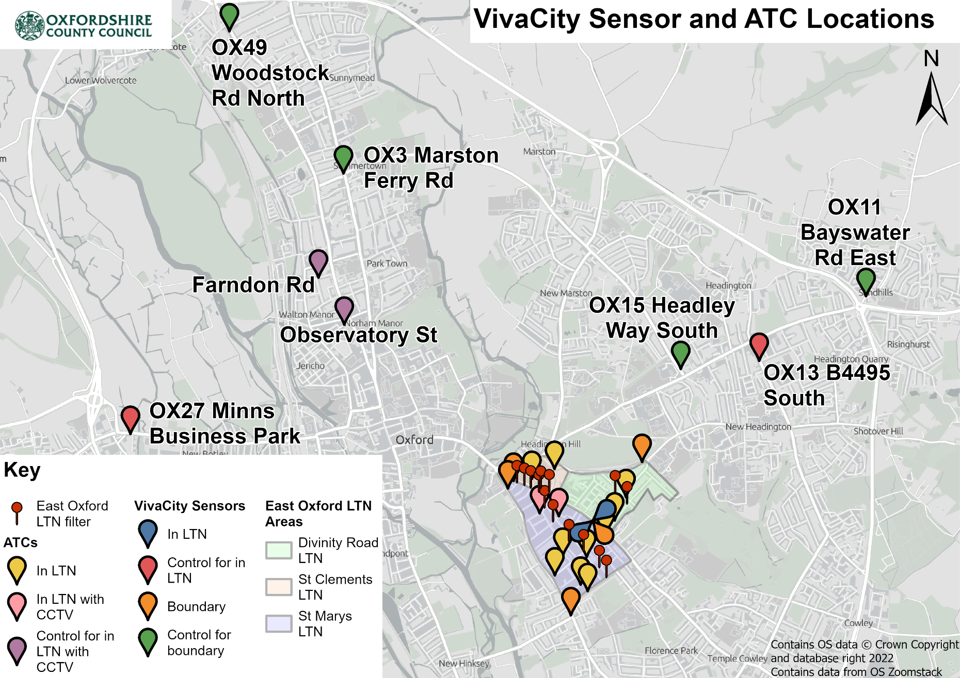

## Confounding Factors

1. In analysing the impact of the LTNs, it is worth noting a few confounding factors which will affect the data gathered. These include:

* Significant levels of vandalism and non-compliance with LTN restrictions, causing areas which should be closed to through-traffic to be open for some periods of time.
* The lack of availability of a full year of baseline data prior to the implementation of the LTNs owing to instability of travel patterns after COVID-19. The Quickways cycling routes (as well as other roadworks) were implemented during the evaluation period, meaning that roadworks and/or changes in infrastructure not directly related to the LTN occurred at the same time as the LTNs. Both roadworks and changes in the infrastructure available at any one time are likely to have had an impact on route choice as well as modal uptake along these routes.
* This snapshot evaluation uses techniques which are outlined in the methodology below with the aim of accounting for the instability in patterns of travel. However, it does not attempt to account for the other factors. A fuller analysis will be performed over the summer, which will aim to take these factors into account, as far as possible.

1. Some additional, more specific, confounding factors have also been raised in the relevant sections of the report below.

# Traffic Volume Analysis

## Methodology

1. The following metrics have been used to calculate the impact of the East Oxford LTN traffic filters on traffic volumes across different modes of transport. For more information see Annex B.

#### Simple Difference

1. This first metric of ‘difference’ is a simplified output to understand the effects of LTN filters on traffic volumes by comparing average daily counts by transport mode before (20th Nov 2021 - 19th May 2022), and after, the LTN filters were installed (20th May 2022 - 10th April 2023).
2. This method provides a simplified difference in traffic volume between two time periods, but does not account for the wider trends in traffic volume across Oxford, for example wider changes due to the impact of the cost-of-living crisis or seasonal effects, such as Christmas. To distinguish the impact on traffic volume attributed to the LTN filters from what is happening more generally across Oxford, a difference-in-differences (DiD) statistical technique was adopted to derive an impact estimate metric.

#### Impact estimate

1. The impact estimate metric uses a DiD statistical technique to estimate the causal effect of the LTN filters by comparing changes in outcomes between the East Oxford LTN areas and a control area before and after the LTNs were implemented. The change in outcomes between the boundary roads associated with the East Oxford LTNs and a set of boundary control roads were then compared. The key idea behind DiD is to compare the difference in outcomes between the in-LTN area and the control before and after the LTN implementation, over time. This approach helps account for general trends that might affect traffic flows, such as fluctuations in travelling to work owing to changing habits over time from COVID-19 and associated home working, and global factors such as the cost of fuel.

#### Adjusted impact estimate:

1. The DiD technique is most effective when the two locations being compared are very similar and assumes that general trends (e.g. effects of seasonality and cost of living) will impact the two areas in the same way. Two disparate locations are never identical, however. To mitigate this potential bias in the findings, the DiD technique was extended to incorporate data from the last ‘typical’ year (pre-COVID-19) to derive an adjusted impact estimate metric – also known as the difference-in-difference-in-differences statistical technique (DiDiD). DiDiD has the benefit of helping to mitigate the impact of any differences between the control and intervention areas, such as variations in the way in which wider trends might have an unequal impact on different locations.
2. When interpreting the results of the **impact estimate** and **adjusted impact estimate**, it was also important to consider some of the assumptions and limitations inherent in the DiD and DiDiD statistical techniques:
   * For DiD there is an assumption that where there are external forces (such as cost of fuel, change in daily work patterns that affect flows following COVID-19), these forces affect both the in-LTN area/boundary roads and the control area/control boundary roads equally.
   * The LTN traffic filters are the only area-specific aspect that changed over time in LTN area/boundary roads and there is not anything else influencing the outcome variable (daily average traffic volume) that did not similarly impact the control areas.
   * The LTN area/boundary roads and the control area/control boundary roads are similar except for the LTN filters.
3. In this snapshot report the median was used as the main measure for ‘average’ daily counts. The mean is known to be more sensitive to outliers and might not be representative of typical daily traffic volume. The median represents the middle value (daily count) of the distribution, making it well suited to minimising the effects of outliers/anomalies in the data (skewed to extreme value counts). For instance, where there were factors other than the LTN filters affecting daily traffic volume: such as roadworks, local and national events, as well as unforeseen power outages on street architecture on which sensors are located. In the final report, the aim is to identify this type of disruptive influence on traffic volume and cross-reference with anomalies in the data and adopt the appropriate processing technique.
4. In the consideration of the above assumptions and limitations of the DiD and DiDiD techniques, the method was refined where possible to mitigate the potential skewing effects on the results. Regarding selection bias, the roads chosen for control purposes were constrained by sensor availability and data completeness over time. However, the roads that were selected (as indicated below) were chosen based on the following criteria:

* Data availability
* Comparability in terms of flow context (e.g., similar levels of traffic and road classification type)
* Reasonable distance from the LTNs (i.e., minimising the likely impact of the intervention on the control sites)
* Choice of locations within Oxford city to minimise differences in overall patterns of travel due to aspects such as the seasonal large student population and tourist movements
* Avoidance of known long-term disruption on the control route during the periods of interest (e.g. major roadworks or road closures).

## VivaCity Sensor Locations

1. The sensors, located on the **boundary roads** can be seen on Figure 2 and are listed below:

* OX38 Iffley Road north
* OX20 Iffley Road east
* OX39 Cowley Road north
* OX44 Cowley Road east
* OX4 Morrell Avenue

1. **Control road** sensors, used to calculate the impact estimate and adjusted impact estimate for **boundary roads** can be seen on figure 1 and are listed below:

* OX11 Bayswater Road east
* OX15 Headley Way south
* OX3 Marston Ferry Road
* OX49 Woodstock Road north

1. Only two VivaCity sensor count lines were available to monitor the **in LTN area**. They can be seen on Figure 2 and are listed below:

* OX44 Leopold Street west
* OX44 Divinity Road north

1. **Control road** VivaCity sensors for the **in LTN** area can be seen on Figure 1 and have the following locations:

* OX27 Minns Business Park
* OX13 B4494 south

1. As two locations are not sufficient to understand traffic flow patterns within the LTN area, we also analysed ATC data, located as shown on Figure 1.

Figure 2 Location of VivaCity boundary road sensors and filters in East Oxford LTNs

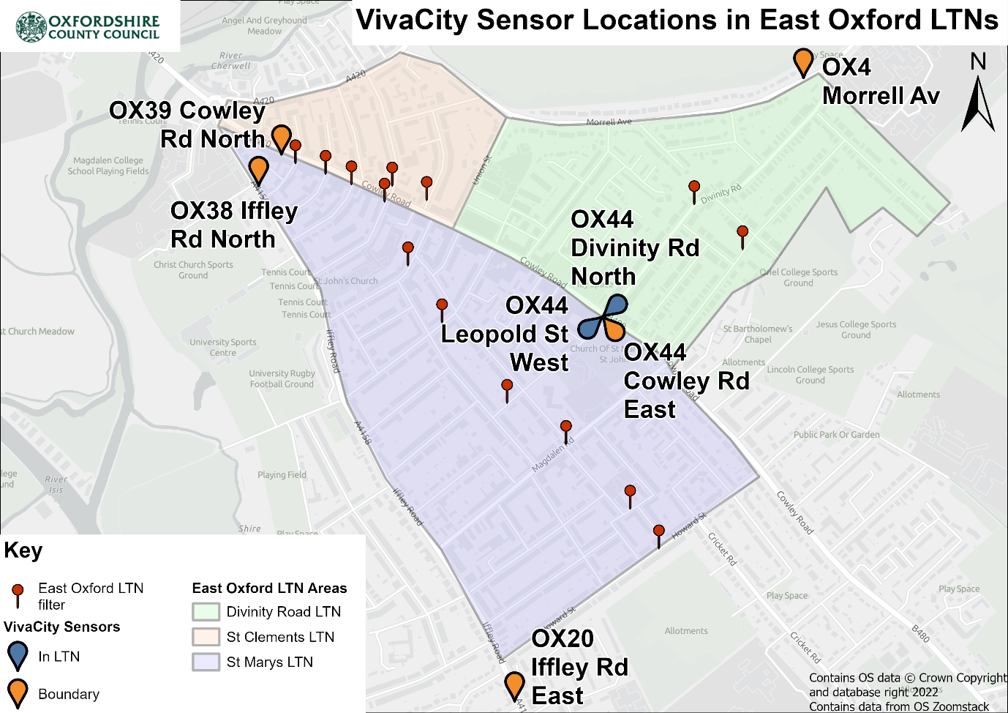

## Traffic Volume Analysis – LTN Boundary Roads

1. The key metrics (difference, impact estimate and adjusted impacted estimate) are calculated for data collected from the boundary road sensors and are summarised in this section.
2. For each boundary road, the daily (over a 24 hours) median count is calculated for the pre-implementation period (20th Nov 2021 - 19th May 2022) and the post-implementation period (20th May 2022 - 10th April 2023). The daily median counts for the two periods can be seen in the columns ‘Before’ and ‘After’ of Tables 2, 3 and 4. Additionally, percentage differences, impact estimates and adjusted impact estimates are shown (the latter where sensors had been in place long enough to provide 2019 data), aiming to highlight the effect of the LTN alone, without other factors that may have affected traffic volumes in Oxford. Results from all calculations are given for pedestrians, cyclists and cars.
3. A colour coding of ≥ +25% and ≤ -25% is used within the following tables to highlight sensors which saw larger differences, impact estimates and adjusted impact estimates. It should be noted that this kind of sensor has a published accuracy level of +/-3%, so a change in simple difference of less than this amount should be discounted as within the margin of error.

Table 1: Pedestrian VivaCity analysis of boundary roads

|  |  |  |  |  |  |
| --- | --- | --- | --- | --- | --- |
| **Road** | **Before** | **After** | **Difference** | **Impact estimate** | **Adjusted impact estimate** |
| Iffley Road north | 1219 | 840 | -31% | -42% | -24% |
| Iffley Road east | 477 | 523 | +10% | -1% | -34% |
| Cowley Road north | 5,999 | 5,589 | -7% | -17% | -29% |
| Cowley Road east | 6,606 | 6,024 | -9% | -19% | * |
| Morrell Avenue | 350 | 515 | +47% | +37% | * |

1. As seen in Table 2, there is a decrease in the number of pedestrians on most boundary roads, excepting a large increase (+47%) in pedestrians on Morrell Avenue. It should be noted that parking spaces were removed along Morrell Avenue in August 2022. The removal of local parking may have contributed to people having to walk from further afield to reach locations on this road, which would increase pedestrian counts accordingly due to people walking past a sensor who would not have done when the parking spaces were located adjacent to their destinations.

Table 2: Cycle VivaCity analysis of boundary roads

|  |  |  |  |  |  |
| --- | --- | --- | --- | --- | --- |
| **Road** | **Before** | **After** | **Difference** | **Impact estimate** | **Adjusted impact estimate** |
| Iffley Road north | 2,609 | 2,635 | +1% | +5% | +17% |
| Iffley Road east | 690 | 756 | +10% | +14% | +16% |
| Cowley Road north | 2,110 | 2,795 | +32% | +37% | +31% |
| Cowley Road east | 2,349 | 2,721 | +16% | +20% | * |
| Morrell Avenue | 635 | 853 | +34% | +39% | * |

1. Overall, as shown in Table 3, an increase in cycling volumes is observed on all boundary roads, with Cowley Road reporting bigger increases (+32% and +16%), compared to Iffley Road (+1% and +10%). Similarly to pedestrians, a pronounced increase in cycling volume is also seen on Morrell Avenue. Cycle lanes have been installed on Morrell Avenue and Iffley Road during the evaluation period, which may also influence cycling levels. It is worth noting that the way in which the cycle infrastructure is provided in each location differs. Morrell Avenue offers a more segregated environment than other boundary routes, which may influence user route choice. However, more analysis over a longer time period is needed to draw any firm conclusions on causality.

Table 3: Car VivaCity analysis of boundary roads

|  |  |  |  |  |  |
| --- | --- | --- | --- | --- | --- |
|  | **Before** | **After** | **Difference** | **Impact estimate** | **Adjusted impact estimate** |
| Iffley Road north | 7,764 | 9,691 | +25% | +33% | +13% |
| Iffley Road east | 16,015 | 13,234 | -17% | -9% | -9% |
| Cowley Road north | 5,361 | 8,414 | +57% | +65% | +26% |
| Cowley Road east | 10,561 | 8,509 | -19% | -11% | * |
| Morrell Avenue | 3,139 | 3,384 | +8% | +16% | * |

*Adjusted impact estimate was not calculated due to lack of data for 2019 (the year that was used as the last typical year pre-Covid).

1. On boundary roads, an increase in car volumes is observed on most monitored locations. Interestingly, there is a distinct difference in pre-existing volumes on Iffley Road and Cowley Road between the more northern and eastern locations – lower volumes near the city centre and higher at the outer sensors. These same sets of sensors also generally see an increase in traffic post LTN implementation, where the volume was lower, and a decrease in traffic where the volume was higher. Further investigation will need to be made to understand what is causing these differences in volume along the same road pre-LTN, looking at directional flows and peak patterns, and also comparing the data with other sources. However, it may be that prior to LTNs going in place, a large proportion of traffic would have diverted off these two roads between the sensor locations; now that movements are constrained, it is no longer possible to divert and so a flattening (consistent level of traffic) of the overall volume of traffic along each road can be seen.
2. The reduction in traffic at the outer sensors could point to people re-routing and/or choosing alternative transport to gain access to the city. However, once a driver reaches the inner sensor locations, they have little alternative than to continue on that road, so what would have been dispersed previously is all contained to the radial routes. The reduction in volume between Iffley Road East and Iffley Road North can be explained by some diversion along Donnington Bridge Road, whereas Cowley Road has no side road options to divert along.

## Traffic Volume Analysis – In LTN Roads

1. Only two VivaCity count lines were available to monitor traffic modes in the in-LTN areas. For both, data from 2019 requires validation. Therefore, the calculation of adjusted impact estimate was not carried out. Since there are only two in-LTN VivaCity locations, detailed analysis of ATC counters has also been undertaken (see the ATC traffic volume analysis section of this report). The available VivaCity sensor data for daily (24 hours) median counts is presented below:

Table 4: Pedestrian VivaCity analysis of in LTN roads

|  |  |  |  |  |  |
| --- | --- | --- | --- | --- | --- |
| **Road** | **Before** | **After** | **Difference** | **Impact estimate** | **Adjusted impact estimate** |
| Divinity Road north | 2,641 | 2,457 | -7% | -8% | * |
| Leopold Street west | 1,409 | 1,337 | -5% | -6% | * |

Table 5: Cycle VivaCity analysis of in LTN roads

|  |  |  |  |  |  |
| --- | --- | --- | --- | --- | --- |
| **Road** | **Before** | **After** | **Difference** | **Impact estimate** | **Adjusted impact estimate** |
| Divinity Road north | 454 | 559 | +26% | +3% | * |
| Leopold Street west | 220 | 187 | -15% | -38% | * |

Table 6: Car VivaCity analysis of in LTN roads

|  |  |  |  |  |  |
| --- | --- | --- | --- | --- | --- |
| **Road** | **Before** | **After** | **Difference** | **Impact estimate** | **Adjusted impact estimate** |
| Divinity Road north | 3,888 | 677 | -83% | -84% | * |
| Leopold Street west | 1,289 | 958 | -26% | -27% | * |

1. The available data shows that car volumes have decreased at the two LTN locations. The large decrease in volume on Divinity Road is because it is now a no-through road, which would previously have been used to cut between Cowley Road and Morrell Avenue/Warneford Lane, providing access to locations such as Oxford’s hospitals and Headington. However, there is also a substantial decrease in traffic volumes on Leopold Street, which was previously a less obvious through-route between Cowley and Iffley Roads.
2. Pedestrian flows have decreased slightly (an average of 7%).
3. There are more noticeable and mixed changes in cycling volumes – an increase in difference of 26% on Divinity Road and a decrease in difference of 15%, on Leopold Street. However, when compared with the control, Divinity Road shows only a small % increase in pedestrian flows with an impact estimate 3%. In contrast, the impact estimate on Leopold Street shows that there was significant decrease in Pedestrian flows – 38%. The greater reductions in car use on Divinity Road and the creation of the ‘Quickway’ on this road may have made for a more attractive cycling route than some of the other in-LTN roads with higher relative traffic levels.
4. As noted above, however, firm conclusions cannot be drawn based only on two locations. The following section outlines the results from the in-LTN ATC surveys, which help to complete the picture to some degree.

## ATC Sensor Locations and Results

1. The majority of sensors used in the monitoring and evaluation for the LTNs were located on the boundary roads, owing to constraints such as suitable street architecture necessary to facilitate and power the VivaCity sensors. Consequently, the coverage for in-LTN area was limited to two VivaCity count lines: Divinity Road and Leopold Street. To overcome this coverage issue, additional ATC and CCTV surveys were conducted twice consecutively, one year apart (2021 and 2022) over 12 locations (as seen in Figure 3). The locations were identified as those likely to provide a clear demonstration of the traffic impact within the LTNs. This included roads which may be impacted by the placement of the restrictions, as well as roads where LTN restrictions had been applied. The timing and duration of these surveys can be seen in Table 8-10 below. It is worth noting that without the use of historic data from pre-COVID and/or the use of control sites, the simple difference between the counts over the two years cannot be attributed to the LTNs alone. Traffic patterns were still in flux in 2021, following the pandemic, and the cost-of-living crisis will also have influenced travel choices during the interim period. In all cases therefore, a simple before and after comparison can only be indicative.
2. In addition to these 12 locations, there were two control locations (as shown in Figure 3) surveyed independently of those in Table 8 and which included CCTV pedestrian and cycle counts. The surveys in these two locations were carried out as per the timings shown in Tables 9 and 10.

1. All periods covered at least a full continuous week, although the exact days monitored were inconsistent, with setup and removal on different days of the week and issues with the ATC sensors, including obstruction and damage.

Table 7: 10 in LTN ATC surveys

|  |  |  |  |  |
| --- | --- | --- | --- | --- |
| **Road** | **2021** | | **2022** | |
| **Start** | **Finish** | **Start** | **Finish** |
| Minster Rd | 07/11/2021 | 23/11/2021 | 03/11/2022 | 21/11/2022 |
| Southfield Rd | 19/11/2021 | 30/11/2021 | 03/11/2022 | 21/11/2022 |
| Cross St | 07/11/2021 | 23/11/2021 | 03/11/2022 | 21/11/2022 |
| Jeune St | 07/11/2021 | 23/11/2021 | 03/11/2022 | 12/11/2022 |
| Stanley Rd | 07/11/2021 | 23/11/2021 | 03/11/2022 | 21/11/2022 |
| Magdalen Rd (Iffley Rd) | 07/11/2021 | 23/11/2021 | 03/11/2022 | 21/11/2022 |
| Magdalen Rd (Cowley Rd) | 07/11/2021 | 23/11/2021 | 03/11/2022 | 21/11/2022 |
| Hertford St | 12/11/2021 | 23/11/2021 | 03/11/2022 | 21/11/2022 |
| Charles St | 19/11/2021 | 30/11/2021 | 03/11/2022 | 21/11/2022 |
| Howard St | 07/11/2021 | 23/11/2021 | 03/11/2022 | 21/11/2022 |

Table 8: Two additional ATC surveys with control

|  |  |  |  |  |  |
| --- | --- | --- | --- | --- | --- |
| **Road** | **Type** | **2021** | | **2022** | |
| **Start** | **Finish** | **Start** | **Finish** |
| James St | LTN | 11/10/2021 | 24/10/2021 | 11/10/2022 | 24/10/2022 |
| Bullingdon Rd | LTN | 11/10/2021 | 24/10/2021 | 11/10/2022 | 24/10/2022 |
| Farndon Rd | Control | 11/10/2021 | 24/10/2021 | 11/11/2022 | 20/11/2022 |
| Observatory St | Control | 11/10/2021 | 24/10/2021 | 11/10/2022 | 24/10/2022 |

Table 9: Two additional CCTV pedestrian and cycle counts with control

|  |  |  |  |  |  |
| --- | --- | --- | --- | --- | --- |
| **Road** | **Type** | **2021** | | **2022** | |
| **Start** | **Finish** | **Start** | **Finish** |
| James St | LTN | 11/10/2021 | 24/10/2021 | 17/10/2022 | 30/10/2022 |
| Bullingdon Rd | LTN | 11/10/2021 | 24/10/2021 | 17/10/2022 | 30/10/2022 |
| Farndon Rd | Control | 11/10/2021 | 24/10/2021 | 17/10/2022 | 30/10/2022 |
| Observatory St | Control | 11/10/2021 | 24/10/2021 | 17/10/2022 | 30/10/2022 |

Figure 3 Location of ATC surveys and filters in East Oxford LTNs

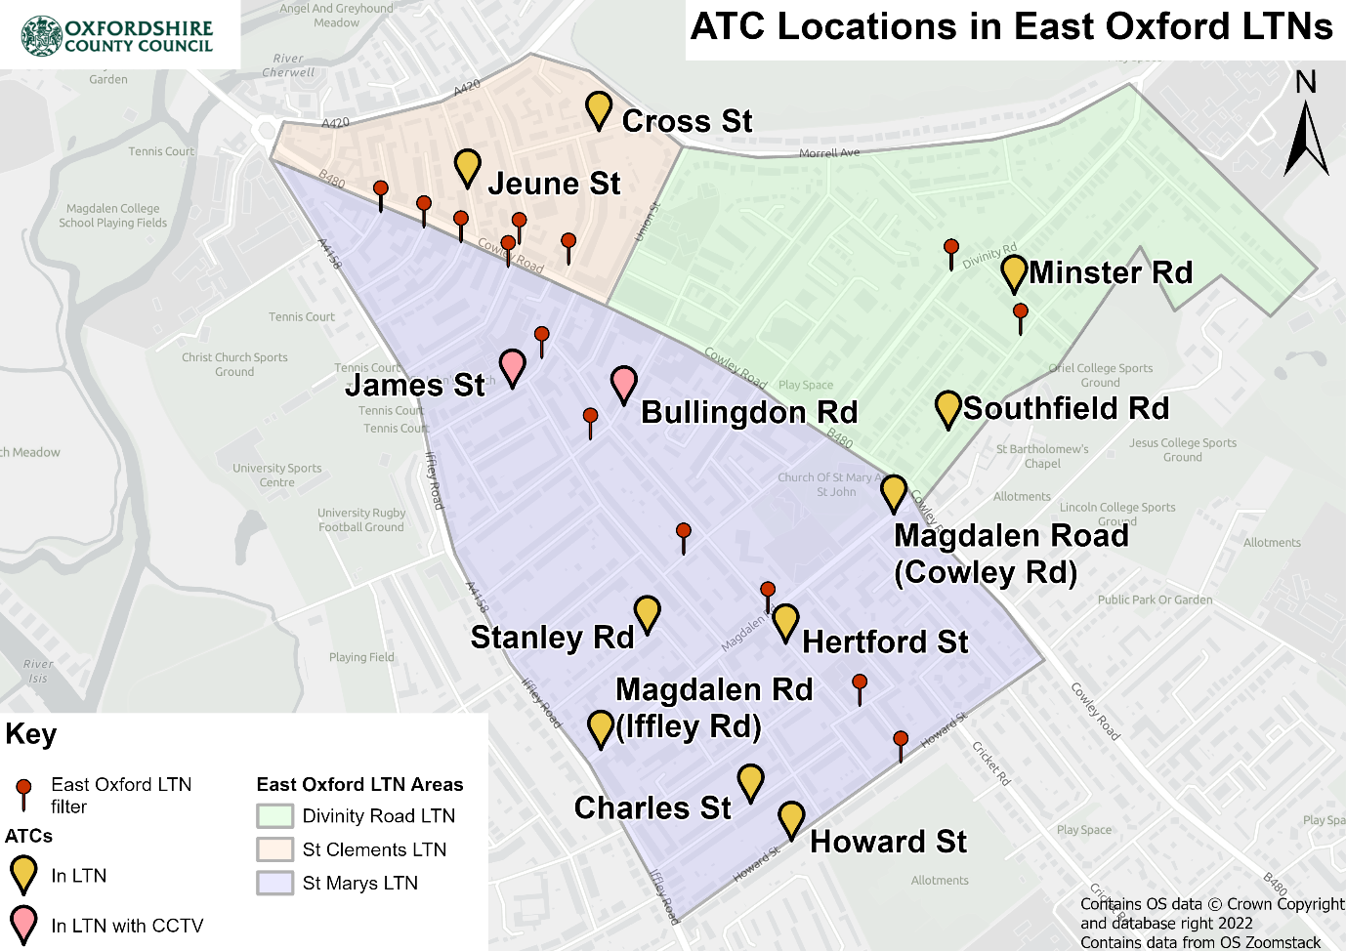

## ATC Data Collection Method

1. The data is received as counts broken down by sensor, travel direction and mode of transport at 15-minute intervals during the survey period. For this snapshot analysis, both travel directions are summed and aggregated daily for the main modes of transport available. Days where only partial data was collected were omitted from the analysis. Roads affected by partial data include Hertford St (in 2021) and Jeune St (in 2022).
2. The 10 ATCs categorise vehicle type as follows:

* Cycle
* Motorcycle
* Car
* LGV
* Bus and
* several categories of HGV.

1. It was decided to omit the cycle counts from the analysis as other studies indicated that cycles are not always picked up by the counters. This is due to the low speed and weight of bicycles. There is inconsistency in how many cycles are recorded, or not, from site to site, making any comparison unreliable. This issue does also occur when surveying motorcycles. However, the problem is less of an issue due to the greater weight of the vehicles. Therefore, motorcycles have been included in the analysis, but 3 sensors which contained extreme outliers in either the before or during period have been removed from the data set. All categories of HGV have been grouped together, including the occasional bus recorded, as there were no scheduled bus routes using these roads during the survey periods.
2. The two additional in-LTN area ATCs and control sites recorded vehicles differently, with no cycles or motorcycles monitored, and with cars and LGVs grouped together. When grouping vehicles together, this gives two vehicle categories of cars/LGVs and HGVs. The CCTV cameras provide pedestrian and cycle counts at 15-minute intervals between 7am and 7pm in the survey periods.
3. The average daily count is calculated differently for the ATC and CCTV surveys compared to the VivaCity sensors. This is because the ATC and CCTV survey periods comprise two short, but consistent, periods rather than long, continuous periods as monitored by the VivaCity sensors. The effects of seasonality on the data are minimised by the before and during periods being at similar dates in 2021 and 2022, during October and November. However, there is likely significant variation by day of the week, for example with commercial vehicles, commuting, and the school run, which with small samples, may skew an overall mean.
4. To reduce the potential distortion caused by full weeks not being evenly covered, a day-of-week daily average approach is taken. First, the mean daily count by each individual day of the week is calculated. Then, the mean of the seven days is calculated to determine the overall daily average. The ‘Average’ row at the bottom of Tables 11 to 15 shows the mean of all ATC locations for the year stated, and used the daily average from at each ATC survey location.
5. The difference and impact estimate follow the previous Traffic Volume Analysis Methodology, shown in paragraphs 12 to 14 above.

## ATC Traffic Volume Analysis

1. The key metrics, as described in the methodology sections above, derived from the 10 ATCs are shown in Table 11.
2. A colour coding of ≥ +25% and ≤ -25% is used within to highlight sensors which saw larger differences and impact estimates.

Table 10: In LTN 10 ATC average vehicle count differences from 2021 to 2022

|  |  |  |  |  |  |  |  |  |  |  |  |  |
| --- | --- | --- | --- | --- | --- | --- | --- | --- | --- | --- | --- | --- |
|  | **Car** | **Car** | **Car** | **Motorcycle** | **Motorcycle** | **Motorcycle** | **LGV** | **LGV** | **LGV** | **HGV** | **HGV** | **HGV** |
| **Road** | **2021** | **2022** | **Diff.** | **2021** | **2022** | **Diff.** | **2021** | **2022** | **Diff.** | **2021** | **2022** | **Diff.** |
| Jeune St | 341 | 493 | +44% | 48 | 63 | +32% | 25 | 90 | +265% | 6 | 14 | +139% |
| Cross St | 1,887 | 750 | -60% | 63 | 89 | +42% | 223 | 55 | -75% | 44 | 15 | -66% |
| Minster Rd | 174 | 174 | 0% | 13 | 16 | +24% | 32 | 34 | +7% | 8 | 11 | +29% |
| Southfield Rd | 1,505 | 267 | -82% | 89 | 136 | +54% | 95 | 44 | -53% | 32 | 22 | -32% |
| Stanley Rd | 240 | 214 | -11% | 10 | 13 | +32% | 41 | 33 | -19% | 7 | 8 | +19% |
| Magdalen Rd (Iffley Rd) | 2,063 | 487 | -76% | * | * | * | 311 | 199 | -36% | 61 | 50 | -18% |
| Magdalen Road (Cowley Rd) | 2,326 | 1,106 | -52% | 279 | 351 | +26% | 427 | 75 | -83% | 120 | 48 | -60% |
| Hertford St | 376 | 229 | -39% | * | * | * | 34 | 33 | -2% | 6 | 12 | +102% |
| Charles St | 619 | 506 | -18% | 21 | 30 | +42% | 72 | 78 | +8% | 15 | 18 | +24% |
| Howard St | 2,189 | 344 | -84% | * | * | * | 205 | 20 | -90% | 56 | 37 | -35% |
| **Average** | **1,172** | **457** | **-61%** | **52** | **70** | **+34%** | **146** | **66** | **-55%** | **35** | **23** | **-34%** |

*Some motorcycle counts excluded with one of the surveys showing strong anomalous counts in these locations

1. The daily average car count saw a general decrease across most ATCs with a total average decrease in difference of 61%. The five ATCs recording the highest car flows in 2021, both ends of Magdalen Road, Howard Street, Cross Street, and Southfield Road, all saw significant decreases in difference of at least 50%. The ATCs with lower before counts mostly experienced smaller decreases in flows, although Minster Road saw no change and Jeune Street had an increase in difference of 44%.
2. Jeune Street is one-way from Cowley Road to St Clement’s and this road does not currently include a traffic filter. There have also been reports, anecdotally, that traffic has been using this route in the wrong direction, which the ATC won’t have recorded – as such, the real (bi-directional) increase may be higher than that recorded here.
3. The daily average motorcycle counts generally showed an increase in difference between 24% to 54% across all locations, and an average increase in difference of 34%. The traffic restrictions do not physically prevent motorcyclists travelling through. Therefore, it is likely that the combination of the reduced levels of car traffic within the LTNs, alongside the general increases in traffic on the boundary roads nearing The Plain would make these routes more attractive to motorcyclists.
4. LGVs follow a similar trend to cars, with an overall decrease in difference of 55%. The five ATCs recording highest flows in 2021 saw significant decreases of between 36% to 90% difference. Jeune Street saw a large increase of 265% difference from being the ATC site with the lowest flows to the second highest. The other four ATC sites measured small decreases in difference between of 19% to 8%.
5. HGV flows also followed similar trends to car and LGV flows with the five ATCs with highest 2021 counts seeing significant decreases of between 18% to 66% difference, whilst the findings also showed an average overall decrease of 34% difference. The other five ATCs all saw increases in HGVs from 19% difference to the highest of 139% difference on Jeune Street, although the volume of HGVs is much lower than other vehicles.

## Additional ATC and CCTV Difference and Impact

|  |  |  |  |  |  |  |  |  |
| --- | --- | --- | --- | --- | --- | --- | --- | --- |
|  | **Pedestrian** | **Pedestrian** | **Pedestrian** | **Pedestrian** | **Cycle** | **Cycle** | **Cycle** | **Cycle** |
| **Road** | **2021** | **2022** | **Diff.** | **Impact estimate** | **2021** | **2022** | **Diff.** | **Impact estimate** |
| James St | 745 | 686 | -8% | -3% | 316 | 341 | +8% | +10% |
| Bullingdon Rd | 1,038 | 1,706 | +64% | +70% | 384 | 523 | +36% | +39% |
| **Average** | **892** | **1,196** | **+34%** | **+39%** | **350** | **432** | **+23%** | **+26%** |

Table 11: In LTN additional CCTV count differences and impact from 2021 to 2022

Table 12: In LTN additional ATC count differences and impact from 2021 to 2022

|  |  |  |  |  |  |  |  |  |
| --- | --- | --- | --- | --- | --- | --- | --- | --- |
|  | **Car/LGV** | **Car/LGV** | **Car/LGV** | **Car/LGV** | **HGV** | **HGV** | **HGV** | **HGV** |
| **Road** | **2021** | **2022** | **Diff.** | **Impact estimate** | **2021** | **2022** | **Diff.** | **Impact estimate** |
| James St | 1,519 | 343 | -77% | -67% | 139 | 54 | -61% | -37% |
| Bullingdon Rd | 648 | 401 | -38% | -27% | 99 | 45 | -55% | -31% |
| **Average** | **1,083** | **372** | **-66%** | **-55%** | **119** | **49** | **-58%** | **-34%** |

Table 13: Control for in LTN additional CCTV count differences and impact from 2021 to 2022 for impact

|  |  |  |  |  |  |  |
| --- | --- | --- | --- | --- | --- | --- |
|  | **Pedestrian** | **Pedestrian** | **Pedestrian** | **Cycle** | **Cycle** | **Cycle** |
| **Road** | **2021** | **2022** | **Diff.** | **2021** | **2022** | **Diff.** |
| Farndon Rd | 216 | 196 | -9% | 80 | 69 | -14% |
| Observatory St | 952 | 910 | -4% | 230 | 234 | +2% |
| **Average** | **584** | **553** | **-5%** | **155** | **152** | **-2%** |

Table 14: Control for in LTN additional ATC count differences and impact from 2021 to 2022

|  |  |  |  |  |  |  |
| --- | --- | --- | --- | --- | --- | --- |
|  | **Car/LGV** | | | **HGV** | | |
| **Road** | **2021** | **2022** | **Diff.** | **2021** | **2022** | **Diff.** |
| Farndon Rd | 456 | 322 | -30% | 75 | 53 | -30% |
| Observatory St | 929 | 917 | -1% | 157 | 123 | -21% |
| **Average** | **693** | **619** | **-11%** | **116** | **88** | **-24%** |

1. The daily average pedestrian count varied between the two locations of James Street and Bullingdon Road. James Street experienced a decrease of 8% difference (Table 12) and a smaller negative impact estimate of 3% (Table 12) when comparing to the control areas (which had a 5% decrease in difference as seen in Table 14). Conversely, Bullingdon Road saw a large increase of 64% and an impact estimate of 70% increase in pedestrians (Table 12). These roads run parallel to each other with several joining roads and the James Street camera is closer to the Iffley Road side and Bullingdon Road to the Cowley Road side.
2. The daily average cycle volumes increased for both James Street and Bullingdon Road, but as with pedestrians there was a larger difference on Bullingdon Road. As seen in Table 12, there was a 36% increase in difference compared to an 8% increase on James Street. The impact estimate also shows a similar finding to the difference metric; an impact estimate of 39% increase on Bullingdon Road compared to a 10% increase on James Street (after adjusting for the control decrease of 2%[1] as seen in Table 14).
3. The decrease in cars and LGVs followed a similar overall trend to the data recorded at the 10 ATCs. Across both James Street and Bullingdon Road (as seen in Table 13) there was an average decrease in difference of 66%, as well as an impact estimate decrease of 55% when compared to the control area locations (which experienced a smaller decrease of 11% as seen in Table 15). However, when looking at the roads individually, there was a significantly higher impact estimate decrease on James Street ( -67%) when compared to the 27% decrease on Bullingdon Road (as seen in Table 13).
4. HGVs also followed a decreasing trend, although reductions were more similar than for cars and LGVs across the two roads. James Street and Bullingdon Road HGV flows decreased by 61% and 55% respectively, with impact estimates of -37% and -31% when taking into account the control decrease of 24%.
5. The ATC data supports the picture derived from the VivaCity in-LTN data, in that the effects of the LTNs on mode share are not the same across all locations. Overall, there is a clear picture of reduced vehicular traffic (excluding motorcycles) within the LTNs, and some cycling increases, but a less clear picture for the changes in pedestrian flows.

# Air Quality

## Air Quality Sampling

1. Evaluation of air quality within the East Oxford LTNs was undertaken using the existing air quality monitoring network managed by Oxford City Council, the air quality authority for Oxford. This network was supplemented with 16 additional sensors in 2021 to provide greater coverage in the East Oxford and Cowley LTN areas. We are grateful for the City Council’s collaboration in this work.
2. Diffusive samplers (as described in paragraphs 7.197 – 7.234 of the [Technical Guidance LAQM.TG22](https://laqm.defra.gov.uk/aq_reporting/uk-regions-exc-london-technical-guidance/)) are widely used for indicative monitoring of ambient nitrogen dioxide (NO2) in the context of regular Review and Assessment of local air quality levels by Local Authorities. This monitoring technique is particularly useful to give an indication of longer-term average NO2 concentrations and for highlighting areas of high NO2 (particularly when assessing NO2 sources such as traffic emissions, which do not change much from day to day). Diffusion tubes take samples over, approximately a one-month period, hence a monthly mean value of NO2 can be derived.
3. The diffusion tubes used for the purpose of assessing the impacts of LTNs were supplied and analysed by accredited laboratories. In 2021 by South Yorkshire Air Quality Samplers and in 2022 by SOCOTEC, both using the 50% TEA in Acetone method. All accredited laboratories processing diffusion tubes are subject to quality assurance testing as part of their accreditation. This involves an independent comparison to other laboratories, under the independent AIR-PT scheme. The [results of these inter-comparisons](https://laqm.defra.gov.uk/wp-content/uploads/2022/07/LAQM-NO2-Performance-data_Up-to-June-2022_V2.1.pdf) are publicly available.
4. All the diffusion tube results that are used in this LTN analysis have been fully corrected and adjusted according to the specific DEFRA guidelines that local authorities are required to follow and which are available [here](https://laqm.defra.gov.uk/wp-content/uploads/2022/08/LAQM-TG22-August-22-v1.0.pdf).

## Air Quality Analysis

1. The location of the sampling tubes used in this analysis are shown in the map below. (Note - DT72 can be found behind DT81 on the map)

Figure 4 Location of air quality sensors used in the analysis

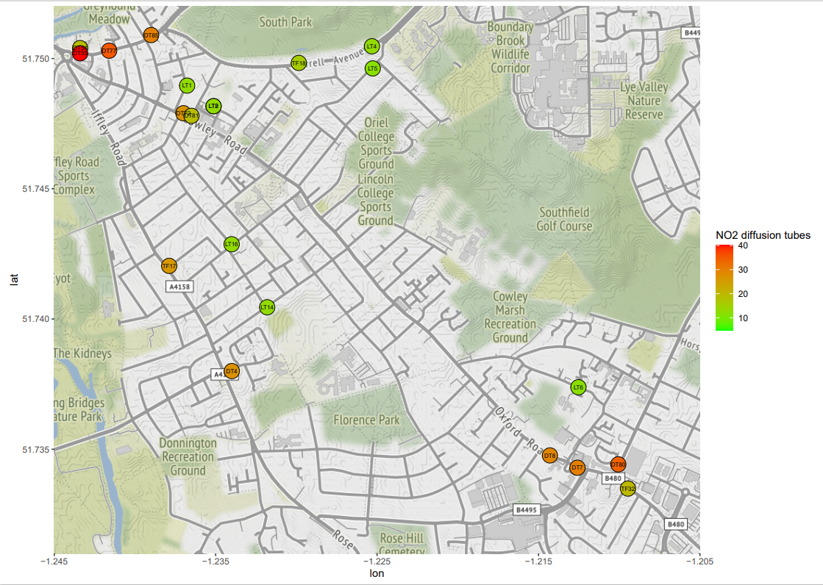

1. As outlined below, there are multiple factors which can influence NO2 levels. To control for these factors, it is important to understand how air quality has changed more widely across the city. An assessment has therefore been conducted to analyse overall 2022 air quality levels across all the City of Oxford monitoring sites that would not show differences in air quality data that would be due to the introduction of the LTNs or ZEZ. The 2022 data has been compared to the 2021 data to identify what the wider changes in NO2 levels have been in Oxford City. The results of this analysis indicate that overall, air quality levels have improved across the city by approximately 2 micro grammes per cubic metre (2 ug/m3). This reduction is not considered to be statistically significant, as it’s within the margin of error of the monitoring technique. It has therefore been decided not to include this correction as part of the analysis. The analysis is therefore based on a simple comparison between 2021 and 2022 data.
2. The following limitations to the air quality analysis should be noted:

* The data has been compared between the two full calendar years of 2021 and 2022, to allow for comparison of only fully ratified air quality datasets and so that exact LAQM procedures and DEFRA guidelines could be followed. However, the east Oxford LTNs have only been in place from May 2022 onwards.
* Fully ratified data for the automatic monitors that are used to calculate the bias adjustment factor that is used to correct the diffusion tube data is only available at the time of the analysis for up to Dec 2022. Unratified data cannot be used in comparison with ratified data, as ratification can change the figures significantly.
* There were weeks where LTNs were not in full operation because of episodes of vandalism to bollards, as outlined previously in this evaluation
* Air Quality measurements can also be heavily impacted by external factors such as the weather and short-term roadworks. Therefore, it is difficult to isolate the exact contribution of the LTNs to the air quality levels measured. This limitation needs to be acknowledged in this analysis.
* A local study conducted in [2020](https://www.oxford.gov.uk/downloads/download/1185/oxford_source_apportionment_study) identified that approximately 40% of Nitrogen Oxides (NOx)[2] in Oxford City are contributed by road transport, as such any changes in the measures provided by diffusion tubes may be caused by changes in other factors which generate NO2, such as domestic combustion (e.g. wood-burners) and other forms of transport.

1. Table 16 below compares the annual mean NO2 levels in ug/m3 for the sensor sites. A numerical difference is calculated between the data for 2022 and 2021 in ug/m3 and the associated percentage change is also given. Data from 2020 and 2019 are included as reference points, where available. In 2020 and 2021 when ‘NM’ is shown instead of a reading, this means ‘no measurements’ were available because this tube was not in place during that period. Where NM is provided in both 2020 and 2021, a comparison cannot therefore be made with earlier years and the data is only included to supplement the analysis.

Table 15 Air quality data from diffusion sampling tubes

Table of air quality data from the sampling tubes used in the analysis. Comparisons are made between 2021 and 2022 results in absolute and percentage change terms, in annual average nitrogen dioxide levels.

1. Of the 16 sensors with comparative 2021/22 data there are 11 which show either no change, an insignificant or significant decrease in NO2 levels and 5 which show an insignificant or significant increase in NO2. The term ‘significant’ refers to changes of more than 2 ug/m3 of NO2.
2. All sensors **inside the LTNs** show a decrease in NO2 with the greatest effects seen on LT5 189 Divinity Rd (-6 ug/m3 or -33%) and LT1 26 Prince Street (-4 ug/m3 or -24%). Note that DT81 Cowley Road/Union Street diffuser tube is a little way down Union Street away from Cowley Road; readings are the same in 2020 and 2022 at 19 ug/m3. The 2021 reading of 30 ug/m3 from this site cannot be used for comparison purposes with the 2022 result, as the measurement has been extremely influenced by external factors for most of 2021: the emissions from the construction works above the Tesco Express, including generators and associated HGV movements.
3. On the **boundary roads** the picture is more mixed. LT4 138-146 Morrell Av has shown a reduction (-3 ug/m3 or -19%). But on St Clements there is a significant and consistent increase in NO2 at two locations: DT77 St Clements 2 (+5 ug/m3 or +17%); DT55 St Clements (+4 ug/m3 or +10%). Whilst at DT72 Cowley Rd/James Street there is a significant increase in NO2 levels (+7 ug/m3 or +35%). The diffusion tube here is located directly on Cowley Road and has recorded the greatest percentage increase of all sensor locations but still below national and local limits and shows a reduction from the 2019 reading.
4. Of the NO2 levels recorded in 2022, one site is above the national limit of 40 ug/m3: DT55 St Clements increasing from 39 in 2021 to 43 in 2022. However it is significantly down on the 2019 result of 53 ug/m3. In addition, there are a further three sites above the local target of 30 ug/m3: DT77 St Clements 2 increasing from 30 ug/m3 in 2021 to 35 in 2022; DT80 Hollow Way Road decreasing from 35 ug/m3 in 2021 to 34 in 2022 and TF34 Oxford Road/Newmans Road with a reading in 2022 of 35 ug/m3.
5. **Overall** these AQ results mirror the findings of the vehicle counts analysis: there is an overall improvement in air quality inside the LTNs. On the Boundary Roads, Cowley Road and St Clements see a marked deterioration of air quality as measured by levels of NO2.
6. It should be noted that the LTNs are part of wider strategy for Oxfordshire County Council to manage traffic in Oxford. This includes the introduction of trial traffic filters, expected in 2024, which will introduce strategic traffic filters at six locations in Oxford. Two of the locations will be on St Clement’s and Hollow Way with the intention of improving air quality, amongst other benefits, on these two roads. The traffic filters will be subject to separate evaluation to assess whether the projected benefits are realised.

# Emergency Services Response Times

1. To understand the impact of the East Oxford LTNs on the emergency services, South Central Ambulance Service (SCAS) included the East Oxford LTN traffic filters as road closures in the Optima Predict event simulation platform. This models the impact on response time of introducing LTN filters against a baseline of the prevailing response times for the period selected. Note this includes the Cowley LTNs as business as usual (BAU).
2. The simulation reports the impact on mean response times using historical incident and response data from 01/05/2022 to 13/11/2022. The model assumes that ambulances will route or divert against known factors, such as the road closures associated with the LTNs and calculate the additional journey time using average road speed data from the period.
3. The effects of the traffic filters in all three East Oxford LTNs were simulated as a group. Analysis was conducted at local level, which is defined as between a half a mile and two-mile radius of the LTNs – in this instance a one-mile radius was used for the East Oxford LTN area simulation. The simulation reports on the impact on NHS England ambulance response categories described in table 17 below.

Table 16 Emergency response categories

|  |  |  |
| --- | --- | --- |
| **Category** | **Example injuries/illness** | **Response target** |
| Category 1: Life-threatening | Cardiac arrest  Severe allergic reaction | 7 minutes on average, and 90% of calls in 15 minutes |
| Category 2: Emergency | Stroke  Severe burns | 18 minutes on average, and 90% of calls in 40 minutes |
| Category 3: Urgent | Late stages of labour  Non-severe burns | 90% of calls in 120 minutes |

Source: NHS England, ‘[Ambulance response programme](https://www.england.nhs.uk/urgent-emergency-care/improving-ambulance-services/arp/)’

1. The simulation found that the impact on SCAS performance for East Oxford LTN at the local level is between 35 and 45 seconds across the urgent response categories (CAT1, CAT2 and CAT3). Table 18 below shows the difference in seconds between the baseline and the combined East Oxford LTN scenario by response category.

Table 17 Results of simulation on impact of East Oxford LTNs on local response times, by category

|  |  |  |  |
| --- | --- | --- | --- |
| **Scenario** | **CAT1** | **CAT2** | **CAT3** |
| East Oxford LTN | 45 secs | 45 secs | 35 secs |

1. To contextualise these figures, a 40 second delay in response time within CAT1, when factored up to the whole response area covered by the service for this NHS Trust area, would have an estimated cost impact of approximately £10 million to correct.
2. A second simulation was run to cover the Cowley LTN area, to model what the delay on this locale was of the East Oxford LTN filters being put in place. It therefore used the same period and again the analysis was conducted at a local level of a one-mile radius. Table 19 below shows the difference in seconds for response times within the Cowley area between the baseline and the East Oxford LTN scenario by response category.

Table 18 Results of simulation on impact to Cowley LTN area on response times, by category

|  |  |  |  |
| --- | --- | --- | --- |
| **Scenario** | **CAT1** | **CAT2** | **CAT3** |
| Cowley LTN area | 8 secs | 1 secs | 12 secs |

1. Table 20 provides the results of the previously modelled Cowley LTNs for reference.

Table 19 Results of simulation of Cowley LTNs on impact to the Cowley area on response times, by category[3]

|  |  |  |  |
| --- | --- | --- | --- |
| **Scenario** | **CAT1** | **CAT2** | **CAT3** |
| Cowley LTN | 3 secs | 6 secs | 0 secs |

1. The simulation found that impact on SCAS performance for the Cowley LTN area was lower than that of the East Oxford LTNs at the local level, across the urgent response categories (CAT1, CAT2 and CAT3). Note that this is modelling the difference in response times between just having the Cowley LTN filters in place versus the addition of having the East Oxford LTN filters. It does not compare to a baseline prior to the Cowley LTN implementation and as such is additional to the delay already experienced following the Cowley LTNs implementation, which was between 0 and 6 seconds across the three categories.
2. The effect of the East Oxford LTNs on both East Oxford and Cowley areas combined was then simulated using the same period with the area considered within two miles of the LTNs. The simulation found that the impact on SCAS performance for the combined East Oxford and Cowley areas was between 14 and 54 seconds across the urgent response categories (CAT1, CAT2 and CAT3). Table 21 below shows the difference in seconds between the baseline (including Cowley LTNs as BAU within the baseline) and the combined LTN scenario by response category.

Table 20 Results of simulation on the impact of East Oxford LTNs on Cowley and East Oxford areas combined, on response times by category

|  |  |  |  |
| --- | --- | --- | --- |
| **Scenario** | **CAT1** | **CAT2** | **CAT3** |
| Combined LTN areas | 14 secs | 17 secs | 54 secs |

1. The reason for the lower response time delay for the combined areas compared to only the East Oxford LTN area response times is the change in the modelling area from a one-mile to two-mile radius, which was necessary to capture both East Oxford and Cowley LTNs in the combined simulation. The fact that the response times provided are a mean average across this larger area causes the combined delay to be less than the worst affected area, but not as good as the least affected. It is therefore unsurprising that the delay is greater for the locations closer to the restrictions themselves and becomes smaller the larger the area encompassed. Therefore, to understand where the impact is most significant it is important to look at the smaller individual areas alone.
2. However, it is also of note to consider to what degree the delays at the local level are also impacting the mean response time across the entire area covered by the Ambulance Service. This was therefore also modelled and results are shown in Table 22 below.

Table 21 Results of simulation on the impact of East Oxford LTNs on the full area covered by the ambulance service for the Trust area on response times by category

|  |  |  |  |
| --- | --- | --- | --- |
| **Scenario** | **CAT1** | **CAT2** | **CAT3** |
| Combined LTNs | 4 secs | 26 secs | 72 secs |

1. At a Trust-wide level therefore, the impact of the LTNs is sufficient at the CAT1 level to have a cost implication of approximately £650K. It is worth noting that addressing this delay by spending this additional money would not correct the delay to the LTN areas themselves but would improve average response times across the whole Trust area. Therefore, even if these overall delays were rectified, the areas affected by the East Oxford LTNs would not be returned to pre-LTN response times.
2. However, changes are being promoted for both Cowley LTNs and East Oxford LTNs for certain streets within both areas to be enforced by ANPR cameras which is expected to help response times, in consultation with the emergency services. It should be noted that changes to East Oxford will only be implemented if the wider scheme is approved to continue after the trial period. Equally, the wider strategy (e.g., trial traffic filters and wider zero emission zone) is expected to reduce response times in the longer term. As noted above, these schemes will be subject to their own evaluations to assess whether the benefits are realised.

# Conclusions

1. As described above, this snapshot report provides a partial evaluation of the impacts of the East Oxford LTNs since their implementation on 20th May 2022. It is not a full evaluation and does not cover all impacts of the LTNs. Furthermore, more detailed analysis is also required within the elements included in this report. It should also be noted that during the evaluation period considered, there were significant levels of vandalism of bollards and non-compliance with traffic restrictions, which will have impacted significantly on the evaluation. As such, it should be considered indicative rather than definitive in nature.
2. However, generally, it can be concluded that there are indications of both positive and negative effects from the LTNs, and that these effects are not evenly distributed across the areas covered by this evaluation.
3. A complete evaluation, covering greater analytical detail and other aspects, including effects on overall journey times and speeds and bus journey times, will be undertaken over the summer period, to be published in October 2023.

# Annex A

## Types of Sensors Used

#### VivaCity object identification sensors

These sensors count and classify a variety of road users including cars, pedestrians and cyclists, using cameras and machine vision. No personal data is collected, and the raw images from the camera are not used. In this evaluation VivaCity count lines[4] have been analysed from sensors on Cowley Road, Iffley Road and Morrell Avenue, at two locations on each of the former two roads and one location in the latter, and two are located inside the LTNs (one in St Mary’s LTN and one in Divinity Road LTN).

Figure 5 Vivacity camera installed on lamp post

#### Automatic Traffic Counters (ATCs)

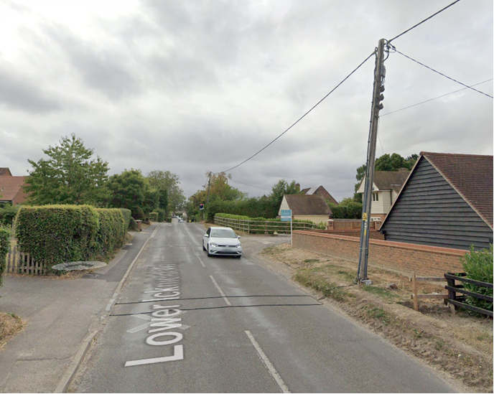These sensors are used to count vehicles inside the LTNs where there are limited VivaCity cameras available. ATCs use pneumatic tubing that is laid across a road to count air pulses from passing traffic. They can determine flow rate, mean speed, and type of vehicle. ATCs are unable to count pedestrians and cycle counts can only be used with caution.

Figure 6 An ATC installation

#### Closed Circuit TV (CCTV)

CCTV images are recorded for the duration of the survey and that CCTV footage is then manually analysed to count pedestrians and cycles. This method has been used to supplement the ATC count data to understand the impact on pedestrian and cycle counts.

# Annex B

## Calculations Used for Statistical Analysis

#### Difference

To calculate the difference in counts the average daily traffic counts for the pre-implementation period (20th November 2021 to 19th May 2022) was subtracted from the post-implementation period (starting 20th May 2022 to 10th April 2023). To derive the percentage difference, this difference was divided by the pre-implementation period average daily counts.

#### Difference in Difference (DiD)

The calculation for DiD (impact estimate) takes the difference in the average daily traffic volumes (by mode) for the roads inside the East Oxford LTN before and after the implementation of the traffic filters, and then subtracts the difference in the average daily traffic volume (by mode) for the control area roads before and after the implementation of the traffic filters. The resulting difference is the estimated effect of the LTN on the traffic volumes by mode of transport. The same method was also applied to the boundary roads and their control roads. For the control roads, the aggregated daily average across all the roads from each individual road’s daily median count was taken.

To account for the potential scaling effect on -/+ difference calculations (owing to differences in traffic volume sizes between control and intervention area roads), firstly the DiD (impact estimate) as a % increase/decrease in average daily traffic volumes were calculated. This % was then applied to the pre- implementation traffic count to derive the estimated average daily count (by mode), which was the estimated effect attributed to the traffic filters.

#### Difference in difference in difference (DiDiD)

To derive the adjusted impact estimate metric, 2019 data was incorporated by repeating the same procedure used to calculate the first ‘difference’ metric; average daily traffic volumes data from 2019 was selected that matched the same pre and post implementation time periods. The average of the difference between 2019 data and the pre-post implementation data was then calculated before repeating the subtraction part of the impact estimate metric calculation between in LTN area roads and control roads (as previously stated). As with the impact estimate metric, the difference as % -/+ in average daily volumes was calculated – for the reasons stated – then the % value was applied to the daily average pre- implementation traffic count to derive an adjusted average daily impact estimate count by mode.

1. Note that figures do not sum due to rounding
2. The term Nitrogen Oxides includes Nitrogen Dioxide, but also includes other compounds of Nitrogen and Oxygen
3. Data in table 20 is based on response data from 01/03/2019 to 29/02/2020, modelling the delay caused by the implementation of the Cowley LTNs
4. sensor 'count lines' are virtual lines across a road and used as part of the sensor analysis derived from each camera sensor. The modes such as pedestrians, cars, cyclists are then counted. Each sensor has at least one count line and some have multiple count lines.