County Hall
New Road
Oxford
OX1 1ND

Directorate Environment & Place
2April 2022

Dear Resident

Re: Quickway Cycle Route – Newman Road / Oxford Road junction works

Measures to improve cycling and walking were approved at Cabinet Member Decision on 27th January 2022. The scheme provides a number of ‘Quickway’ cycle routes which include a range of measures including new and improved crossing points, cycle lanes, on-street parking removal and centre line removal. More information on the schemes can be found on our website at https://www.oxfordshire.gov.uk/residents/roads-and-transport/active-travel/oxford-city-quickways

As part of these works, we will be undertaking works at the Newman Road/Oxford Road junction which include increasing the width of the pedestrian refuge island, road markings and the installation of cycling facilities, as shown in the diagram below.
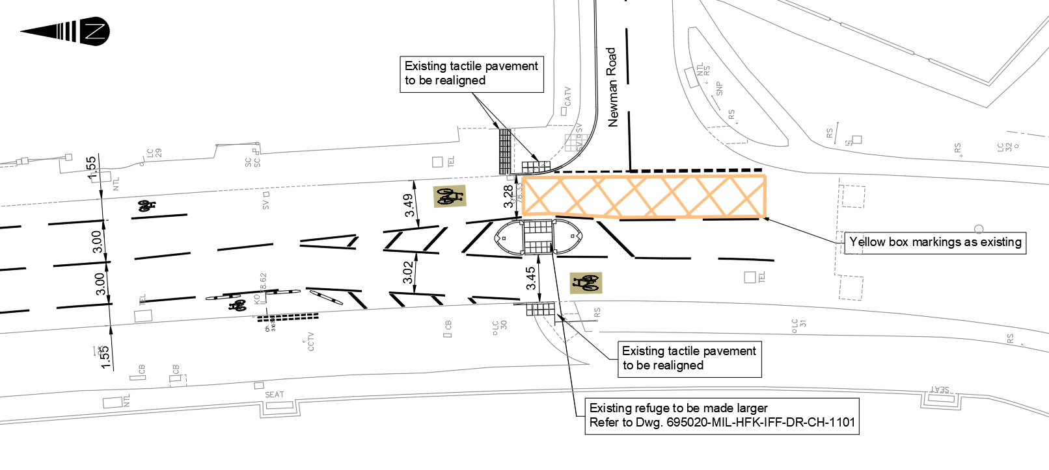

Works on the widening of the central island are due to commence on 11 April 2022 for a period of up to 2 weeks. To allow these works to take place safely and with minimal impact on traffic, they will be undertaken at night between the hours of 8pm and 5:30am by virtue of three-way traffic lights.
We will endeavour to keep noise to a minimum, but unfortunately, we do anticipate some noticeably noisy activities which we planned to complete by 11pm each night and over the first few nights. Other less noisy activities will take place then after.
This work will not affect the access to or from your property and you will be able to access/egress as normal.

We apologise for the inconvenience this will cause but we will endeavour to keep disruption to a minimum. Thank you for your patience and cooperation.

If you have questions or concerns about the scheme, please do not hesitate to contact our project team at HighwayEnquiries@Oxfordshire.gov.uk or you can call Oxfordshire County Council’s Customer Services team on 0345 310 1111.

Yours faithfully,
Active Travel Team
Oxfordshire County Council

