County Hall
New Road
Oxford
OX1 1ND

Directorate Environment & Place

2April 2022

Dear Resident

Re: Quickway Cycle Route – Iffley Turn roadworks

Measures to improve cycling and walking were approved at Cabinet Member Decision on 27th January 2022. The scheme provides a number of ‘Quickway’ cycle routes which include a range of measures including new and improved crossing points, cycle lanes, on-street parking removal and centre line removal. More information on the schemes can be found on our website at https://www.oxfordshire.gov.uk/residents/roads-and-transport/active-travel/oxford-city-quickways

As part of this we will be undertaking works at the Iffley Turn to install cycle lanes and associated works as shown in the diagram below. This work will include the closure of Iffley Turn north of Cavell Road including temporary parking suspension from Cavell Road to Bristol Street Motors. Access will still be possible to the frontages of the properties north of Cavell Road from Iffley Turn. Access from the south end of Iffley Turn from Henley Avenue will still be possible.

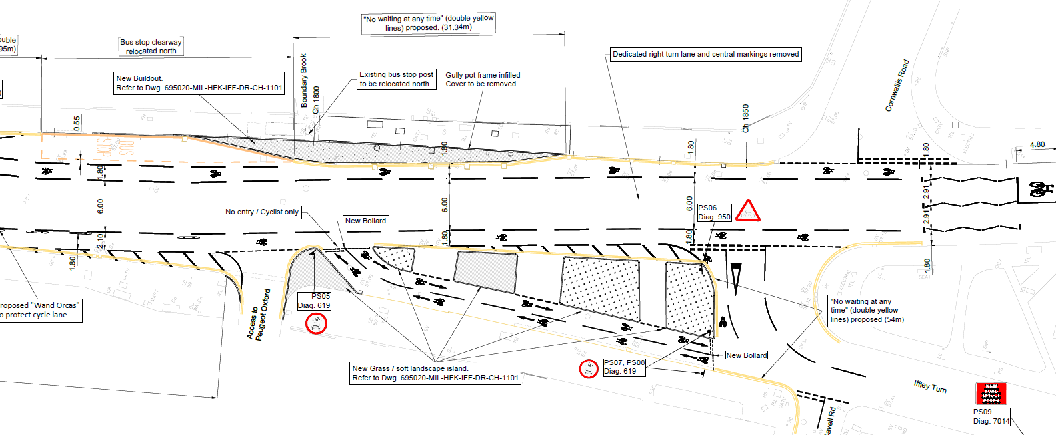

These works will take place safely and in an efficient manner with minimal impact on traffic and will require a period of 5 weeks starting on 25 April 2022 and finishing on 29 May 2022.

We apologise for the inconvenience and the noise. We will endeavour to keep disruption to a minimum and thank you for your patience and cooperation. If you have questions or concerns about the scheme, please do not hesitate to contact our project team at HighwayEnquiries@Oxfordshire.gov.uk or you can call Oxfordshire County Council’s Customer Services team on 0345 310 1111.

Yours faithfully,

Naomi Barnes
Project Manager (Major Infrastructure Delivery)
Oxfordshire County Council

