Appendix 11 - Chapter 5

A new movement pattern

Strategic movement

Strategic growth

Didcot’s strategic location is unique. Sitting comfortably at the southern end of the Oxford Cambridge growth corridor, it is in a place that will see significant growth and investment in strategic infrastructure over the coming years. The two areas of strategic investment most relevant to the garden town are the Oxford Cambridge expressway (promoted by the Department for Transport) and future investment within the national rail network.

The Oxford Cambridge Expressway

This project is currently at an initial feasibility stage. This stage will review options for route alignment north or south of Oxford. A southerly alignment could have major benefits to relieve strategic A34/ M40 traffic, bring inward investment to the region but importantly for the garden town, it could relieve the local road network from strategic traffic making investment more efficient for the town’s growth.

Rail and Didcot Station

The railway has always been at the heart of Didcot and is now seeing unprecedented interest as patronage grows to meet increasing demand. Electrification of the London to Bristol line will greatly improve national services and there is growing interest in Oxford’s metro rail to serve the city and its region. The railway system is changing and will continue to evolve. The garden town needs to both drive and respond to this evolution.

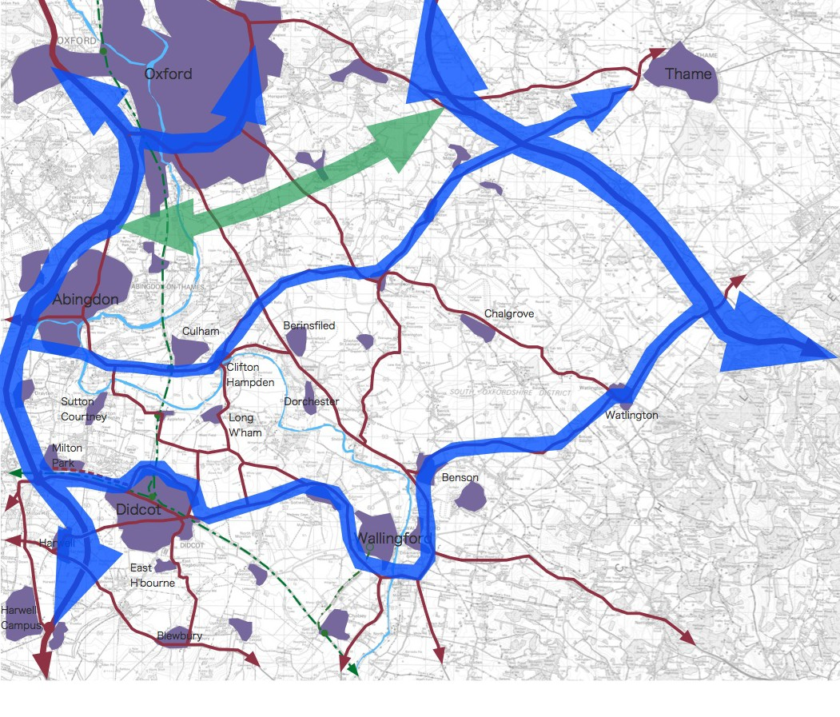
Figure 5.9 - The alignment for the Oxford Cambridge Expressway is undecided, but a southerly alignment could bring major benefit to the garden town
To Birmingham
To London
To Newbury
To Reading

Future investment in rail offers a major opportunity for the town’s growth, prosperity and regional rail movement.

Proposals for changes to the station and rail network are at an early stage and all of the points made in this chapter are early options that require further consideration. The next step in bringing forward a revitalised station is a capacity and accessibility study conducted in partnership between Network Rail and the Didcot Garden Town team. There are significant challenges here, including the junction itself, the need for more platforms, the embankment and levels, and land ownership near the railway line. The scope for this study is under review but likely to include:

- A transport assessment which links transport need to local growth. This would include:
- A demand forecast and design capacity assessment for Didcot and the surrounding area to identify options to either extend, rebuild or relocate the station
- Review of options with comparison of cost benefit

- A ‘desk-top’ options review and feasibility study to determine options that provide extra capacity, followed by design development of preferred options to establish costs, programme and approvals. It is envisaged that the feasibility study will include the following:
- Consideration for a ‘grade separated junction’ east of Didcot, which will enable trains travelling to Oxford and the Midlands to cross east-west services without conflict.
- Considering whether to rebuild, extend or relocate Didcot Station
- Review of improved connectivity to the Midlands and possibly the establishment of a Heathrow Airport service, via Reading
- Wider rail connections across the country (Great Western Railway, Cross Country and Chiltern Railways)
- Coordination with strategic electrification work
- Review of freight and passenger capacity
- Car parking and inter-modal transport assessment

As this is a multi year phased development, the garden town masterplan promotes flexibility, allowing various changes to be considered over time.

The potential improvements are clear opportunities to make national and international connections for business, residents and visitors to Didcot.

Studies will consider the benefits to Didcot, Heathrow, Crossrail and High-Speed one and two along with new services to Cambridge. Again, improved direct connections from Didcot need to be explored in depth as part of these proposals, as they could offer very significant benefits for residents and businesses associated with the town.

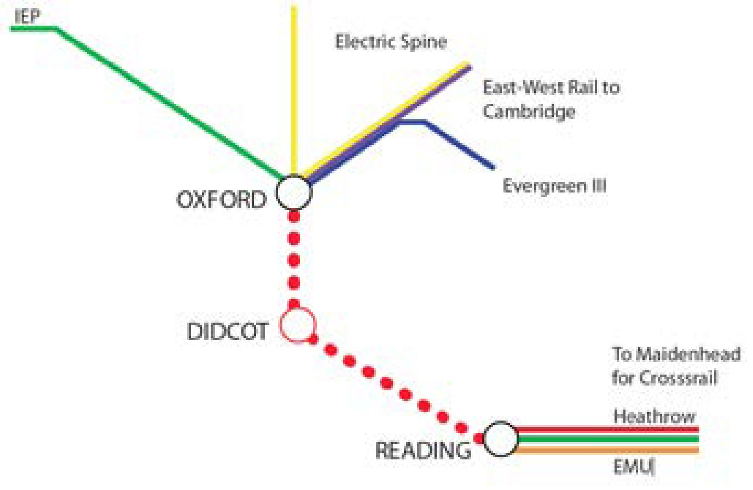
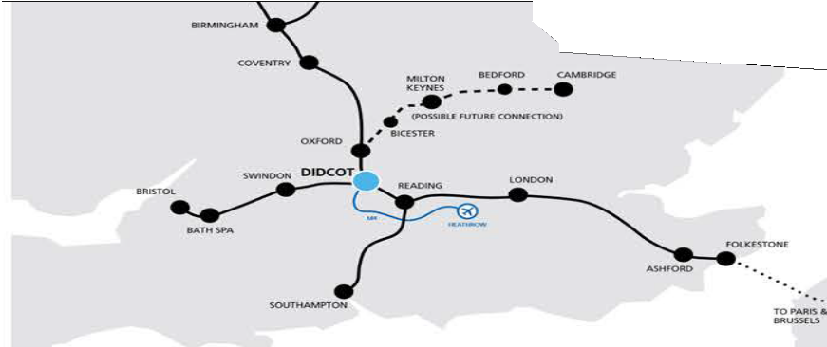
Figure 5.11 - Potential for improved direct services to Didcot from Oxford and Reading
Figure 5.10 - Wider rail connections across the country

Town wide movement

Diversifying movement patterns

The Didcot Garden Town vision recognises that Didcot will grow from approximately 26,000 people to over 60,000 by 2031. With this growth Didcot will become the largest town in Southern Oxfordshire. If the means by which residents move around the town remains unchanged, town wide journeys by car will double.

The current methods for travel to work are shown below. 64 per cent of residents travel to work by car; this representation is fairly typical of a car dependent place.

In addition to the large portion of journeys by car, the diagrams demonstrate that 11 per cent of residents travel by public transport and 5 per cent by cycling.
The challenge that lies ahead is moving travel patterns away from private cars to more sustainable alternatives. Moving travel away from the car has other benefits including making our streets safer, promoting healthier lifestyles amongst residents and allowing greater human interaction and activity in public space.

The garden town team have assessed other (less car dominated) places across the UK and can see significant opportunities to change the movement profile of Didcot towards one that is more diverse and ultimately more sustainable.

This change in travel patterns (above that included in the existing Local Transport Plan) can be realised by:
- Increased investment in public transport
- Enhancing the cycling network
- Investment in new technologies to both improve transport systems and engage residents and employees in alternative forms of transport
- Future proofing transport infrastructure to accommodate evolving transport systems

With investment in these areas the Didcot Garden Town team conclude that the future split of transport choices for the garden town should at a minimum target 47 per cent car, 15 per cent public transport and 13 per cent cycling by 2031.

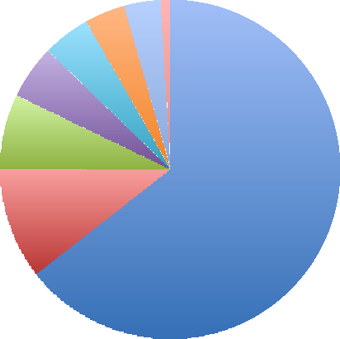
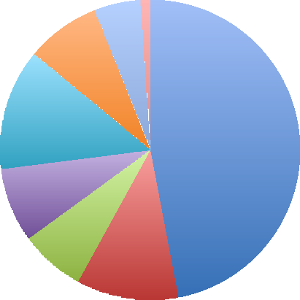
1% 1%
4% 3%
5%
5%
7%
11%
64%
5%
8%
13%
47%
8%
7%
11%

Driving a car or van On foot
Train
Passenger in a car or van Bicycle
Bus, minibus or coach
Work mainly at or from home Motorcycle, scooter or moped

Figure 5.12 - Method of travel to work
Didcot today (14,200 residents in employment)
Figure 5.13 - Method of travel to work Garden Town 2031 target

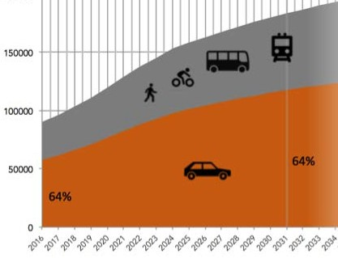
Investment strategy, a balanced approach

To achieve this target a balanced approach to investment is required. The existing transport plan has identified a number of strategic infrastructure projects that require investment by 2031. The town requires thatinvestment for its existing and new strategic transport infrastructure to address the issue of growing congestion and growth. This investment is primarily related to new roads and bridges (see later section) with the assumption that transport choices will change little over time.

If the desired change in movement choices is to be achieved, the investment in strategic infrastructure needs to be balanced with a new garden town sustainable infrastructure fund. The existing transport plan initiatives will be supported by the strategic infrastructure fund whilst a garden town sustainable infrastructure fund will address transport choices.

Figure 5.14 - Total number of journeys per day growth scenario one - no change: investment focused on cars and building more roads

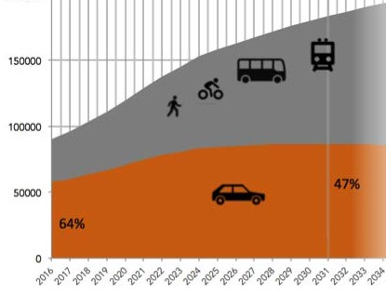
Figure 5.15 - Total number of journeys per day growth scenario two - investment shifting to other modes of transport and smarter journey planning

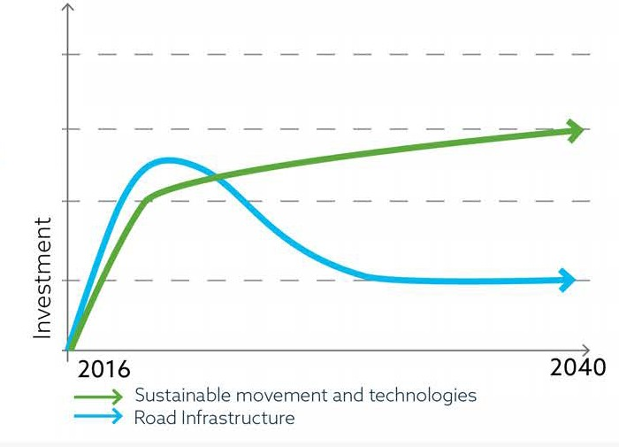
Figure 5.16 - Investment sustainable movement and technologies should be prioritised over investment in road infrastructure

A sustainable movement hierarchy

To Oxford
To Berinsfield
To Abingdon

To Oxford

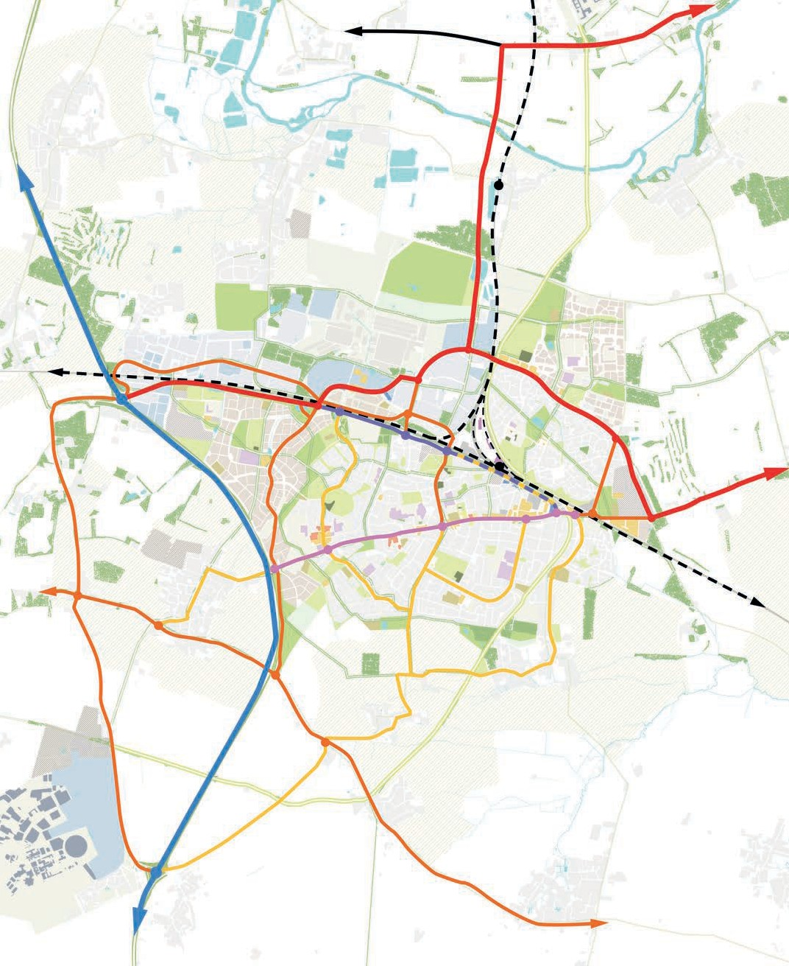
1

To Swindon

2

3 2
To Wallingford

4

5
To Wantage

To Paddington
To Reading
To Newbury

A34, a national strategic route

East-west movement corridors and Science Bridge

The Gateway Spine

Station Gateway

The Cultural Spine Local strategic route Local connector Alternative River Thames

Figure 5.17 - Street hierarchy and summary of proposals

It is recognised that, in the short term, the choices people make in the way they travel are unlikely to significantly change. Despite this the masterplan and the movement strategies for the garden town are aimed at encouraging a shift away from reliance on the private car and towards other modes of transport.

Investment in new infrastructure to accommodate town-wide movement therefore needs to enable alternative modes of transport to become the preference for as many journeys as possible.

A clear movement hierarchy is needed to achieve this as local journeys, in particular, should be made by alternatives to the private car. The masterplan establishes this hierarchy through a series of interventions that develop the existing transport plan towards the sustainability targets embedded in the garden town vision.

- The top of the movement hierarchy is unchanged and is set by the A34, a national strategic route primarily dealing with north-south traffic movement, both to the town and past to Oxford and beyond
- The next tier is set by the east-west movement corridors. The first is a strategic route from the A34 through the town via the A4130 and the northern perimeter road to Wallingford. This is a route that will handle traffic that passes through and stops in Didcot and other forms of local movement within the town. This route offers relief to the town centre and station from the pressure caused by strategic traffic movement. The second route is the A417 and connects the A34 to Reading
- Below this, a series of local strategic routes interconnect the town, providing main connectors for traffic and bus routes
- Finally, shared streets near the station and Broadway interconnect all forms of movement in places with restricted vehicular access

Overlain on this hierarchy are two streets that form the radial movement back-bone to the plan (the Gateway Spine runs from the A4130 to Station Road and the Cultural Spine along Broadway to the town centre). These routes contain a bus network that serves the whole town, a greatly improved cycling network and a series of smaller scale transport hubs. These hubs form interconnections for all forms of movement and will help create a seamless journey experience.

Predictions of future levels of traffic in the town have, in the past, been based on an assumption that the number of car-based journeys will rise in line with population and economic growth in the region. The garden town strategy, by contrast, will accommodate all forms of
movement.

More detailed transport modelling is now being commissioned as part of the garden town project. This modelling will enable different scenarios and assumptions on travel choices to be tested.

These, in turn, will enable a better understanding of the effect of transport patterns and how to phase and establish this movement hierarchy and promote the town’s sustainable transport initiatives. Several ‘early win’ projects have also been identified. These projects are not dependent on this transport modelling and should be implemented now for maximum effect.

The Gateway Spine

The Gateway Spine corridor runs from the A34 to Jubilee Way. There are four movement characters along its length. From Milton Interchange to the northern perimeter road, the route handles a mixture of strategic and local traffic. Here the new corridor includes separate walking and cycling routes, two lanes for traffic and the potential for a segregated lane for public transport; a lane that in future could be dedicated to autonomous vehicles. From the northern perimeter road to Station Gateway the route changes slightly but still accommodates walking, cycling traffic and a segregated public transport route. At Station Gateway the route changes character. Here there is a much higher priority for pedestrians within a shared space in front of the station. After the station square the corridor returns to the same form as the western arm.

Appendix 11 – Chapter 6

6.1.3 Supporting high quality housing

Selection of affordable and private housing types for a particular development will require an analysis of the local area, need and the scheme character as seen in figure 6.6. The assessment for a site should consider the garden town housing objectives to:

- Offer wider housing options to local people who are currently unable to access suitable accommodation
- Increase the variety of housing types delivered and the quality of design, linked to the design review panel
- Provide homes which are affordable to and meet the lifestyle needs of local key-workers and those within the wider Science Vale
- Build to greater density in appropriate town centre locations and near to transport hubs

- Provide flexible approaches for longer term schemes to respond to changing need over time
- Support the development of a professional, high quality private rented sector (build to rent)
- Maximise the total quantity of homes delivered across a broad range of tenures
- Ensure housing delivery can support and improve other opportunities for the local community, for example access to employment, skills or support
- Increase provision of purpose built housing for older people and other people with other specialist housing needs
- Accelerate housing delivery

The approach outlined above should ensure that a wider mix of homes is

delivered, supporting the objectives of the garden town as a whole. It is proposed that developers adopting the suggested approach could receive support from the garden town team.

Support could include resource during the pre-application process and positive support of the application, the potential for a predictable and expedited planning consent should act as an incentive for developers to work with the approach. It should be noted that the wider range of affordable housing should not necessarily impact negatively on scheme viability, there will be a need to select a mix of homes which ensures a deliverable scheme.

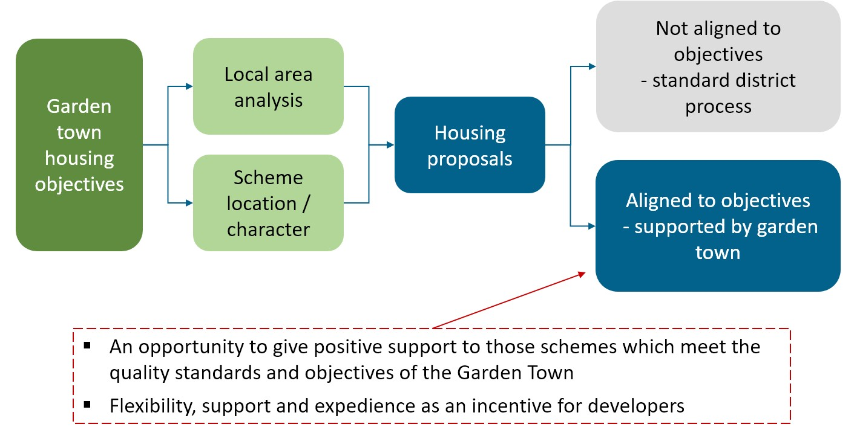

Figure 6.6 - Process to support high quality housing

