Oxfordshire’s Strategic Economic Vision to 2030

Our Vision
Focussing on the overarching theme of Driving Economic Growth through Innovation and recognising our opportunities and challenges, the Oxfordshire vision is:
“By 2030 Oxfordshire will be recognised as a vibrant, sustainable, inclusive, world leading economy, driven by innovation, enterprise and research excellence.”
In achieving our vision we foresee an economy based on the continual cross- fertilisation of ideas, investment and application. This will take place within an entirely permissive business environment, and which is fully integrated with and supportive of its natural environment.
In order to achieve our Vision, we will need to focus our energy and investment to capitalise on our opportunities, and address our challenges.
Our City Deal provides the immediate impetus for delivery in the short term, and will be complemented by our Strategic Economic Plan to further accelerate delivery to 2020 initially, and to 2030 in the longer term.
“By 2030
Oxfordshire will be recognised as a vibrant, sustainable, inclusive, world
leading economy, driven by innovation, enterprise
and research excellence.”

Objectives
Our ambition is to create the conditions that make Oxfordshire the location of choice for the world’s leading science,
challenges. These themes are underpinned by specific objectives that are achievable and measurable. Through our interventions and delivery plan, we have the opportunity to fulfil the objectives and drive economic growth across Oxfordshire, growing the UK economy as a whole.
The objectives reflect our priorities for economic growth to 2030, focusing limited government resources on areas of greatest economic impact. They are based on four themes:

Innovative Enterprise

Innovation-led growth is at the heart of our strategy, underpinned by the strength of our University research and development capacity, business collaboration and supply chain potential.

Innovative People

Delivering and attracting specialist and flexible skills at all levels, across all sectors, as required by our businesses, with full, inclusive employment and fulfilling jobs.

Innovative Place

Providing both the quality environment and choice of homes needed to support growth whilst capitalising upon the exceptional quality of life, vibrant economy and the dynamic urban and
rural communities of our county.

Innovative Connectivity

research and technology businesses.

In order to achieve this we have developed four key themes based on identification
of Oxfordshire’s opportunities and
Allowing people to move freely, connect easily and providing the services, environment and facilities needed by a dynamic, growing and dispersed economy.

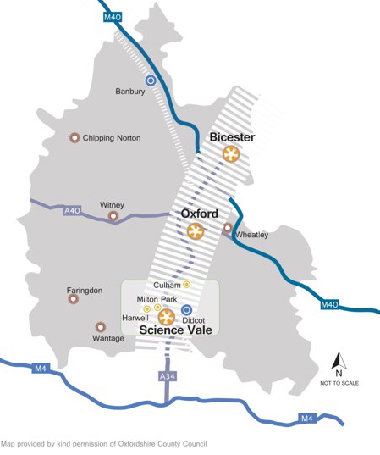

The Oxfordshire Knowledge Spine
The Strategic Economic Plan prioritises interventions in key locations, specifically along the ‘Oxfordshire Knowledge Spine’. The Knowledge Spine runs through the centre of the county with the three key areas for growth potential in population, employment and housing at Bicester, Oxford City and Science Vale Oxford.
  - Science Vale Oxford - where we will build on its extensive research infrastructure and the designation of Harwell as the home of the national
Satellite Applications ‘Catapult’ and the European Space Agency.
  - Bicester - where we will support significant increases in employment growth through infrastructure improvements and land availability.
  - Oxford - where we will continue to invest in developing the critical infrastructure necessary to realise the full potential of its world-class
education, research and innovation that underpins our growth.
The projects identified in this Economic Plan for delivering growth focus on the connectivity of the Knowledge Spine that will link the key hubs to the wider transport network locally, nationally and internationally. In this way, growth in the Knowledge Spine will drive benefits throughout the whole economy of Oxfordshire, the south east region, and nationally.
As this growth is critical to the future of Oxfordshire and the ability to add to
the national GVA in real terms attracting international business, this is the focus of our strategy for this Strategic Economic Plan.
30 Minute Public Transport travel time within Oxfordshire knowledge spine, before and after City Deal/Local Growth Fund investment in infrastructure

The Oxfordshire Knowledge Spine

As such, the investment for the Strategic Economic Plan, builds on this potential to seek to release the maximum economic growth for the UK as possible. This will have significant indirect jobs growth across the county as a whole in the supply chain industries.

