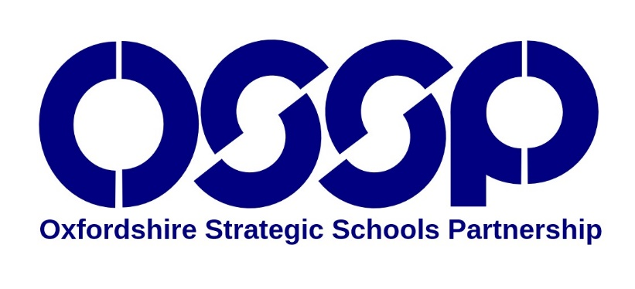 | Working together to  provide the best education for every child and young person in Oxfordshire

Purpose  The OSSP is a forum where organisations which play a significant role in publicly funded education in Oxfordshire meet with the aim of addressing Oxfordshire’s key educational priorities that go beyond the responsibilities or influence of any one organisation. With respect to these identified priorities, the representatives of those organisations meet to:  - Share information  - Identify opportunities for collaboration  - Minimise duplication  - Provide challenge and support  - Influence the strategic direction of education in Oxfordshire | Principles  - The OSSP is a partnership of equals, with partner representatives being responsible for representing the work and views of their organisations and for making appropriate contributions to the strategic improvement of education in Oxfordshire.  - Our work focuses on inclusive practice and provision, in order to improve education for all.  - We will observe complete confidentiality when matters are deemed to be confidential.  - Partners will agree strategic priorities, to which everyone will make a commitment.

Area of focus 2023-2026

Develop inclusive practice and provision in order to improve the progress and life chances for our SEND and disadvantaged learners.

Current Partner Organisations
The OSSP includes representatives from the following groups and organisations:

- Further Education
- Higher Education - The University of Oxford
- Higher Education - Oxford Brookes University
- Oxford Diocesan Board of Education
- Oxfordshire County Council
- Oxfordshire Governors' Association
- Oxfordshire Teaching School
- Oxfordshire Primary Schools
- Oxfordshire Secondary Schools
- Oxfordshire Special Schools
- Oxfordshire City and District Councils
- Early Years

