Oxfordshire County Council
Schools Forum – 7 February 2024
Schools Funding Formula 2024-25 - Authority Proforma Tool (APT) & De-Delegation Union Duties & School Improvement:
Update on Final Submission

DRAFT

Settings |  | Sector |  | Voting Entitlement (for decision papers only)
Academies | ✓ | Foundation Stage |  | Schools’ Forum approval is required in order
Maintained Schools | ✓ | Primary | ✓ | to move funding from the school’s block to the
PVI Nurseries |  | Secondary | ✓ | High Needs Block
Special Schools |  | Special | ✓ | All representatives vote on Block movements
Local Authority | ✓ | 16+
Schools Forum | ✓ | High Needs |  | Voting on amendment to the school
 |  |  |  | funding formula excludes non-school
 |  |  |  | members except for the PVI representative

Item for Information – Update Confirming Final APT Submission
  - At its last meeting (16 January) Schools Forum requested a further paper to provide details of the final APT Submission to ESFA for 2024-25. The submission is based on the agreed allocation (Model 0) with a contribution to the Growth Fund of £0.910m (including the surplus of £0.254m).
  - The table below summarises the Basic Entitlement submitted (Column C) and provides a comparison with the agreed Model 0 (Column B). The APT pro-forma is detailed in Appendix A).
  - There was a correction to the APT which didn’t impact the allocation but did reduce the additional surplus from £0.600m to £0.254m. The correction was due to 3 new Academies being identified which had not been included in the original APT.
Table 1 – APT Final Submission
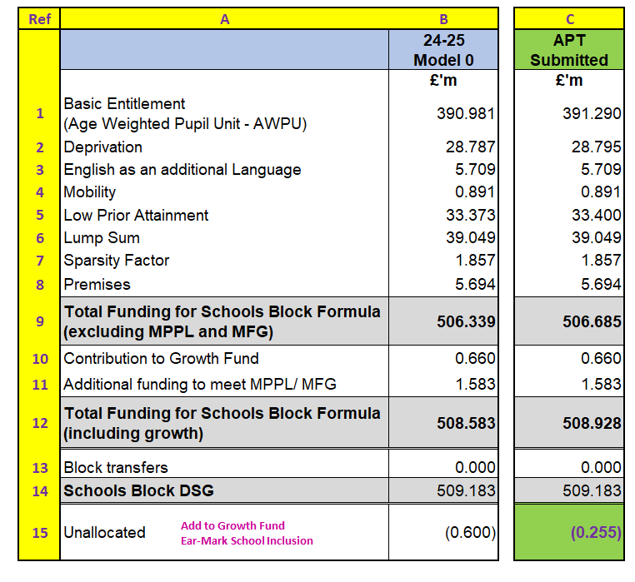

Conclusion:

The APT was approved by Cabinet Member decision (16 January) and uploaded to ESFA (19 January).

Arrangements are now being established to issue school budget shares to mainstream schools ahead of the deadline on 29 February per the timeline set out in the table below.

Table 2: Timeline 2024

Date | Activity
16 January | Schools Forum - Report and discussion of APT 2024-25 submission
22 January | Deadline for submission of final 2024-25 APT to ESFA
23 January | Cabinet Member decision on the School Funding Formula (APT) 2024-25
7 February | Schools Forum – Early Years Funding and Update on APT 2024-25 including if approved by the ESFA
February | If confirmation of APT 2024-25 by ESFA received after 7 February Schools Forum meeting, detail to be circulated to School Forum members by e-mail
29 February | Deadline for the local authority to issue school budget shares to mainstream maintained schools
By 31 March | Confirmation by ESFA of 2024-25 general annual grant for academies open by 12 January 2024
1 April | Start of maintained schools financial year 2024-25

Appendix A – APT Submitted: DSG Allocation 2024-25: Authority Proforma Tool 