**Trading Standards Service**

**Business Plan**

**2024/25**

Incorporating the Food and Feed Delivery Plan for 2024/25

(Annex 1)

## **Foreword**

Good regulation, appropriately monitored and enforced, helps to make Oxfordshire a greener, fairer and healthier county – directly supporting several of the Council’s priorities.

Whether food is accurately described and is traceable through the food chain, whether you are being provided with the correct weight or measurement of something, or if a consumer product is safe to use, cannot be assessed by an individual consumer. It requires a process of inspection, examination, testing and market surveillance. In this respect, we are all vulnerable consumers and the Trading Standards Service acts to help ensure that we can all be confident consumers, who are protected from harm and unfair practices.

High levels of compliance with regulatory rules not only protects consumers, but allows honest businesses to thrive, with the confidence to invest and innovate in the products and services they provide – knowing that they are competing on a ‘level playing field’ and avoiding a ‘race to the bottom’ in standards.

Looking to the future, it is more important than ever to have a trading standards service that is able to provide reassurance to Oxfordshire that legal requirements are being met. This includes helping to tackle some of the inequalities in our community, made stark by the Covid pandemic and the cost-of-living crisis, supporting our national ambitions to be ‘Net Zero’, in ensuring that both environmental legislation is enforced and that misleading ‘greenwashing’ claims are tackled.

The impact of climate change will also see challenges to farming and food production. Trading standards’ role in helping to ensure farming standards are maintained, preventing the spread of animal diseases and providing confidence to the integrity of the food chain, could be made more difficult from increased risk of exotic animal diseases, illegal substitution of food items due to failed crops and the need to provide greater support to farmers and livestock keepers.

The increase in the complexity of global supply chains and the rise in purchasing transactions via internet-based platforms and social media sites provides an opportunity for innovation, but also challenges in enforcing food standards and product safety, particularly when things go wrong and those responsible need to be identified and products need to be recalled. This is at the same time of new product safety challenges, such as from lithium batteries.

The responsibilities of trading standards do not remain static. New legislative burdens are added every year. Important ambitions of a smoke-free future, new restrictions on disposable vapes, more work to tackle single-use plastics are all areas of possible future regulation. In addition, the proposed new Oxford United stadium will bring work in relation to our safety at sports ground obligations, led on by our trading standards team.

This plan shows that residents, businesses and visitors of Oxfordshire are all ‘customers’ of trading standards. Much of the team’s work happens ‘behind the scenes’ but provides an important service for all – helping to ensure that we can have trust in the goods and services that we buy and that we are getting what we paid for!

Through this plan, we hope to meet the ambition of a trading standards service that that is more relevant, more visible to more residents.



Councillor Dr Nathan Ley

Cabinet Member for Public Health, Inequalities and Community Safety

## **Introduction**

The Trading Standards Service (‘the Service’) fulfils Oxfordshire County Council’s statutory responsibilities for the enforcement of a wide range of consumer protection and public safety legislation (see Annex 2).

The responsibilities of the Service are widespread and include:

* Weights and measures
* Product safety
* Food and farming standards
* Trade representations and trademarks
* Unfair trading practices
* Animal health and disease control
* Environmental requirements
* Price marking and price comparisons
* The supply of age restricted products
* The licensing and inspection of explosives and petroleum storage facilities
* The safety certification of sports grounds

The Service aims to provide the residents, businesses, and visitors of Oxfordshire with a level of assurance that legal requirements are being met and adhered to.

The service works to rectify issues found and hold those responsible to account, where appropriate. In doing so, we aim to meet the expectations on Oxfordshire County Council from other government agencies, such as the Food Standards Agency, the Office of Product Safety and Standards, the Department for Environment, Food and Rural Affairs (including the Animal and Plant Health Agency), the Department of Health and the Sports Grounds Safety Authority.

In addition to our regulatory role, the Service undertakes a significant amount of work (directly and in partnership with others) to protect people from various forms of financial abuse, such as scams and doorstep crime – including responding to safeguarding concerns. The Service also enforces the weight restrictions on the county’s roads.

## **About Us**

Our purpose is:

“Keeping individuals, communities, businesses and livestock safe from harm; protecting individuals and businesses from financial loss and preventing unfair practices”.

This recognises that much of the work of the Service, is not only undertaken to meet statutory duties placed on the Council, but to actively seek to achieve the Council’s overall vision and priorities. Our business plan highlights the ‘clear line of sight’ that exists, from the strategic direction set by the Elected Members of the Council, through our leadership team to individual areas of work carried out by the teams in the Service (Figure 1):

Oxfordshire County Council’s Vision and Priorities

Vision: *Working in partnership to make Oxfordshire a greener, fairer and healthier county.*

The nine priorities of the Council are:

1. Put action to address the climate emergency at the heart of our work
2. Tackle inequalities in Oxfordshire
3. Prioritise the health and wellbeing of residents
4. Support carers and the social care system
5. Invest in an inclusive, integrated and sustainable transport network
6. Preserve and improve access to nature and green spaces
7. Create opportunities for children and young people to reach their full potential
8. Play our part in a vibrant and participatory local democracy
9. Work with local businesses and partners for environmental, economic and social benefit

The Service sits within a group of services within the Council, referred to as the Community Safety Services; comprised of Oxfordshire Fire and Rescue, Emergency Planning and the Trading Standards Service. The Community Safety Services purpose is:

*We are here to protect our community, reduce harm and save lives*.

Our business plan not only details the areas of work for the year ahead, but how this work contributes to the aims of both the Council and those of the Community Safety Services.

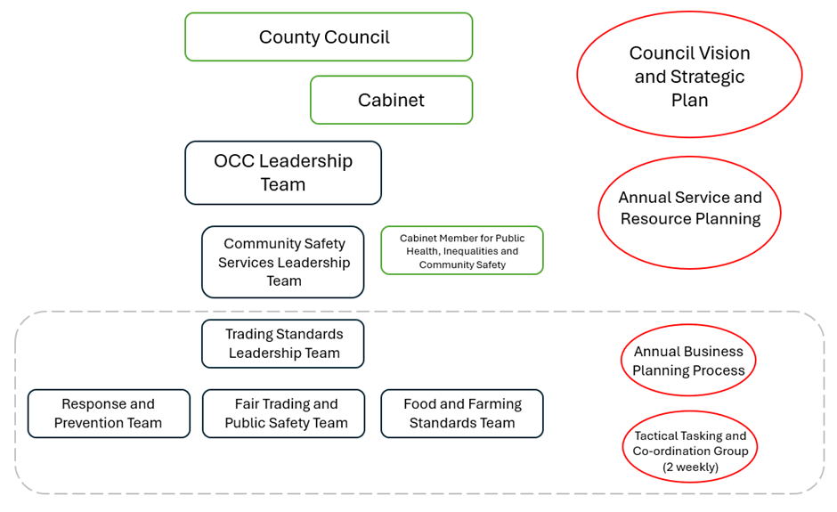

Figure 1 – Priority Setting and Decision-Making Structure

The Service is made up of 29.85 fulltime equivalents (FTE). This includes 4.95 FTE of externally funded hosted positions (see Figure 2). Our operational teams are grouped together by three key areas of work.

Response and Prevention Team

The team works across all areas of trading standards work, responding to the needs of our residents and businesses, and providing community engagement activities. The team lead on responding to priority, unplanned demands on the service. This might include very serious individual complaints, safeguarding referrals and urgent requests from other local authorities and external agencies. The prioritisation of complaints and assessment of areas of potential future work is supported by a regular tasking and co-ordination process, helping to ensure the delicate balance of dividing our capacity and resources against incoming reactive work, with planned +proactive commitments.

In addition, the team lead on our preventative work, particularly supporting those who have been the victim of a scam, or of high risk of being so. This includes working closely with colleagues in Oxfordshire Fire and Rescue and their programme of Safe and Well Visits, and with the National Trading Standards Scams Team. Much of this work involves targeted, one to one support and advice, supporting our residents to feel more confident and better protected.

Fair Trading and Public Safety Team

The team leads on the proactive, planned areas of work in relation to areas such as consumer product safety, fair trading, under-aged sales, legal metrology, petroleum and explosives and consumer protection. Activities include investigating serious breaches of legislation, undertaking inspections, sampling products for compliance with legal requirements and conducting trade audits. The team help to ensure that residents can have trust in the safety of the goods and services they buy and that they are getting what they paid for.

Food and Farming Standards Team

The team has a strong focus on maintaining the integrity of the food chain, from farm to fork. They lead the planned areas of work in this area, particularly the authority’s obligations under the food and feed code of practices and those relating to animal health and farming standards. This important area of work includes ensuring that food is accurately described, including allergen labelling and that it is what it says it is. The team also work closely with the farmers and livestock keepers of Oxfordshire to help ensure traceability within the food chain, to help prevent the spread of animal and zoonotic disease[1] and that animal welfare standards are met. As with other business sectors, this helps to maintain a level playing field and fair competition, where farmers and food producers can thrive.

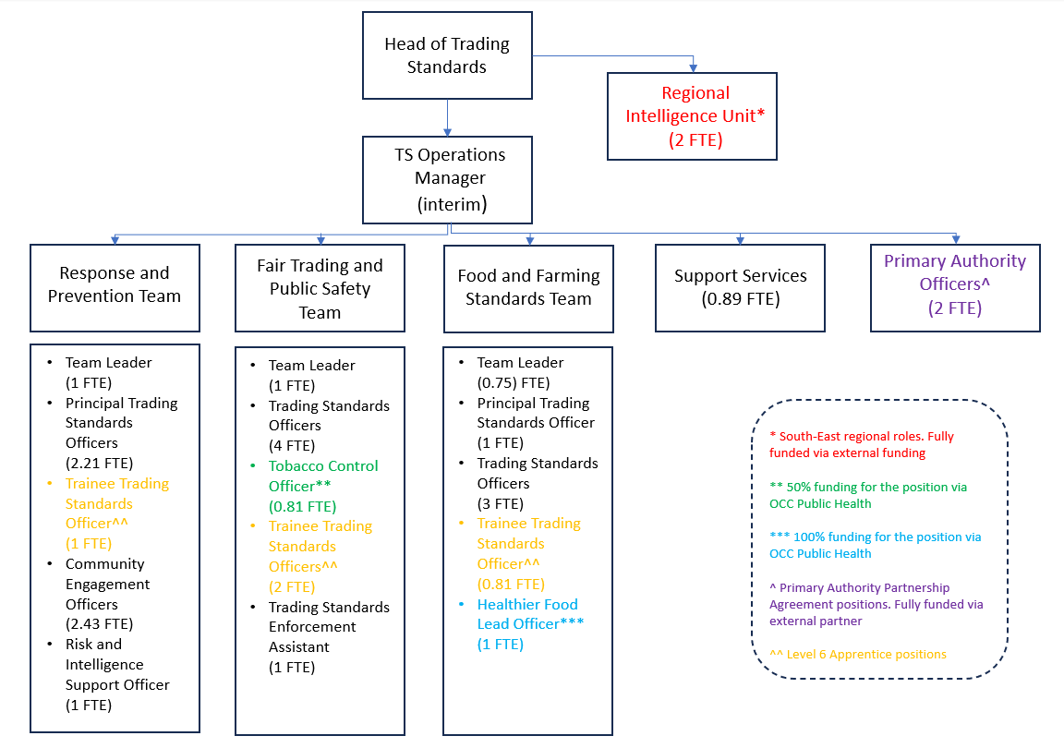

Figure 2 – Trading Standards Team Structure

## **Our Commitment to Consumers**

The primary remit of the Service is to provide a level of assurance that those legal requirements placed upon the Council to enforce are being broadly met in Oxfordshire. Unfortunately, we know that things can go wrong and that consumers will have cause to complain about issues and disputes with traders. Whilst these complaints form a very important part in directing our finite resources, either leading to a specific complaint investigation, or by providing important intelligence on the issues and sectors causing harm to Oxfordshire resident, it is not possible to respond to all individual consumer complaints we receive. The Service is also not able to obtain compensation or redress for consumers who are in a dispute with a trader, with our responsibility being to enforce criminal breaches of legislation.

Nationally, Citizens Advice are responsible for providing consumer advice and education and their national consumer helpline act as the ‘front door’ of our Service. The national helpline receives the vast majority of consumer complaints that may be of interest to trading standards services. The helpline provides consumers with free, impartial, and practical advice to help them to solve their individual problem, whilst automatically sending the details of any alleged breaches of legislation to the most appropriate trading standards service. This also has the benefit of creating national level data on patterns and trends of concern, informing the planned, preventative work we undertake locally.

By balancing our ability to respond to the serious, high priority complaints we receive and also undertaking an intelligence led approach to planned trade audits and project work, we aim to give residents, business and visitors to Oxfordshire the assurance that there is a high level of compliance with consumer protection requirements, including those ‘hidden’ areas where we are all vulnerable consumers and need to have trust in claims being made.

## **Our Commitment to Businesses**

The responsibility to comply with legal requirements always rests with the business or organisation providing the goods and services to the public. However, the Service takes great care to help businesses and others to meet their legal obligations without unnecessary expense, while taking firm action, including prosecution where appropriate, against those who flout the law or act irresponsibly.

We want to work with you to help your business to be a success. We also recognise that your business will receive advice and inspections from other organisations, and we will do our best to work with them to ensure that you receive the best service.

Carrying out enforcement functions in in a fair, practical and consistent manner, helps promote a thriving local and national economy, leading to environmental, economic and social benefit for all; the Service supports and adheres to the principles of the [Regulators’ Code](https://assets.publishing.service.gov.uk/media/5f4e14e2e90e071c745ff2df/14-705-regulators-code.pdf).

How Trading Standards Provides Advice

Where you need advice to help you to meet your legal obligations we will:

* Provide clear advice on the legal obligations relating to your business/trade sector
* Signpost you to the best sources of advice for detailed guidance on how to comply with your legal duties and obligations ([Chartered Trading Standards Business Companion](https://www.businesscompanion.info/))
* Distinguish legal requirements from suggested good practice
* Ensure that any verbal advice you receive is confirmed in writing, if requested
* Acknowledge good practice and compliance.

For those businesses seeking in-depth, tailored advice on complying with trading standards law, including the development of new products and services, trading across local boundaries etc, it may be appropriate to enter into a Primary Authority Agreement. [Primary Authority](https://www.gov.uk/guidance/local-regulation-primary-authority#what-is-primary-authority) is a means for businesses to receive assured and tailored advice on meeting trading standards regulations through a single point of contact. This ensures start-ups get it right at the outset and enables all businesses to invest with confidence in products, practices and procedures, knowing that the resources they devote to compliance are well spent.

Financial fees and charges apply to the provision on detailed business advice and Primary Authority Agreements. The Service also offers a chargeable service for the testing of weights and measures equipment. Please visit our website for more details.

Inspections and Other Compliance Visits

We monitor and support compliance in a number of different ways including through inspections, sampling visits, test purchases, advisory visits and complaint investigations. These visits will always be based on an assessment of risk.

When we visit you, our officers will:

* Explain the reason and purpose of the visit
* Carry their identification card at all times, and present it on request when visiting your premises
* Exercise discretion in front of your customers and staff, where possible.
* Have regard to how you approach compliance within your business, and use this information to inform future interactions with you
* Provide advice to support you in meeting your statutory obligations, if required
* Provide a written record of the visit.

How We Respond to Non-compliance

Where we identify any failure to meet legal obligations, we will respond proportionately, taking account of the circumstances, in line with our enforcement policy.

Where we require you to take action to remedy any failings we will:

* Explain the nature of the non-compliance
* Discuss what is required to achieve compliance, taking into account your circumstances
* Clearly explain any advice, actions required or decisions that we have taken
* Agree timescales that are acceptable to both you and us, in relation to any actions required
* Provide in writing details of how to appeal against any advice provided, actions required or decisions taken. Once a case has been committed to court the appeal process is through the court system
* Explain what will happen next
* Keep in touch with you, where required, until the matter is resolved.

## **Identifying our Key Areas of work for 2024/25**

In setting the specific priorities and work areas of the Service, we consider a range of intelligence and information sources. This includes complaints received by the Service and by other relevant agencies, information provided by external bodies such as National Trading Standards, Food Standards Agency, the Office of Product Safety and Standards, Public Analysts and other regulators (see Table 1 below).

The Service also works with the other trading standards services across the South-East to develop a Strategic Assessment and Control Plan. This also takes account of all consumer complaints being received by Citizens Advice, across the South-East.

In identifying areas of work, the Service also takes in to account the level of risk posed to consumers, should there be non-compliance within a sector or area of legal requirement. This includes considerations of how obvious any non-compliance is to potential consumers, how widespread could it be, what information do we already have about levels of compliance, are certain groups potentially more affected by such non-compliances, does it include consumers who might find themselves in a particularly vulnerable situation and is trading standards the most appropriate body to lead on such work.

|  |  |  |
| --- | --- | --- |
| **National Trading Standards Priorities** | **Trading Standards South-East Priority Areas** | **FSA National Food Crime Unit Priorities** |
| Doorstep and cold calling (including energy fraud), | Protection of older vulnerable consumers | Criminality in the red meat sector |
| Lettings agency | Tobacco control | Fraudulent activity within the chicken sector |
| Mass marketing fraud/scams | Fair trading | Diversion of animal by-products (ABP) back into the food and feed chain |
| Illicit and underaged sale of vapes | Doorstep crime | Entry of illegally harvested or misrepresented shellfish into the human food chain |
| Illicit tobacco | Product safety | Dangerous non-foods sold for consumption |
| Used cars | Animal health | Sustainable products and claims |
| Intellectual property | Food standards |  |
| Other fair trading issues |  |  |
| Estate agency |  |  |
| Animal feed work |  |  |
| **Cross-Cutting Themes** |  |  |
| eCrime and the use of social media/online platforms | Cost of living crisis | Food service |
| Serious and organised crime | E-Commerce | Illicit servicing of community demand |
| Cost of living crisis | EU exit | Brokers, trader and agents |
|  | Workforce and capacity challenges |  |

Table 1 – Identified national and regional priorities for 2024/25

The Service also takes note of the Food Standards Agency’s National Enforcement Priorities for feed law enforcement and food hygiene law enforcement at primary production. More details about this can be found in our Food and Feed Delivery Plan.

## **Our 2024/25 Workplan**

|  |  |  |  |
| --- | --- | --- | --- |
| **Area of Work** | **Project/Trade Audit** | **Description** | **Link to Council Priorities** |
| Fair Trading and Public Safety | Second hand car sales | Intelligence led inspection of second-hand car sellers. Includes issues such as vehicle descriptions, consumer rights and vehicle safety | 2, 3 |
|  | Part-worn tyres | Inspection and sampling of retailers of part-worn tyres | 2, 3 |
|  | Air quality and solid fuel | Continuation of work started in 2023/24 to assess compliance with legal requirements regarding the sale of solid fuel and to work with partners on issues such as enforcement of Smoke Control Areas | 3, 1 |
|  | Average weight at packers | Inspection of businesses packing to ‘average weight’ | 2, 9 |
|  | Botulinum toxin and cosmetic fillers | Continuation of work started in 2023/24 to develop knowledge of this sector and businesses operating in Oxfordshire. The provision of advice and inspection of premises. Investigate options to test compliance with age restriction requirements | 3 |
|  | Under aged sales of age restricted products | Undertake under aged test purchasing operations during 2024/25, with particular focus on vapes | 3, 7 |
|  | Petrol verification/ forecourt inspections | Inspection of petrol and diesel suppliers to verify the accuracy of fuel dispensers | 9 |
|  | HGV weight restriction | Undertake a number of HGV stop/checks (reliant on support from Thames Valley Police) to identify HGV drivers in breach of weight restriction orders | 3, 5, 9 |
|  | Petroleum and explosives inspection programme | Annual, risk-based, programme of inspection of premises storing petroleum and explosives | 3, 9 |
|  | Safety at Sports Ground (inc Regulated Stands) | Safety inspections (including during events) of Kassam Stadium, to ensure compliance with safety certificate and of other Regulated Stands in Oxfordshire | 3, 9 |
|  | Illegal tobacco and vapes | Continuing our work in partnership with Public Health tackling the supply and acceptability of illicit products in our community | 2, 3, 7 |
|  | Bulk fuel testing | Inspection and verification of the accuracy of bulk fuel | 9 |
|  | Weighbridge testing | Inspection and verification of the accuracy of weighbridges | 9 |
|  | Safety of Halloween products and dress-up | Inspection and sampling of retailers of Halloween products | 3, 7, 9 |
|  | Safety of e-bikes and e-scooters | Identification, inspection and advising of locally based businesses involved in the supply and repair of e-bikes and e-scooters | 1, 3, 9 |
| Food and Farming Standards | Food inspection programme | Annual, risk-based, inspection programme of food operators, including associated food sampling | 1, 2, 3, 9 |
|  | Out of home calorie labelling | To assess compliance with the requirement to display calorie labelling on menus (where required) and to sample products to test accuracy of claims made | 2, 3, 9 |
|  | Pub inspections | Trade audit to assess compliance with a range of legal requirements, including food descriptions, authenticity, allergen labelling/control and weights and measures | 2, 3, 9 |
|  | Feed inspection programme | Annual, risk-based, inspection programme of feed businesses, including associated feed sampling | 3, 9 |
|  | Food and feed sampling projects | * Non permitted additives in soft drinks * Substitutions in take aways * Food supplements | 3, 9 |
| Response and Prevention | Electric blanket safety testing | Annual programme of free electric blanket safety testing across Oxfordshire, including wider opportunities to provide prevention advice and involvement with partner agencies | 2, 3 |
|  | Scamchampions | Targeted work to ‘recruit’ and train Scamchampions. A ‘train the trainer’ approach to cascading fraud and scams prevention advice and support. Part of a national initiative | 2, 3 |
|  | Junior Citizen | Key stage 2 safety centre and experiential Learning | 7 |
|  | Consumer Challenge Quiz | Consumer knowledge and safety quiz aimed at students of Oxfordshire Special Schools | 2, 7 |

Table 2 – Identified projects and trade audits for 2024/25

## **Measuring Our Performance**

Measuring the impact of the Service’s work on the overall compliance with trading standards requirements in Oxfordshire is difficult. With many factors having an impact on ‘success’ or ‘failure’ and many of the consumer health protections being in respect of issues that may take many years to come to light. Often, the impact of our work is seen through individual case studies and human stories that show how the Service’s work results in a positive impact for a consumer or business.

However, the Service aims to demonstrate the impact and outcome of its activities in a number of ways. For 2024/25, the Service has identified five key performance objectives. They are:

1. To directly save or recover over £100,000 for victims of doorstep crime, scams and other forms of financial abuse
2. To directly reach over 1500 people (adults and children) with preventative advice and support
3. To undertake over 1500 interventions with businesses (inspections, proving advice and guidance to businesses, announced sampling and testing activities)
4. To complete 100% of our ‘high-risk’ inspections
5. To train and recruit 50 ‘Scam Champions’, via the national Friends Against Scams initiative

In addition to meeting these objectives, the Service will also provide a return to the Association of Chief Trading Standards Officer’s [Impacts and Outcomes Report](https://www.actso.org.uk/impacts-outcomes-reports/). This report shows the impact of Local Authority Trading Standards Services in England and Wales.

**Annex 1**

**Food and Feed Delivery Plan for 2024/25**

**Introduction**

The Food Standards Agency (FSA) requires local authorities to produce food law enforcement plans detailing how the authority will discharge their responsibilities for food safety and standards regulation in their area.

This plan shows how Oxfordshire County Council’s Trading Standards Service (‘the Service’) work to ensure the safety and standards of food in Oxfordshire.

**Profile of the Authority**

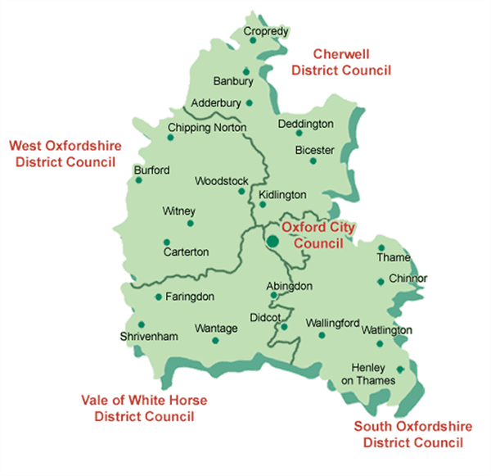

Oxfordshire is a large rural county in southeast England. Oxfordshire is home to an estimated 740,300 residents, including students and armed forces (ONS, mid-year population estimate 2022). Oxfordshire’s population is growing significantly and due to increase by 15% by 2031, including a 25% increase of those aged 65+.

Oxfordshire contains a diverse and varied population. Whilst Oxfordshire has relatively low levels of deprivation, being the 10th least deprived of 151 upper-tier local authorities in England, 17 areas in Oxfordshire are within the 20% most deprived areas nationally.

Oxfordshire is home to 33,405 active businesses, including a significant number of science, engineering and research and development organisations.

In 2022, Oxfordshire welcomed 26.5m visits to the county, including high profile destination such as the city of Oxford, Bicester Shopping Village, Blenheim Palace and the Cotswolds.

More information about Oxfordshire can be found via the following websites:

<http://insight.oxfordshire.gov.uk/cms/>

<https://explore-local-statistics.beta.ons.gov.uk/areas/E10000025-oxfordshire/indicators>

**Aims and Objectives**

This plan, which describes the background to food and feed safety and standards, identifies the scope of the service and the resources that have been allocated to meet the Council’s statutory requirements concerning food chain regulation.

Our interventions and actions are targeted at those businesses who cause great risk to food standards and feed safety and stopping those who seek to take economic advantage from non-compliance with legislation.

Regulation is often perceived to be a barrier to business development and growth. We will continue to seek to break down both actual and perceived barriers to regulatory compliance and to support businesses to develop and grow.

We also recognise that working with partners is key. Working with Public Health, we are trialling work to encourage healthy choices through accessibility and/or greater information provision. The Service will also be focusing on activities relating to cost of living and ensuring that customers are getting what they have paid for.

**Service Plans**

The Service has identified a number of food and feed related priorities for the coming year. These are:

* Improving our service delivery through structural changes in the service
* Adapting to regulatory system changes and developments e.g. changes in legislation as a result of EU Exit, allergen labelling requirements
* Implementing the new food standards risk assessment model for food premises
* To grow the food and feed standards inspection/enforcement capability and competency of the Service through the training of apprentices and training of other staff
* To go out to market for an information management system as per Oxfordshire County Council’s procurement rules
* Work with OCC on developing options to improve the health of Oxfordshire residents in relation to food provision
* To deliver the feed interventions identified by the desk top exercise

**Organisational Structure**

The Service’s structure can be seen in Figure 2 in our Business Plan

The senior management structure for Oxfordshire County Council Community Safety Service is as follows:

Chief Executive

Executive Director of People and Transformation and Deputy Chief Executive

Chief Fire Officer and Director of Community Safety

Head of Trading Standards

Key decisions for Oxfordshire County Council are made by the Cabinet and this group meets on a monthly basis. Cabinet responsibility for the Trading Standards Service is held by the Cabinet Member for Public Health, Inequalities and Community Safety

**Food Examination and Analysis**

For food standards testing and for analysis of contaminated food (e.g. chemical contamination or foreign bodies) the Service has appointed Hampshire & Kent Scientific Services.

**Scope of the Feed and Food Service**

The Service delivers a programme of risk-based interventions, including:

* inspections and audits
* advice for businesses
* response to complaints
* food & feed related investigations.
* sampling
* formal actions

The Service has Primary Authority[2] partnerships for food standards businesses and the public.

Appropriate application of food law helps to ensure that food supplied in Oxfordshire, meets compositional requirements and is accurately described.

Farmers and growers (‘Primary Producers’) must follow basic hygiene procedures to ensure hazards such as contamination arising from soil, water, fertilisers, pesticides, handling of waste, etc. are prevented from entering the food chain.

Through the Food Safety and Hygiene (England) Regulations 2013, we ensure that these hygiene standards are maintained at Primary Producers.

The Agriculture Act also gives the Service responsibilities in relation to the composition and labelling of animal feeding stuff for all animals.

**Demands on the Food and Feed Service**

Oxfordshire has a spread of food businesses, however, due to its tourist industry, many of these are cafes, restaurants and take aways. Oxfordshire has less manufacturing premises due to the labour market and cost of buildings.

In relation to the way the Service works, Oxfordshire County Council has reviewed

the way in which its buildings are used. Buildings have been rationalised and most

officers work on a hybrid basis. This will continue to be the case for the

foreseeable future under the Councils’ agile working policy.

Demands on the service are variable but can come from the following areas;

* Planned and interventions (with some predictability)
* Unplanned response to newly identified risks arising from planned work
* Unplanned and reactive interventions, including incidents requiring immediate response
* Incoming complaints, intelligence and sources of information (managed through our Tactical Tasking and Co-Ordination Group) (TTCG)
* Unplanned requests for business advice. Reaction to these requests is dependant upon other priorities in the service
* Training of apprentices and internal staff requests from external local authorities

The Service also faces the following challenges:

New Businesses

The Service continues to receive a large number of new food business registrations (e.g. 148 in March, 100 in April and 100 in May 2024). It has particularly been noticed that a lot of businesses are continuing to be set up from home, either take away food or home baking. There has also been in an increase in businesses setting up from commercial premises and selling imported foods.

There is also a growing number of businesses who wish to manufacturer pet foods at home and using new ingredients, who are unaware of the requirements of the law in relation to labelling and also Hazard Analysis and Critical Control Points (HACCP). These enquiries can be lengthy and complex.

Information Management System (IMS)

On going issues with the management system are causing the Service difficulties with recording and reporting.

Food Standards Model

The impact of the Food Standards Agency’s new food standards delivery framework is likely to mean significant administrative burden to switch all premise to the new risk rating on our IMS, as well as the potential to require significantly more food standards work to be undertaken by the Council. However, it is hoped that the system will enable better prioritisation of premises using timely information and incoming intelligence.

Novel Food / Social Media Influencers

The Service has been finding imported products being promoted by influencers on social media platforms. Such products are being imported and are appearing on the shelves of Oxfordshire shops, often containing unauthorised novel ingredients or are labelled for another country. This is causing extra burden upon the Service to establish supply routes and enforce against these products. The route to getting these products removed from sale is also complex.

Demands from Intelligence and Tasking Process

Alongside immediate reactive response to new demands on the service, trading standards employs a 2 weekly tactical, tasking and coordination process to ensure that we use intelligence to target work on areas of highest risk to consumers and businesses. For more details, see the Trading Standards Intelligence and Tasking Process section below.

All priority interventions are tasked at these meetings, any intelligence is discussed, along with sampling and proactive project work.

Trading Standards Intelligence and Tasking Process

Trading Standards using an intelligence led approach to prioritise work and identify problem areas. The Service does this by analysing a wide range of information sources, such as the consumer complaints received by Citizens Advice, reports from other agencies, areas of non-compliance identified during routine work, media reports, etc.

Forthcoming events are also taken into consideration. The meetings take place every 2 weeks – one meeting being ‘tasking’, allocating immediate tasks and the other meeting being ‘tasking and tactical’ i.e. any project work, or operations.

How significant an emerging issue might be, is assessed through consideration of a range of factors such as the scale of the potential harm that could be caused, whether the harm will affect vulnerable people, whether the people that might be affected could identify and deal with the risk themselves and whether there would be a high level of expectation that we would respond to the issue.

An overview of the tasking and coordination processes follows-

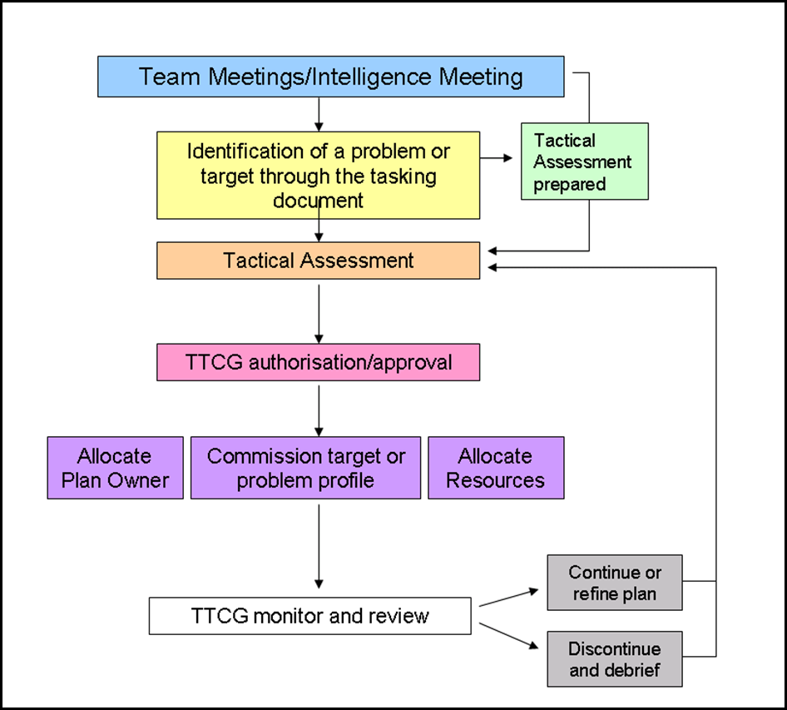

Demands from the National Enforcement Priorities in relation to Feed & Primary Production Prioritisation

In respect to feed and primary production, we also acknowledge and are guided by, the National Enforcement Priorities (NEP) which are published by the FSA each year.

The NEP priorities for 2024-2025 and how we address these can be found below.

Feed Priorities

Priority 1: Verification of effective implementation and maintenance of feed

safety management systems

Priority 2: Effective monitoring of feed on farms

Priority 3: Effective monitoring of storage arrangements at feed premises

Priority 4: : Verification of the accuracy of feed labelling

Priority 5: Effective monitoring of consignments of feed originating from non-EU countries, at points of entry

Priority 6: Effective identification, registration and inspection of food businesses producing higher-risk fresh produce operating at the level of primary production

We aim to identify and register all food businesses involved in primary production that are not already registered with us.

These premises are primarily identified via information received from the Animal & Plant Health Agency, Rural Payments Agency, Veterinary Medicines Directorate and our environmental health and trading standards colleagues who undertake inspections at food premises. We also actively look for such businesses ourselves via internet searches and online business directories, when putting together the inspection plan, and/or undertaking associated project work.

Business Profile

The Service deliver a programme of planned inspections according to risk. The risk assessment determines how often a premises is visited and this can be varied depending on the confidence that the service has on the systems in place. The service also delivers inspections as a result of complaints and revisit after non- compliant inspections.

There are currently 5020 food premises recorded on Oxfordshire’s information management system and approximately 1015 feed premises and 245 primary producers. The service moved to a new IMS 3 years ago and not all of the food premise information was brought over to this new system.

**Work Planned for the Coming Year**

In 2023, a new risk assessment scheme was introduced by the FSA for food businesses. This is being implemented from August 2024 in Oxfordshire. This made the risking strategy more relevant and fluid in that risk could be changed according to intelligence received.

Food standards interventions can be scheduled for the following intervals 1, 3, 6, 12, 24, 36, 48, 72 and 120 months. Those interventions which are due at 1, 3 or 6 months are deemed priority interventions.

The new risk rating takes account of 2 main risk factors, inherent risk and an assessment of compliance. This will then determine the frequency of inspections:

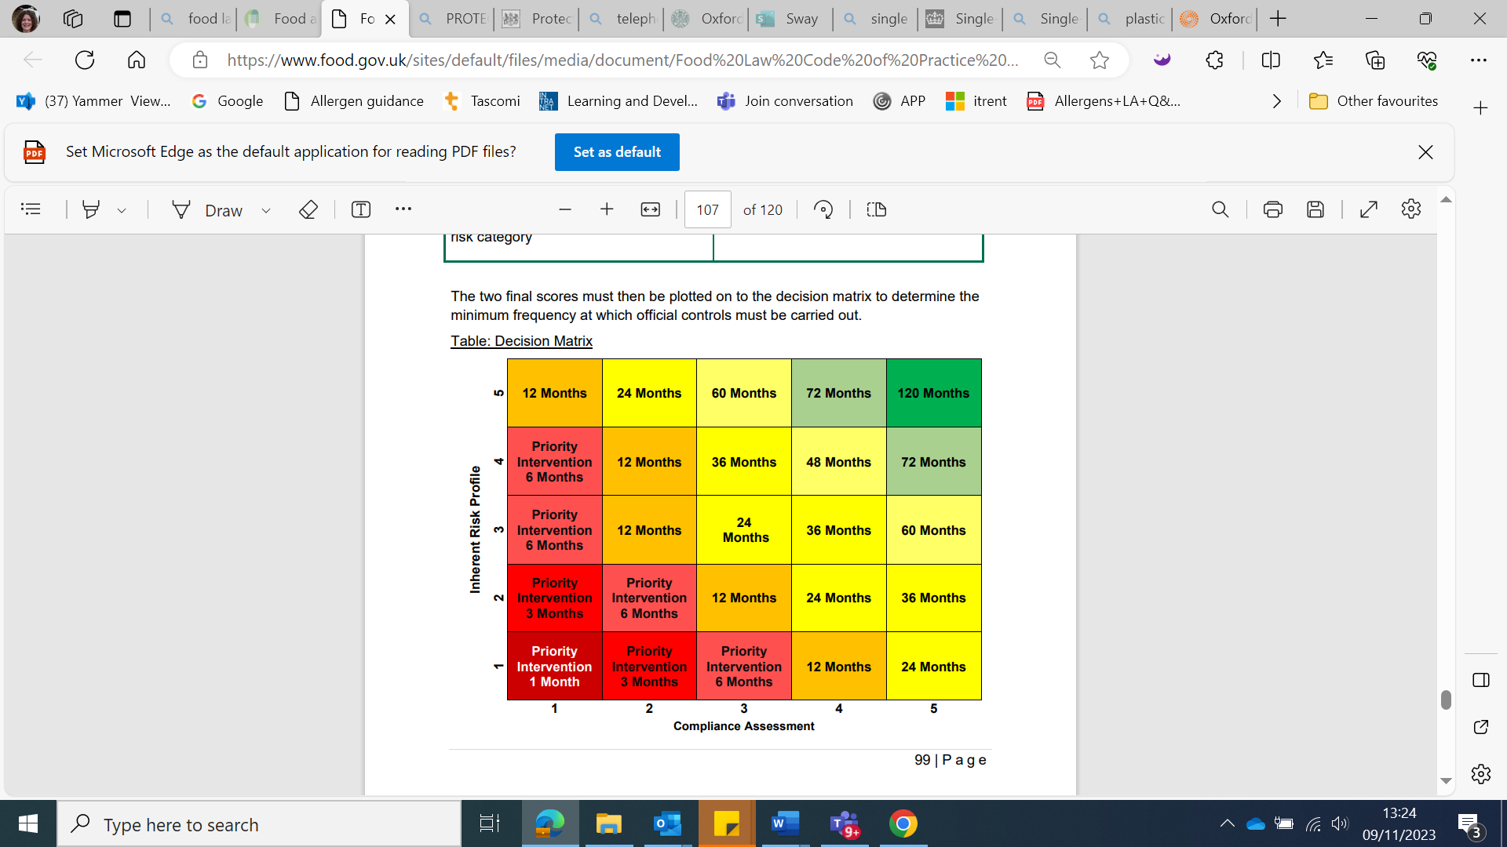

The new FSA food standards delivery framework and associated inspection regime will be formally implemented during 2024/25. As a result, we will begin the year identifying a number of high-risk premises for inspection, as well as a number of targeted audits. These businesses will be determined through the TTCG process, based on intelligence and complaints and where the most problems are occurring. The inspections within such audits will be taken from premises which are not due a priority intervention.

To establish a number of high-risk premises to be visited as of 1st April 2024 and expand the list of premises visited, the service will adopt the following strategy:

1. Importers who import a wide range of products, selling via the internet, who have poor compliance history or who are new to importing
2. All premises which are currently not broadly compliant
3. Premises which have had multiple food complaints over the previous year. These will be assessed and a decision made as to whether they should be additional surveillance and therefore be put as a priority intervention
4. High risk premises carried over from the previous year

Other interventions will be carried out during the year through complaint, intelligence and risk rating from inspections.

The Service will also aim to carry out some interventions based upon a sectorial, audit based approached. The premises will be identified from those which have not been visited for some years.

The numbers of interventions proposed are as follows:

100 interventions, from those identified as priority at start of the year, plus any identified in-year. These figures may change when the FSDM is implemented.

Feed Inspections

Feed business operators are rated against the FSA feed risk scheme. For details of the scheme, please see Chapter 5.5 of the Feed Law Code of Practice.

The annual inspection schedule is usually determined by a desktop exercise which the FSA require local authorities to undertake each year. This exercise profiles the type and number of premises, to calculate which are due an inspection. It considers whether businesses are in an approved assurance scheme, whether they have been inspected or not, and the level of past compliance.

The number of feed qualified officers has reduced; however, we are using officers employed by the TSSE region to ensure that we meet the desktop exercise figures.

The number of inspections planned for 2024-2025 is as follows:

|  |  |  |
| --- | --- | --- |
| Manufacturer A01-08 & R01-04 | 1 |  |
| Co Product Producer R12 | 8 |  |
| Mobile Mixer R04 | 0 |  |
| Importers | 2 |  |
| Stores R09 | 1 |  |
| Distributor A01-08, R01-03 & R05 | 4 |  |
| Transporter R08 | 2 |  |
| On Farm Mixer R10/R11 | 6 |  |
| Pet Food Manufacturer R06 | 5 |  |
| Supplier of feed materials/ Surplus Food R07 | 6 |  |
| R13 - Livestock Farms | 10 |  |
| R14 - Arable Farm | 3 |  |
| High Risk Primary Production FOOD Businesses | 16 |  |

**Delivery Strategy for Interventions**

Feed Interventions

While we endeavour to meet the commitment detailed above, lack of resource in terms of competent and experienced officers, who have the necessary time, may prevent this. The Resources section of this plan provides further details of our staff resources.

Inspection intervals depend on the activity of the business i.e. food, feed or primary production, their past compliance and whether they are a member of an approved assurance scheme.

Inspection intervals are usually only reviewed after a full inspection, in accordance with the Code of Practice. However, if a premise is visited because of a complaint, which is both justified and of a serious nature, the inspection interval may be reviewed at this point.

To cut down on the number of inspections undertaken on farms, we aim to undertake combined inspections, for animal health, feed and food - rather that separate inspections for each matter. However, this only applies if an inspection is due in all areas. As such, a feed inspection will not be brought forward or postponed by more than a year simply to achieve a combine visit.

**Business Profile & Delivery Strategy**

Feed Earned Recognition

Feed businesses who demonstrate high standards, by taking appropriate steps to comply with the law, may have these recognised when an officer determines their inspection frequency This is termed ‘earned recognition’. The effect of earned recognition is to reduce the minimum inspection frequencies.

There are two types of earned recognition type 1 and type 2:

* Type 1: a feed business which is a member of a FSA approved assurance scheme and demonstrates at least a satisfactory level of current compliance, with relevant feed law (an assured feed business)
* Type 2: a feed business which is not a member of a FSA approved assurance scheme and demonstrates a broad level of current compliance, with relevant feed law (a non-assured feed business).

For a current list of those assurance scheme that qualify for earned recognition, please refer to this link:

<https://www.food.gov.uk/business-guidance/earned-recognition-approved-assurance-schemes>

Earned recognition may be lost if the standards found on an inspection do not meet the required level. Where earned recognition is lost, the inspection frequency will increase. When this occurs, we are required to notify the FSA.

The National Targeted Monitoring Strategy (NTMS) is a mechanism to allocate appropriate resources to monitor compliance at low risk farm establishments achieving at least a satisfactory level of current compliance.

NTMS Intervention Type and Frequency

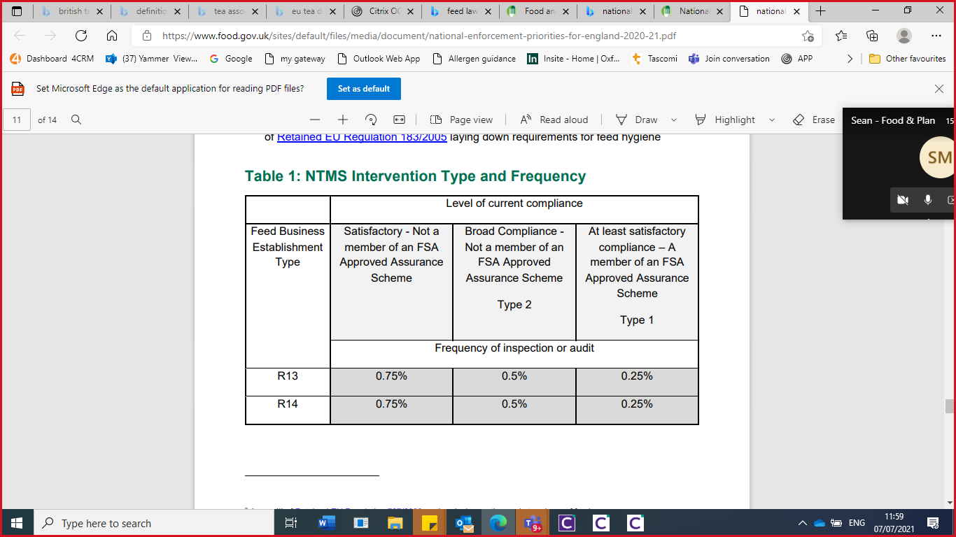

**Feed and Food Analysis and Sampling**

Food and feed sampling is based upon an intelligence-led approach. Many of the samples taken are as a result of complaints received from members of the public. The Service also takes random samples, to assess the compliance of the marketplace. The summary of Rapid Alert System for Food and Feed (RASFF) is circulated amongst the food and feed officers, alerting them to any products they may see whilst on an inspection.

**Food Sampling Strategy**

Nationally/ Regionally Funded Sampling

National Trading Standards (NTS) organise the feed funding and sampling structure, for those local authorities participating in national sampling projects funded by the FSA.

The trading standards service will look at the national sampling priorities and decide if the target feed product identified in the priorities can be obtained from any of our feed premises and if so, whether it is practical to take sample (i.e. skills, resources, equipment).

Trading Standards South East sometimes run a programme of food & feed sampling projects which the authority can opt into. These are based upon intelligence received, both regionally and nationally. TSSE will provide funding towards analysis costs.

If there are any areas in relation to food and feeding stuff sampling, within the annual national sampling priorities or regionally within TSSE, which are applicable to feed or food business in this authority, we will consider bidding for funds to facilitate this sampling.

Local Sampling

Oxfordshire trading standards, in addition to national and regional funding, has its own budget for both feed and food, to enable it to focus on local priorities/intelligence or to support training.

Decisions as to which food products to sampled are made at the Tactical Tasking and Co-ordination group, based on intelligence from complaints, information from the FSA’s Food Crime Unit, horizon scanning for emerging issues and threats, such as crop shortages and problems found with produce in other countries and any projects run by Hampshire Scientific Services.

Trading Standards uses Hampshire Scientific Service as it’s public analyst. The laboratory proposes a number of intel led sampling project during the year. Trading Standards score these projects to decide which ones they participate in.

**Feed Sampling Policy**

Sampling Policy

Sampling of feed is undertaken as part of national and regional projects, in response to specific complaints, to maintain consumer confidence and to support the training of feed officers.

* Samples are taken for the purpose of:
* chemical and/or
* microbiological analysis or
* physical contaminants, or
* for checking compliance with labelling requirements,

and may be obtained from all types of business within the feed chain, including (but not limited to),

* Feed Manufactures/Merchants, Food Business, Feed Stores, Livestock & Arable Farms, Feed Hauliers, Retailers etc.

All samples will be informal, except for those taken:

* in relation to a complaint, investigation, or as part of a project which stipulates otherwise or
* used to support an officer who is undertaking the formal qualification in agriculture

An annual sampling programme will be drawn-up each year in April/May.

It will be risk based and as such consider the current nationalenforcement priorities, any regional projects and local intelligence - but will also have some flexibility to respond to unforeseen issues. Where appropriate, this plan will be drawn up in consultation with our agricultural analyst.

Sampling will only be undertaken by, or under the supervision of, suitable qualified and competent staff and in accordance with work instruction WI5 Animal Feed & Fertiliser Sampling.

On receipt of the test certificate, the results will be disclosed to the FeBO where the sample was taken, and to the manufacturer if a fourth part sample was taken.

If any sample is deemed unsatisfactory, the issue will be referred to the feed distributer and or manufacturers concerned, via the HA or PA principle/s, if appropriate.

**Food Sampling Policy & Plan**

Sampling of food is undertaken as part of national and regional projects, in response to specific complaints or part of an investigation, to maintain consumer confidence and to support the training of food officers.

|  |
| --- |
|  |

Samples are taken for the purpose of chemical analysis, or for checking compliance with labelling requirements and may be obtained from all types of business within the food chain including, retailers, caterer, schools, manufacturers, importers and online.

Whether a sample is taken formally, or informally, is taken on a case-by-case basis and depends on the volume of product available. Other factors which may determine whether a sample is taken formally or informally are:

* in relation to a project which stipulates how the sample should be taken;
* used to support an officer who is undertaking the formal qualification in food.

An annual sampling programme will be drawn-up each year in April/May.

The sampling plan is left deliberately non-specific to take into account local intelligence which happens throughout the year and also to allow for complaint samples. Where appropriate this plan will be drawn up in consultation with our public analyst.

Sampling will only be undertaken by, or under the supervision by suitable qualified and competent staff and in accordance with the work instruction in relation to Food Sampling, the Code of Practice and the Sampling and Qualifications Regulations.

On receipt of the test certificate, the results will be disclosed to the food business operator where the sample was taken.

If any sample is deemed unsatisfactory, a decision will be made on a case-by-case basis as to the best course of action.

**Sampling Plan for 2024**

|  |
| --- |
| **Products to be sampled during the year** |
| Officer initiative, intel led, random samples |
| Samples aligned to FSA food sampling priorities;  Allergens in caterers;  Non permitted additives in soft drinks;  Food supplements;  Substitution in take aways. |
| Peanut butter/peanut product |
| Minced meat |
| All cooking oils (including sprays) |
| Prepacked glazed foods where egg and/or milk is not declared |
| Canned fish and potentially whole fresh or frozen fish/shellfish/molluscs |
| Any single spice |
| Pre-packed for direct sale foods |

**Enforcement Policies**

Trading Standards has an enforcement policy. Please see the following links to the respective policies.

<https://www2.oxfordshire.gov.uk/cms/content/about-trading-standards>

**Business Advice**

Trading standards has business advice policy which applies to the provision of chargeable advice also Primary Authority agreements. The reaction to business advice will depend on other priorities in the service at any given time. The policy can be found here;

[Trading Standards business advice | Oxfordshire County Council](https://www.oxfordshire.gov.uk/business/trading-standards/business-advice)

**Liaison with Other Authorities**

To ensure consistency and effective enforcement across the country, representatives from Trading Standards attends regional meetings and liaise with national organisations. These include:

|  |
| --- |
| **Oxfordshire, Berkshire & Buckinghamshire Food Liaison Group**  The Service participates in the Oxfordshire, Berkshire & Buckinghamshire Food Liaison Group. The group meets on a regular basis and participating local authorities work closely together to ensure that the work is consistent and targeted across the counties, sharing and coordinating activities wherever possible. The group was recently expanded to include Berkshire to improve the representation at the group and to share best practice more widely. |
| **Trading Standards South East** (TSSE)  Oxfordshire is part of the TSSE group, both for feed and food. The lead officers attend the 6 monthly meeting for feed and food. |
| **The Animal and Plant Health Agency (APHA) and the Veterinary Medicines Directorate (VMD)**  The Service liaises with APHA and the VMD on an ad-hoc basis depending on demands. |

**Resources**

**Financial Allocation**

The Service has a finite budget and staff on which to run the food and feed service and currently there is a national shortage of food standards qualified officers, including agency staff. In addition, Oxfordshire is an expensive place to live and it is difficult to attract staff.

**Demand & Resources**

For 2024/25 the following budgets have been set aside at for sampling:

|  |  |
| --- | --- |
| Purpose | Budget 2020-21 |
| Food Testing and Analysis | £9,500 |
| Livestock Feeding Stuffs and Fertilisers Testing | £5,500 |

Delivery of this work plan will depend on a fully resourced and appropriately qualified team. Officers are required to meet the necessary competencies as defined in the relevant guidance.

Lead officers for food and feed are appointed internally, as required by the Codes of Practice and are responsible for the operational management of the respective matters. The lead officers for feed and food are respectively Sean Maclaren and Emily James, with primary production shared between the two lead officers.

The County Council has an Officer’s Code of Conduct. As part of this there is an obligation for staff to declare where they have a conflict of interest.

There are a total of 8 members of staff who are authorised under Food Safety Act. Whilst all of these are qualified and competent under the Food Law Code of Practice, officers are required to carry out a wide range of trading standards duties. Many are also part-time.

Due to the need to meet other statutory requirements placed upon the Council, the Service has allocated 1.77 FTE towards undertaking food standards work. Based upon an estimated 100 planned interventions for the 2024/25 financial year, the Service believes that this level of resource is sufficient. However, to fully meet the requirements of the Code of Practice, the Service would require and additional 5.55 FTE. As a result, the Service is required to adopt a sampling approach to non-priority interventions.

There is 1 staff member and 1 internal contractor (appointed on a temporary basis), authorised and competent under the Agriculture Act. There is 1 regional feed officer within TSSE, who may work across the region. They are fully authorised by the Service for feed & food hygiene and animal health.

Details of each officer’s specific competencies are detailed in their training records. All of these officers also carry work in relation to other statutes. Our resource for all aspects of feed work equated to approximately 0.65 FTE. In addition, the same officers are authorised to carry out food hygiene inspections at a primary production premises.

Only those officers who are qualified and competent under the Food Law code of Practice are permitted to undertake work related to Primary Production.

Primary Production

The Service currently estimates it has 0.05 FTEs directed to food at primary production inspections and sampling. The Service believes it is sufficiently resourced to meet its current commitments in this area of work and the requirements of the Food Law Code of Practice.

In relation to feed work, the Service feels it has the resources to carry out the inspections identified in the desktop exercise (a sample of the due inspections) along with the resulting administration and follow up work that is required. However, the Service does not have the resources required to complete all of the due inspections.

The Service accepts that having only one feed qualified officer, may provide low resilience for the service and is attempting to mitigate this risk through the training of four Trainee Trading Standards Officers.

**Staff Development Plans**

The Codes of Practice stipulate the qualifications and competent officers must have to be able to carry out official food controls and other food work. For details of how we ensure staff meeting this requirement.

**Staff Development**

Assessment of competence and recommendation of authorisation of food and feed law enforcement officers, is completed by the appropriate lead officer, in accordance with the relevant Code of Practice.

All staff authorised for the purposes of enforcing the provisions of the food and/or feed legislation are suitably qualified (with some exceptions[3]) and deemed competent for their role. They also receive ongoing training in the appropriate subject areas.

Staff are authorised in accordance with the scheme of delegation for the Council. In accordance with the Food and Feed Law Codes of Practice, we will aim to provide a minimum of:

* 20 hours CPD (for food)
* 10 hours CPD (for feeding stuffs)
* 4 hours CPD – (for food hygiene at primary production)

to each officer in issues relevant to Food and Feed Safety and Hygiene interventions

and associated matters.

The Service has adopted the CTSI Continual Professional Development (CPD) scheme and all officers create development plans under this scheme. The Service’s training co-ordinator collates such plans and produces a service wide training plan.

The Food Law Code of Practice 2020 introduced a new competency framework for officers. At the current time, only new food officers, or those moving into new areas of work are expected to be assessed against the scheme. The Service currently has 1 officer in this position, and they have been assessed using the new competency form. Existing officers will continue to maintain competence through CPPD, monitored through the Council’s supervision policy, known as 12-3-2.

**Quality Assessment**

Assessment and Self-Assessment

Food Standards internal monitoring will be conducted the TTCG meeting every 2 weeks, to assess how many high-risk inspections have been completed and samples have been taken.

Feed work will also be monitored through the TSSE quarterly return. The programme of inspections and sampling are reviewed as part of completing the quarterly

feed return and discussions with the team leader.

**In Year Variations**

The inspection and sampling plans may vary over the year. This is due to availability of samples at the premises we inspect and to accommodate that those businesses which may have ceased trading or no longer act as a feed/food business operator. In this case, we would substitute the visit with another business due an inspection. We will also leave some slots in the programme unassigned, to allow capacity to respond to complaints.

**Review of Previous Year**

This plan is reviewed and updated annually.

**Review of 2023-2024**

* Completed 17 planned food standards high risk inspections
* Carried out 61 inspections, such as revisits, complaint visits and partial inspections (excluding sampling inspections)
* Took 80 food samples for composition and labelling and followed these up where they had failed
* Issued 2 improvement notices for incorrectly labelled food

Delivered the following feed inspections (where possible, these were combined with animal health and welfare inspections)

|  |  |
| --- | --- |
| **Premise type** | **Number of inspections achieved** |
| Co-Producers (E12) | 5 |
| Mobile mixer | 1 |
| Importer (E10) | 1 |
| Stores (E9) | 1 |
| Distributors (R1,3,5) | 3 |
| Transporters (E9) | 1 |
| On farm mixers (E7) | 6 |
| Pet Food Manufacturers (E1) | 4 |
| Suppliers of surplus food (E4) | 8 |

**Primary Production visits**

|  |  |
| --- | --- |
| Farms (E9) | 10 |
| Farms (E11) | 2 |
| Primary Production (High risk activities planned) | 6 |

**Food and Feed Complaints**

The service receives incoming complaints/queries from members of the public, businesses and from the National Citizens Advice Consumer Service. The service has a documented policy on how it will deal with and prioritise complaints.

The Service has dealt with:

* 31 food standards and labelling related complaints from members of the public
* 56 referrals from other agencies or local authorities
* 81 Primary authority referrals
* 28 requests for business advice in relation to food.
* 15 requests for business advice in relation to feed
* 13 requests for feed registration/approval

**Annex 2** (correct as of 1st April 2024)

**Non-exhaustive List of Legislation Enforced by Trading Standards**

Part 1 - Authorisation for officers enforcing legislation generally:

Agriculture (Miscellaneous Provisions) Act 1968

Air Quality (Domestic Solid Fuels Standards)(England) Regulations 2020

Animal Health Act 1981

Animals (Penalty Notices) Act 2022

Animal Welfare Act 2006

Animals Act 1971

Animals (Low-Welfare Activities Abroad) Act 2023

Anti-social Behaviour Act 2003

Botulinum Toxin and Cosmetic Fillers (Children) Act 2021

Brucellosis (England) Order 2015

Cancer Act 1939

Calorie Labelling (Out of Home Sector) (England) Regulations 2021

Children and Families Act 2014

Children and Young Persons (Protection from Tobacco) Act 1991

Children and Young Persons Act 1933

Clean Air Act 1993 – Motor Fuel (Composition and Content), and Biofuel Labelling Regulations.

Companies Act 2006

Consumer Credit Act 1974

Consumer Protection Act 1987

Consumer Rights Act 2015

Copyright, Designs and Patents Act 1988

Criminal Justice Act 1988

Criminal Justice and Police Act 2001

Education Reform Act 1988

Energy Efficiency (Private Rented Property)(England and Wales) Regulations 2015

Enterprise Act 2002

Environmental Protection (Microbeads)(England) Regulations 2017

Environmental Protection (Plastic Straws, Cotton Buds and Stirrers) (England) Regulations 2020

Environmental Protection (Plastic Plates etc. and Polystyrene Containers etc.)

(England) Regulations 2023

Equipment Theft (Prevention) Act 2023

Estate Agents Act 1979

European Union (Withdrawal) Act 2018 as it continues to give effect to the following Regulations or Orders under which this local authority has an enforcement duty:

Advanced Television Services Regulations 2003

African Horse Sickness (England) Regulations 2012

Animal By-Products(Enforcement)(England) Regulations 2013

Avian influenza (Preventative Measures)(England) Regulations 2006

Avian Influenza (Vaccination)(England) Regulations 2006

Beef and Veal Labelling Regulations 2010

Biofuel Labelling Regulations 2004

Bluetongue Regulations 2008

Business Protection from Misleading Marketing Regulations 2008

Cat and Dog Fur (Control of Import, Export and Placing on the Market) Regulations 2008

Cattle Identification Regulations 2007

Construction Products Regulations 2013

Consumer Contracts (Information, Cancellation and Additional Charges) Regulations 2013

Consumer Protection from Unfair Trading Regulations 2008

Consumer Rights (Payment Surcharges) Regulations 2012

Cosmetic Products Enforcement Regulations 2013 and the EU Cosmetic Products Regulation 1223/2009

Crystal Glass (Descriptions) Regulations 1973

Detergents Regulations 2010

Diseases of Swine Regulations 2014

EC Fertilisers (England and Wales) Regulations 2006

Eggs and Chicks (England) Regulations 2009

Electrical Equipment (Safety) Regulations 2016

Electromagnetic Compatibility Regulations 2016

Energy Information Regulations 2011

Energy Performance of Buildings (England and Wales) Regulations 2012

Equine Identification (England) Regulations 2018

Financial Services (Distance Marketing) Regulations 2004

Fluorinated Greenhouse Gases Regulations 2015

Foot-and-Mouth Disease (Control of Vaccination)(England) Regulations 2006

Footwear (Indication of Composition) Labelling Regulations 1995

Gas Appliances (Enforcement) and Miscellaneous Amendments Regulations 2018

General Product Safety Regulations 2005

Package Travel and Linked Travel Arrangements Regulations 2018

Packaging (Essential Requirements) Regulations 2015

Passenger Car (Fuel Consumption and CO2 Emissions Information) Regulations 2001

Personal Protective Equipment (Enforcement) Regulations 2018

Pressure Equipment (Safety) Regulations 2016

Products of Animal Origin (Disease Control)(England) Regulations 2008

Pyrotechnic Articles (Safety) Regulations 2015

Quality Schemes (Agricultural Products and Foodstuffs) Regulations 2018

Radio Equipment Regulations 2017

REACH Enforcement Regulations 2008

Recreational Craft Regulations 2017

Registration of Establishments (Laying Hens)(England) Regulations 2003

Rights of Passengers in Bus and Coach Transport (Exemptions and Enforcement) Regulations 2013

Simple Pressure Vessels (Safety) Regulations 2016

Supply of Machinery (Safety) Regulations 2008

Textile Products (Labelling and Fibre Composition) Regulations 2012

Timeshare, Holiday Products, Resale and Exchange Contracts Regulations 2010

Tobacco and Related Products Regulations 2016

Toys (Safety) Regulations 2011

Trade in Animals and Related Products Regulations 2011

Transmissible Spongiform Encephalopathies (England) Regulations 2018

Veterinary Medicines Regulations 2013

Volatile Organic Compounds in Paints, Varnishes and Vehicle Refinishing Products Regulations 2012

Welfare of Animals at Time of Killing (England) Regulations 2015

Zoonoses (Monitoring) (England) Regulations 2007

Fireworks Act 2003

Food (Promotion and Placement) (England) Regulations 2021

Fraud Act 2006

Hallmarking Act 1973

Health Act 2006

Knives Act 1997

Leasehold Reform (Ground Rent) Act 2022

Legal Services Act 2007

Licensing Act 2003

Medicines and Medical Devices Act 2021

Motor Cycle Noise Act 1987

Offensive Weapons Act 2019

Olympic Symbol etc. (Protection) Act 1995

Prices Act 1974

Protection of Animals Act 1911

Psychoactive Substances Act 2016

Registered Designs Act 1949

Road Traffic Acts 1988 and 1991

Road Traffic (Foreign Vehicles) Act 1972

Road Traffic Regulation Act 1984

Single Use Carrier Bags Charges (England) Order 2015

Tenant Fees Act 2019

and the Housing and Planning Act 2016 as it relates to Client Money Protection Schemes

Theft Act 1968

Tobacco Advertising and Promotion Act 2002

Tobacco Products (Traceability and Security Features) Regulations 2019

Trade Descriptions Act 1968

Trade Marks Act 1994

Unsolicited Goods and Services Acts 1971 and 1975

Video Recordings Act 1984

Vehicles (Crime) Act 2001

Part 2 - Additional List of Legislation for officers with qualification/competency in Food Law:

European Union (Withdrawal) Act 2018 as it continues to give effect to the following Regulations or Orders under which this local authority has an enforcement duty:

Animals and Animal Products (Examination for Residues and Maximum Residue Limits)(England and Scotland) Regulations 2015

Country of Origin of Certain Meats (England) Regulations 2015

Food for Specific Groups (Food for Special Medical Purposes for Infants, Infant Formula and Follow-on Formula) (Information and Compositional Requirements) (Amendment etc.) (England) Regulations 2020

Food for Specific Groups (Information and Compositional Requirements)(England) Regulations 2016

Food Information Regulations 2014

Food Safety and Hygiene (England) Regulations 2013

Genetically Modified Organisms (Traceability and Labelling)(England) Regulations 2004

Materials and Articles in Contact with Food (England) Regulations 2012

Novel Foods (England) Regulations 2018

Official Controls (Animals, Feed and Food, Plant Health Fees etc.) Regulations 2019 *in so far as it relates to food law*

Official Feed and Food Controls (England) Regulations 2009 *in so far as it relates to food law*

Olive Oil (Marketing Standards) Regulations 2014

Organic Products Regulations 2009

Poultrymeat (England) Regulations 2011

Quick-frozen Foodstuffs (England) Regulations 2007

Scotch Whisky Regulations 2009

Specified Products from China (Restrictions on First Placing on the Market)

(England) Regulations 2008

Calorie Labelling (Out of Home Sector) (England) Regulations 2021

Spirit Drinks Regulations 2008

Wine Regulations 2011

Food Act 1984

Food (Promotion and Placement) (England) Regulations 2021

Food and Environment Protection Act 1985 [Note: Authorisation must be issued directly to the officer by the FSA.]

Food Safety Act 1990

Part 3 - Additional List of Legislation for officers with qualification/competency in Feed Law:

Agriculture Act 1970

Animal Feed (Composition, Marketing and Use)(England) Regulations 2015

Animal Feed (Hygiene, Sampling etc and Enforcement)(England) Regulations 2015

European Union (Withdrawal) Act 2018 as it continues to give effect to the following Regulations or Orders under which this local authority has an enforcement duty:

Animal Feed (Basic Safety Standards) (England) Regulations 2019

Genetically Modified Organisms (Traceability and Labelling)(England) Regulations 2004

Official Controls (Animals, Feed and Food, Plant Health Fees etc.) Regulations 2019 *in so far as it relates to feed law*

Official Feed and Food Controls (England) Regulations 2009 *in so far as it relates to feed law*

Part 4 - Additional List of Legislation for officers with qualification in Weights and Measures Law:

European Union (Withdrawal) Act 2018 as it continues to give effect to the following Regulations or Orders under which this local authority has an enforcement duty:

Measuring Container Bottles (EEC Requirements) Regulations 1977

Measuring Instruments Regulations 2016

Non-automatic Weighing Instruments Regulations 2016

Weights & Measures (Packaged Goods) Regulations 2006

Weights and Measures Act 1985

Part 5 - A separate authorisation is required under the Health and Safety at Work etc Act 1974 referring to the following:

1. Sections 20, 21, 22 and 25 of the 1974 Act;

ii) The following Regulations made under the 1974 Act:

The Ammonium Nitrate Materials (High Nitrogen Content) Safety Regulations 2003

The Biocidal Products and Chemicals (Appointment of Authorities and Enforcement) Regulations 2013

The Chemicals (Hazard Information and Packaging for Supply) Regulations 2009

The Dangerous Substances and Explosive Atmospheres Regulations 2002,

The Explosives Regulations 2014,

The Petroleum (Consolidation) Regulations 2014, and

1. The provisions of the following Acts mentioned in Schedule 1 to the 1974 Act:

Explosives Act 1875

Public Health Acts 1936 and 1961

Part 6 - List of Extracted Legislation appropriate to specialist Animal Health and Welfare Officers ONLY:

Agriculture (Miscellaneous Provisions) Act 1968

Agriculture Act 1970

Animal Health Act 1981

Animals (Penalty Notices) Act 2022

Animal Welfare Act 2006

Animals Act 1971

Animals (Low-Welfare Activities Abroad) Act 2023

Brucellosis (England) Order 2015

Companies Act 2006

European Union (Withdrawal) Act 2018 as it continues to give effect to the following Regulations or Orders under which this local authority has an enforcement duty:

African Horse Sickness (England) Regulations 2012

Animal By-Products (Enforcement)(England) Regulations 2013

Animals and Animal Products (Examination for Residues and Maximum Residue Limits)(England and Scotland) Regulations 2015

Avian influenza (Preventative Measures)(England) Regulations 2006

Avian Influenza (Vaccination)(England) Regulations 2006

Bluetongue Regulations 2008

Business Protection from Misleading Marketing Regulations 2008

Cattle Identification Regulations 2007

Consumer Protection from Unfair Trading Regulations 2008

Diseases of Swine Regulations 2014

EC Fertilisers (England and Wales) Regulations 2006

Eggs and Chicks (England) Regulations 2009

Equine Identification (England) Regulations 2018

Food Safety and Hygiene (England) Regulations 2013

Foot-and-Mouth Disease (Control of Vaccination)(England) Regulations 2006

Genetically Modified Organisms (Traceability and Labelling)(England) Regulations 2004

Official Controls (Animals, Feed and Food, Plant Health Fees etc.) Regulations 2019

Official Feed and Food Controls (England) Regulations 2009

Products of Animal Origin (Disease Control)(England) Regulations 2008

Registration of Establishments (Laying Hens)(England) Regulations 2003

Trade in Animals and Related Products Regulations 2011

Transmissible Spongiform Encephalopathies (England) Regulations 2018

Veterinary Medicines Regulations 2013

Welfare of Animals at Time of Killing (England) Regulations 2015

Zoonoses (Monitoring) (England) Regulations 2007

Food and Environmental Protection Act 1985

Food Safety Act 1990

Protection of Animals Act 1911

Trade Descriptions Act 1968

Part 7 - Additional list of legislation for public safety, petroleum, explosives, road traffic and miscellaneous matters:

Customs & Excise Management Act 1979

Environmental Protection Act 1990

Environment Act 1995 - as it applies to the Volatile Organic Compounds in Paints,

Varnishes and Vehicle Refinishing Products Regulations 2012

Petroleum Consolidation Regulations 2014

Public Health Act 1961 (Section 73)

Fire Safety and Safety of Places of Sport Act 1987

Safety at Sports Grounds Act 1975

Road Traffic Acts 1988 and 1991

Road Traffic (Foreign Vehicles) Act 1972

Road Traffic Regulation Act 1984

Malicious Communications Act 1988 (common informers)

National Lottery Act 1993 (common informers)

Protection from Harassment Act 1997 (common informers)

Violent Crime Reduction Act 2006

Regulatory Enforcement and Sanctions Act 2008

Proceeds of Crime Act 2002

1. An infectious disease that is transmitted between species from animals to humans
2. Primary Authority allows businesses to receive assured and tailored advice on meeting regulations through direct or co-ordinated partnerships with local authorities
3. Some members of staff who are not qualified may still be required to undertake limited activities as identified in the Code of Practice as these tasks may be fulfilled by officers who are not qualified.