The Virtual School
2nd Floor, Abbey House
Abbey Close
Abingdon
OX14 3JD
Tel: 01865 328550
Address
Address
Address
Address
Address

03 March 2021

Dear Carer/Parent

We are writing to you to ask for your support to ensure all our children take holidays outside of term time. We are committed to guarantee the best possible education for every child to prepare them for the next stage in life. Each school day is carefully planned, and each lesson informs a wider programme of learning. Therefore, every lesson and every day does count.
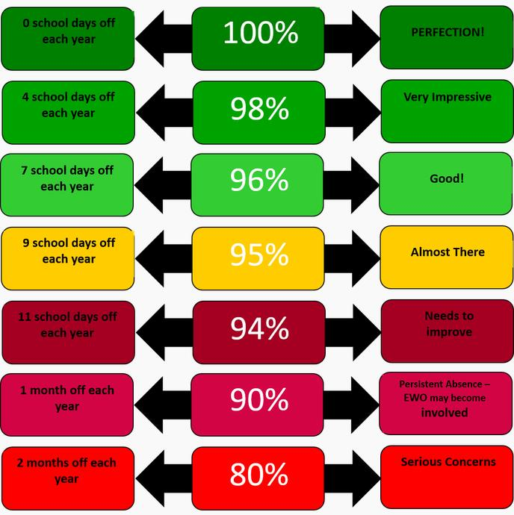

If you expect an absence of two consecutive school days or more, a request needs to be made in writing to the School Headteacher, Corporate Parenting Manager, Sarah Duerden and Headteacher of the Virtual School, Michelle Johnson. This should be made no later than two working weeks before the first day of absence requested. Approvals will only be granted in exceptional circumstances such as bereavements, funerals, weddings and not for holidays. If the request is declined, then the foster carer should ensure that the child attends school.

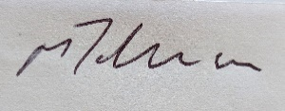

Michelle Johnson
Headteacher for Virtual School for Looked After and Care Leavers
Children, Education and Families Directorate

Tel: 01865 328550
Email: virtualschool.lac@oxfordshire.gov.uk
https://www.oxfordshire.gov.uk/cms/public-site/virtual-school-looked-after-children-and-care-leavers-0-25

